The link for the Maine FTP site is: https://www.maine.gov/dep/ftp/MVTSC/

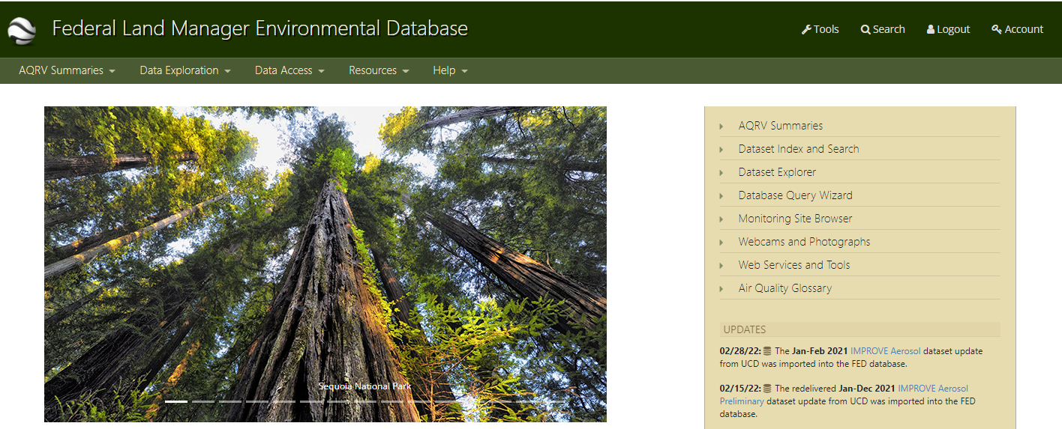

Open the Federal Land Manager web-page (http://views.cira.colostate.edu/fed/) and choose Database Query Wizard

1 Select RHR II data.

Datasets – IMPROVE RHR Metrics II

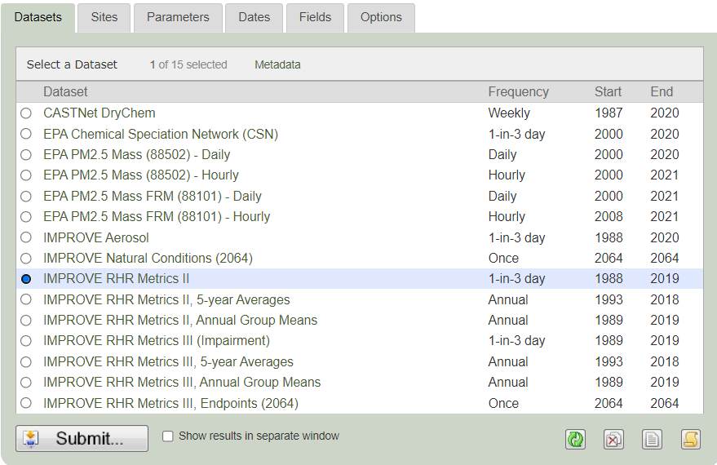

Sites (32 sites)

ACAD1 | ADPT1 | AREN1 | BALT1 | BRIG1
BRMA1 | CABA1 | CACO1 | COHI1 | DOSO1
FRRE1 | GRGU1 | JARI1 | LOND1 | LYBR1
LYBR_RHTS | LYEB1 | MAVI1 | MKGO1 | MOMO1
MOOS1 | NEYO1 | OLTO1 | PACK1 | PENO1
PITT1 | PMRF1 | PRIS1 | QUCI1 | QURE1
SHEN1 | WASH1

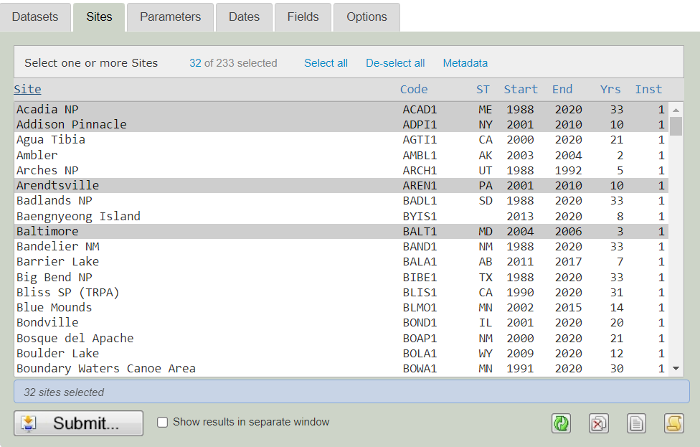

Parameters (19 Parameters)

RHR II – aerosol_bext, ammNO3f, ammNO3f_bext, ammSO4f, ammSO4f_bext, CM_bext, CM_calculated, dv, ECf, ECf_bext, OMCf, OMCf_bext, RCFM, SeaSaltf, SeaSaltf_bext, SOILf, Soilf_bext, SVR, total_bext

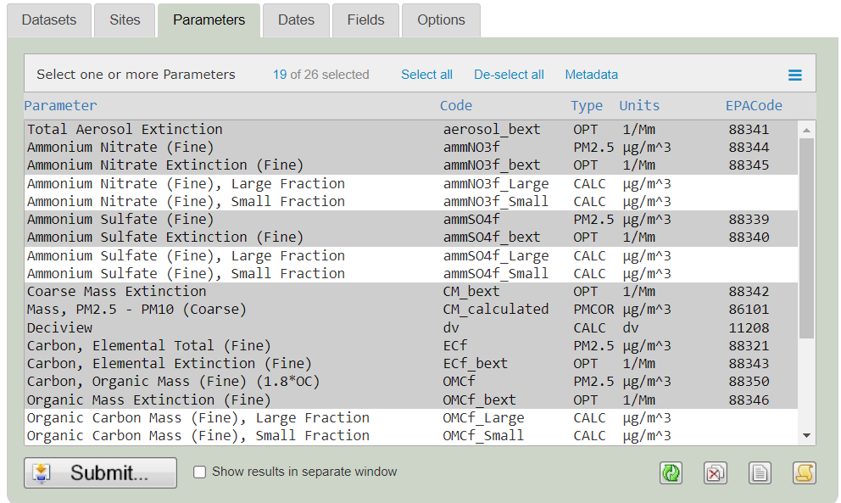

Dates – 1/1/2000 to 12/31/????

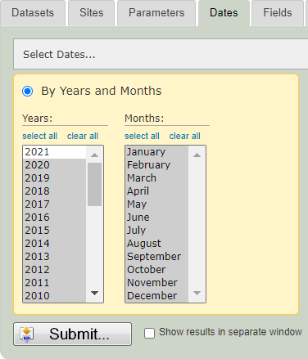

Fields – keep the pre-selected fields and AuxID

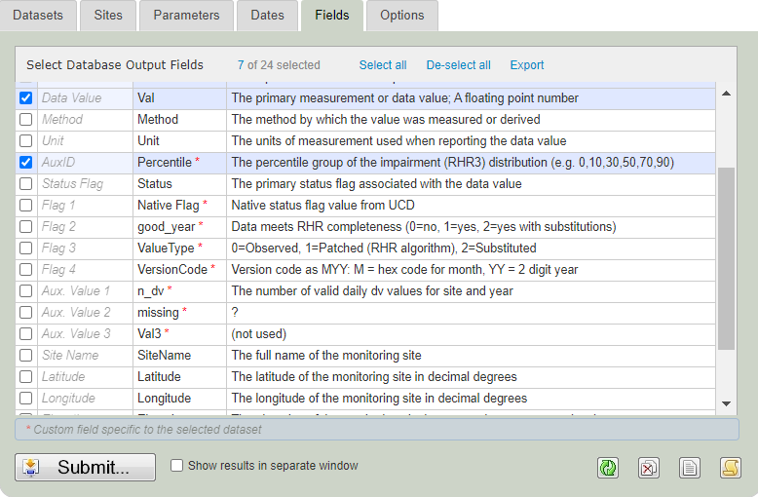

Options – Text File, Delimited (,), Standard, Data Only

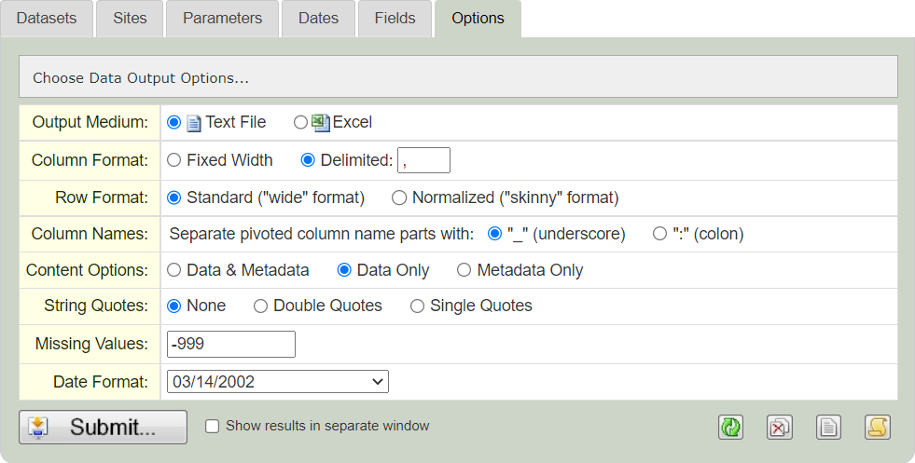

Save as RH II.txt
Do not close Data Fed

2. Select IMPROVE aerosol data.
Dataset – IMPROVE Aerosol

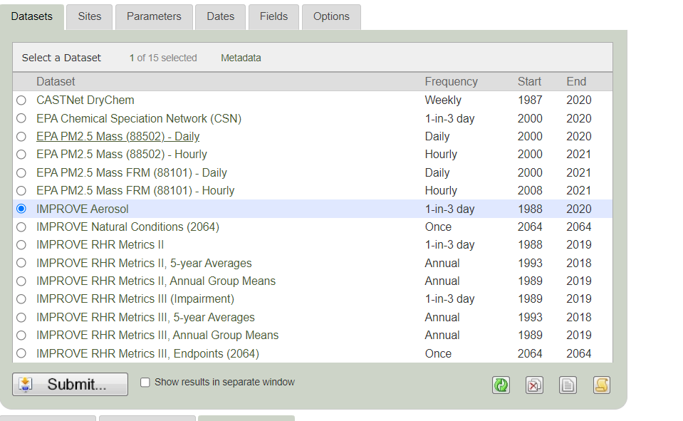

Sites (31 sites no LYBR_RHTS)

ACAD1 | ADPT1 | AREN1 | BALT1 | BRIG1
BRMA1 | CABA1 | CACO1 | COHI1 | DOSO1
FRRE1 | GRGU1 | JARI1 | LOND1 | LYBR1
 | LYEB1 | MAVI1 | MKGO1 | MOMO1
MOOS1 | NEYO1 | OLTO1 | PACK1 | PENO1
PITT1 | PMRF1 | PRIS1 | QUCI1 | QURE1
SHEN1 | WASH1

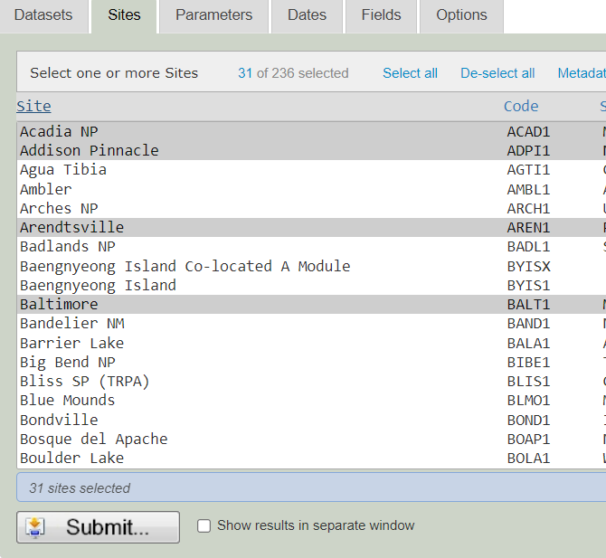

Parameters (40 Parameters)

IMPROVE Aerosol – Alf, ASf, BRf, CAf, CHlf, CLf, CRf, CUf, EC1f, EC2f, EC3f, FEf, Kf, MF, MGf, MNf, MT, N2f, NAf, NIf, NO3f, OC1f, OC2f, OC3f, OC4f, OCf, OPf, PBf, Pf, RBf, RCTM, SEf, Sf, Sif, SO4f, SRf, TIf, Vf, ZNf, ZRf

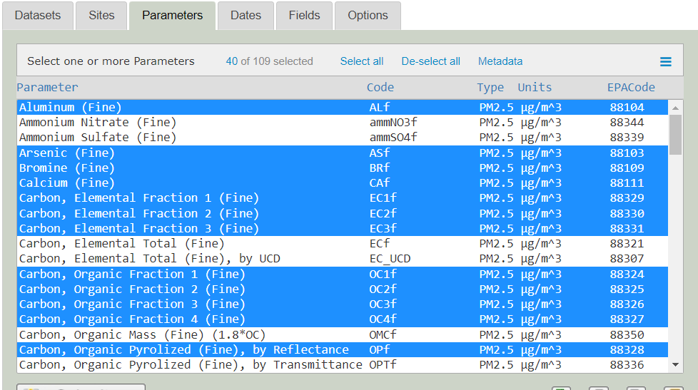

Dates – 1/1/2000 to 12/31/????

Fields – keep only the pre-selected fields – no AuxID

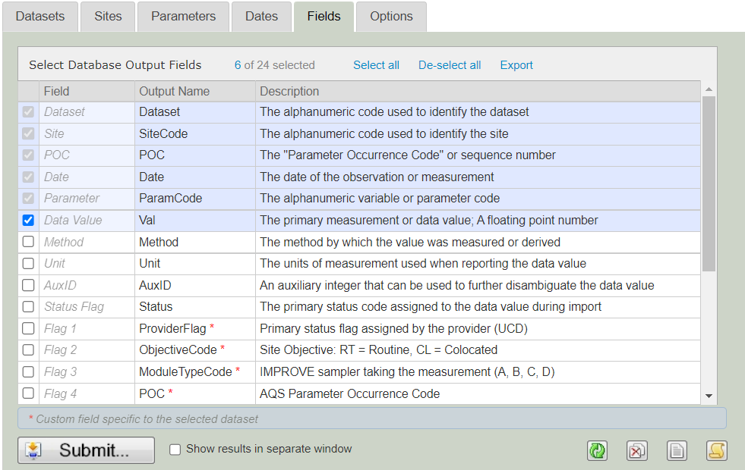

Options – Text File, Delimited (,), Standard, Data Only

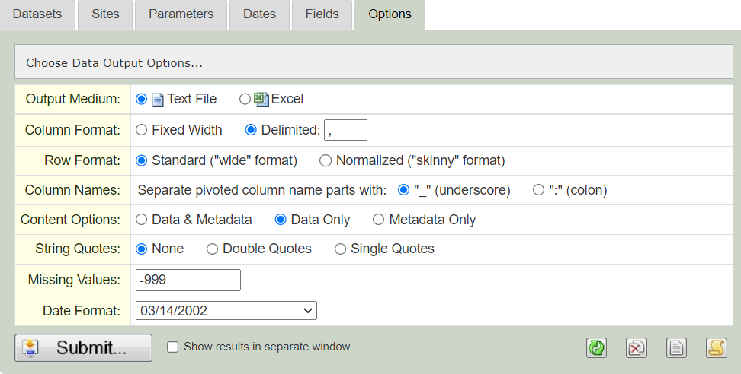

Save as IMPROVE.txt
Do not close Data Fed

3. Select RHR III data.
Dataset – IMPROVE RHR Metrics III (Impairment)

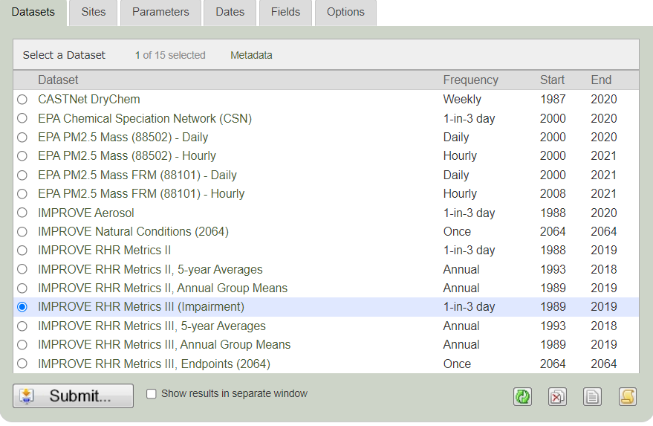

Sites (30 sites no BALT1 OR PITT1 reselect LYBR_RHTS)

ACAD1 | ADPT1 | AREN1 |  | BRIG1
BRMA1 | CABA1 | CACO1 | COHI1 | DOSO1
FRRE1 | GRGU1 | JARI1 | LOND1 | LYBR1
LYBR_RHTS | LYEB1 | MAVI1 | MKGO1 | MOMO1
MOOS1 | NEYO1 | OLTO1 | PACK1 | PENO1
 | PMRF1 | PRIS1 | QUCI1 | QURE1
SHEN1 | WASH1

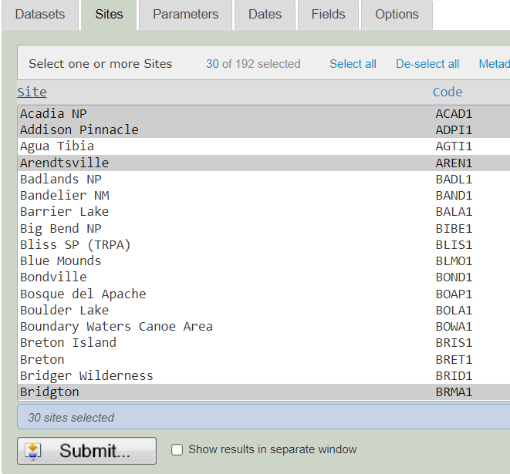

RHR III –AnthBext, Impairment, S_Rayleigh
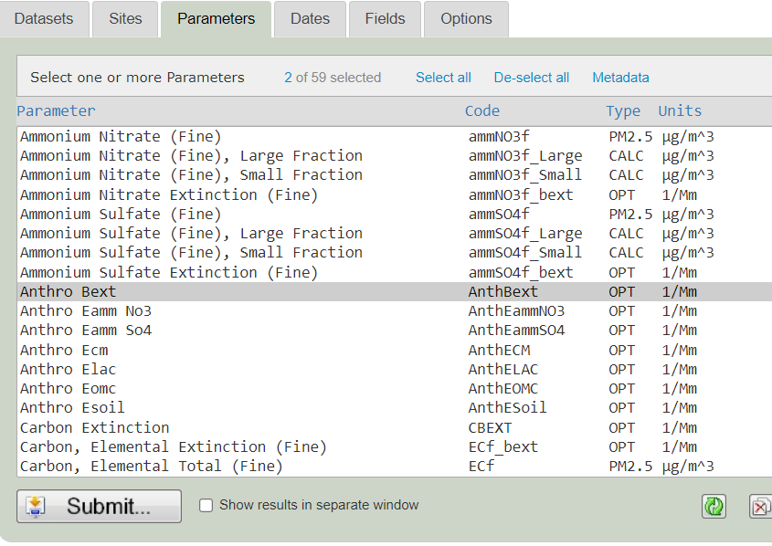

Dates – 1/1/2000 to 12/31/????

Fields – keep the pre-selected fields and AuxID

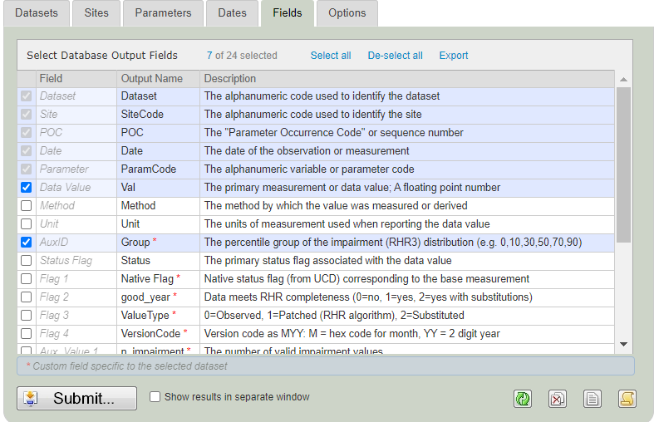

Options – Text File, Delimited (,), Standard, Data Only

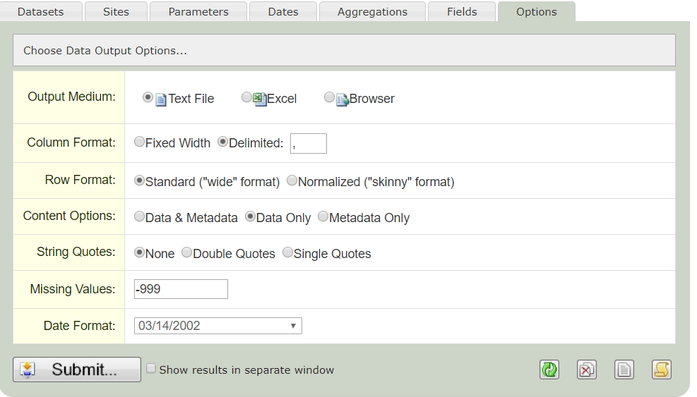

Save as RH III.txt

Close Data Fed

Open 1. MANEVU 2000-?? Parameter and Extinction Data Analysis ??-??-?? (file must be located in the same folder as the data)

Select Data/Refresh All from the ribbon



This will merge all of the .txt files and put the proper data into the data model. It will also refresh the two main pivot tables (Species and Extinction). Unfortunately, the only way to know when it is finished is by looking at the status bar.



When the queries finish running (about 2 minutes), update 20% Best, 20% Worst and 20% Most Impaired sheets using the Species and Extinction pivot tables.

Open 2. MANEVU site analysis 2000-?? Summary 2nd SIP ??-??-??



Use RANK-IMPAIRMENT in the pivot tables for Species and Extinction in 1. MANEVU 2000-?? Parameter and Extinction Data Analysis ??-??-??

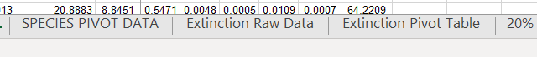

Update pink cells in Tracking using Extinction Pivot Table sheet in 1. MANEVU 2000-?? Parameter and Extinction Data Analysis ??-??-??.

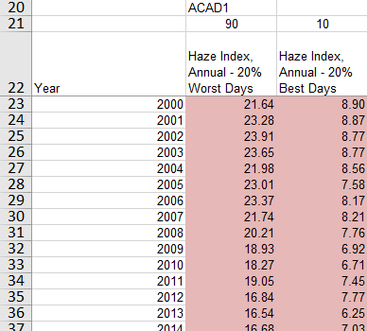

Copy 5-yr Haze Index rolling average formulas (green) down to current year.

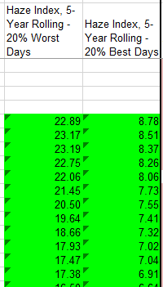

Trend charts will update automatically.

Update pink cells in Species sheet using both Pivot tables in 1. MANEVU 2000-?? Parameter and Extinction Data Analysis ??-??-??.

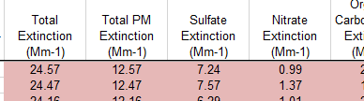
Use Extinction Pivot Table

And

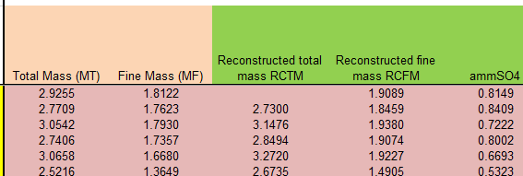
Use Species Pivot Table
Copy Haze Index – annual and Haze Index 5-Year formulas (green) down to current year.
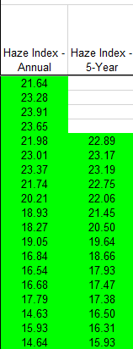
Copy yellow cells (columns AI-BV)

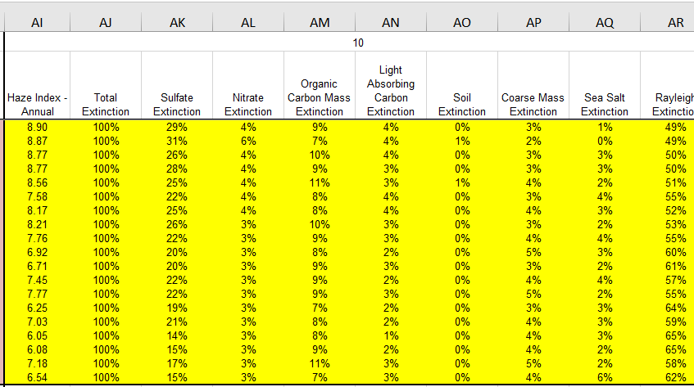

and the blue cells (columns L-FP)

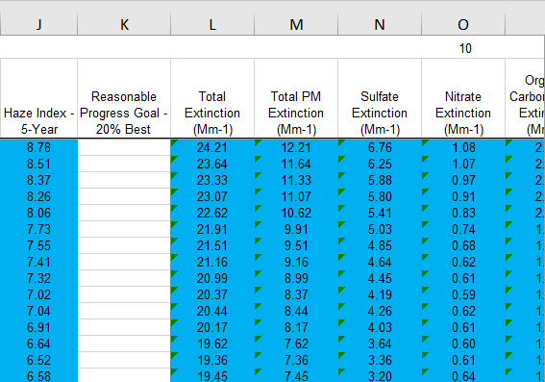

down to current year. Species charts will update automatically.

Update pink cells in 5-yr plot data sheet using the 5-yr averages (blue) cells from Species sheet.

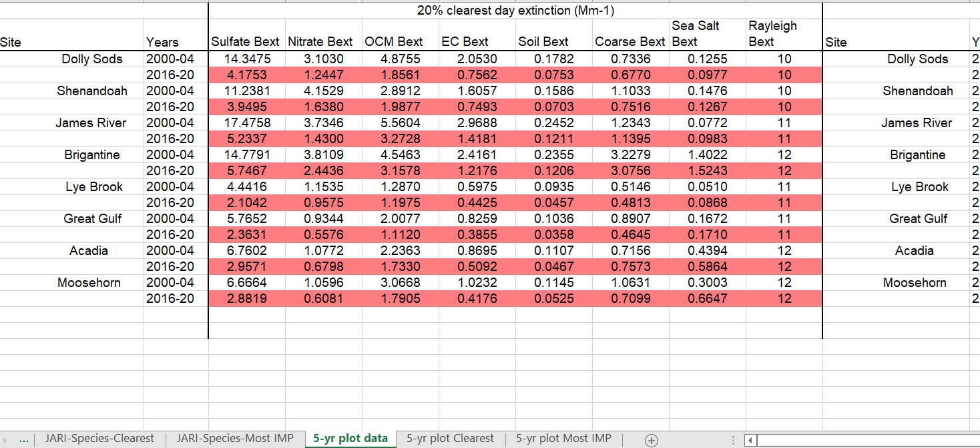

Plots update automatically.

Open 3. MANE-VU 2000-?? RH METRICS COMPARISON PLOTS ??-??-??
Update lavender cells (Summary for pivot sheet) with Extinction Pivot Table of 1. MANEVU 2000-?? Parameter and Extinction Data Analysis ??-??-??.

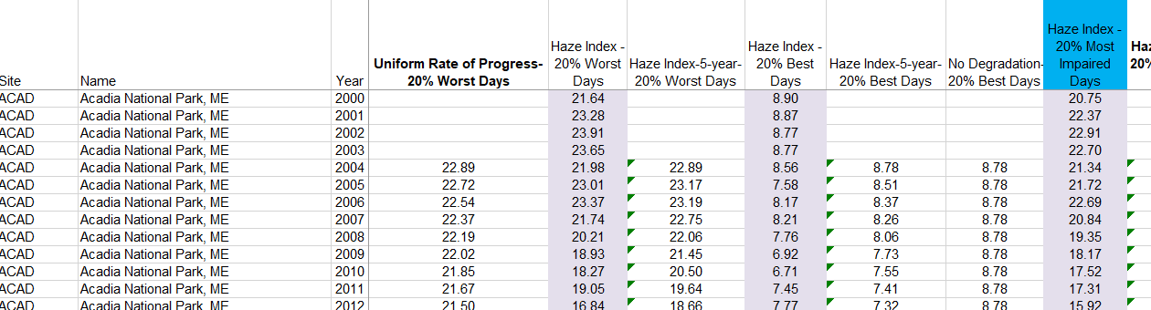

Copy cells for each Haze Index (5 year) down to the current year. Refresh
Pivot.

Open 4. MANE-VU 2000-?? RHII & III Metrics Trends Plots ??-??-??

Follow instructions for 2. MANEVU site analysis 2000-?? Summary 2nd SIP ??-??-?? to update all Tracking and Species sheets. On the Pivot data sheets, copy the formulas for the previous year (columns I – S) to the current year. Refresh all pivots.

Open 5. MANEVU sites constituents analysis 2000-?? summary 2nd SIP ??-??-??.
Using PT for const. analysis SIP 2 sheet in the 1. MANE-VU 2000-?? Parameter and Extinction Data Analysis ??-??-?? workbook

to update the orange cells (columns C-L).

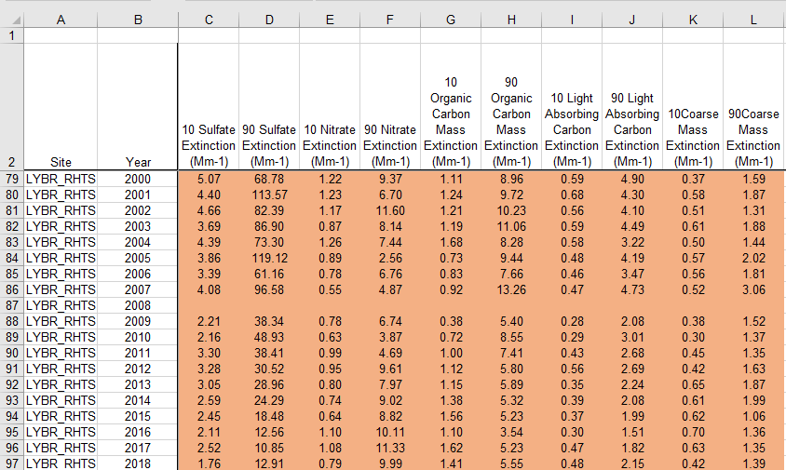

Open 6. MANEVU 2000-?? RHII & III Speciation plots ??-??-??.

- Open the current Parameter and extinction workbook go to the Extinction Raw Data sheet

- Back in the Speciation plots workbook select the RAW DATA sheet.

- Update the Pivot(Columns AB – AR) so that the data source is as in Step 1.

- Copy the formulas in rows A-Z until there are the same number of rows as in the pivot table.

- Refresh pivot table on Percent Histogram by year (columns A-I)

- Refresh pivot table on SESON (columns A-F)

