Instructions for Merging Voter File and VPH File

Important note: These instructions are based on using a Windows 7 computer and Microsoft 2010; these instructions may not work on all computers and with all spreadsheet applications. Recipients of data are responsible for determining how this is done on other computers and with other spreadsheet applications.

- Copy Voter File into Excel Spreadsheet (worksheet 1).

- Follow directions for importing/copying provided.
- Sort worksheet by Voter ID (lowest to highest).

- Copy VPH file into the same spreadsheet (worksheet 2).
- Follow directions for importing/copying provided.
- Sort worksheet by Voter ID (lowest to highest).

- Select the Voter ID’s from the Voter File worksheet, copy them, and paste them into the Voter ID column in the VPH worksheet (select a cell below the last Voter ID in the VPH worksheet for pasting).
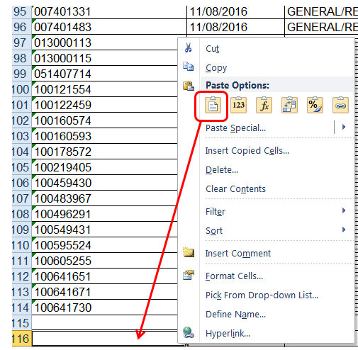

- Repeat this step for each of the name fields from the Voter File worksheet that you want (in this example, last/first/middle were copied over):

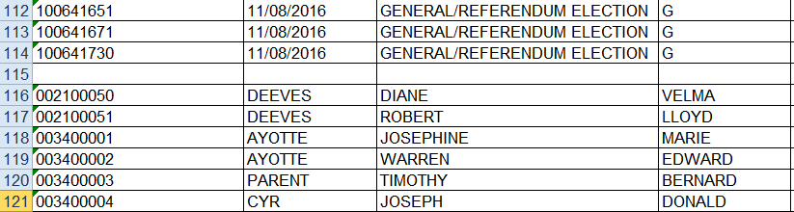

continued on reverse
- Select all of worksheet 2 by clicking in the upper left-hand corner:

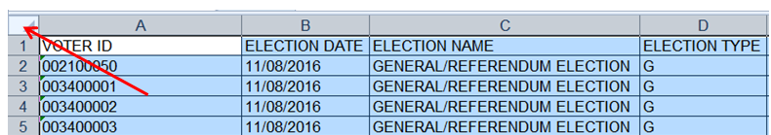

- With the entire worksheet selected, sort the worksheet by Voter ID (check the box indicating that the worksheet has a header row):

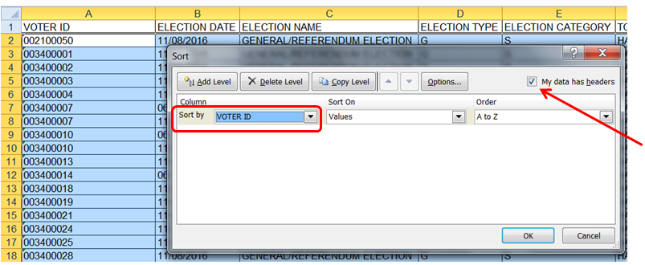

- If you get a soft warning about sorting numbers, select the first option, then click OK.

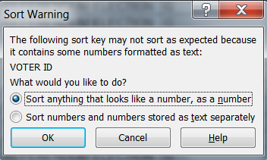

- When the sort is complete, voter names will appear in rows below the VPH records (highlighting added for this example):

