Slipping and Falling on Ice –
A Serious Workplace Hazard

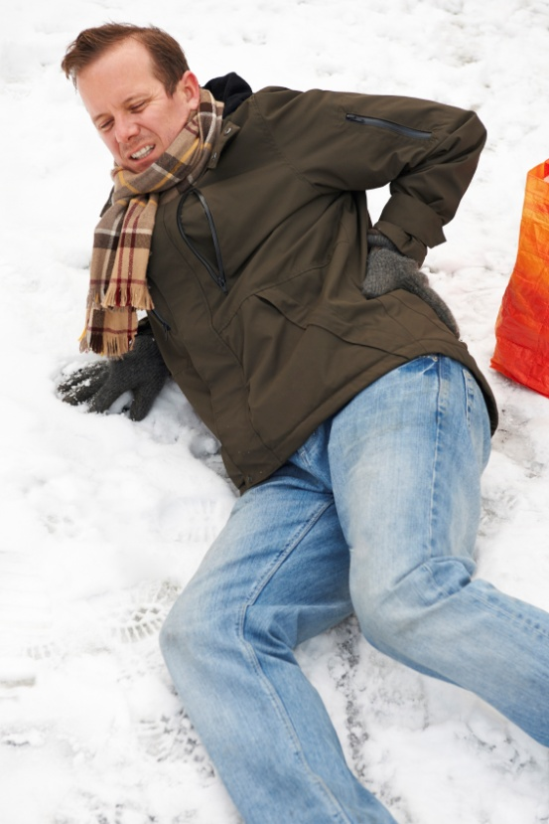
Injuries to Maine Workers, 2012 - 2013

November 2013

Introduction
Snow and ice cover Maine for most of the cold months, transforming our state into a true “winter wonderland” that is enjoyed by thousands. However, those same forms of frozen water pose serious hazards for work-related and other activities. Slipping and falling on ice may seem a common and inevitable nuisance in the winter, it may even seem comical at times; however, people sustain serious injuries from winter slips and falls. Each year, hundreds of Maine workers get hurt and lose valuable work time by slipping or falling on ice and snow. Indeed, the frequency of these incidents should raise more concern for everyone, employers and workers in particular.
Using information provided by the Maine Workers’ Compensation Board (WCB) illness and injury claims database, this report examines the nature and extent of injuries occurring dues to slipping and falling on snow and ice. It includes data about the physical effects the injured employees sustain; the financial burdens injuries place on employees, employers and insurance carriers; and factors that might affect the frequency of these accidents. This report aims to better define and examine the problem and its causes in the hope of guiding further work to foster effective measures that reduce these kinds of injuries to Maine workers.
Since 1973, the WCB has logged more than 14,000 lost-time injury cases from slips and falls on snow and ice, representing millions of lost work days. However, this report focuses on just a subset of those cases—incidents recorded by the WCB from January 2012 through June 2013. This 18-month period correlates with the most recent version of the Occupational Injuries and Illnesses Manual produced by the U.S. Department of Labor Bureau of Labor Standards (Version 2.01). Earlier cases were coded under a different set of rules and protocols, thus their aggregates do not match well with the more recent subset.

Significance of Ice/Snow-Related Injuries
From January 2012 through June 2013, more than 1,035 Maine employees submitted lost-time injury claims to the WCB due to slips and falls on ice and snow. This represents about 5 percent of all lost-time claims during that time period and about 27 percent of all reported slips, trips and falls. To put these accidents into perspective, Figure 1 illustrates both that there were six times as many injuries from snow and ice-related slips and falls as there were involving falls from ladders or falls from buildings and other structures and that there were four times as many ice/snow injuries as there were from falls off vehicles or trailers.
*January 2012 through June 2013

Moreover, injuries from slips and falls on ice and snow have meant substantial economic impacts. Since 2011, these accidents have led to more than 25,000 days of lost time each year in the Maine workforce, with medical costs topping more than $1.5 million each year and total costs to Maine workers, employers and insurance providers exceeding $2.3 million annually.

Affected Industries and Occupations
Figures 2 and 3 show the distribution of ice/snow-related injuries among worker occupations and industries. As shown in Figure 2, the highest number of ice/snow related injuries occurred to workers in the transportation and material moving occupations. This should be of little surprise, as those occupations are likely to involve work in outside conditions. Importantly, the graph shows that snow/ice-related injuries are well distributed among all occupations, which affirms that workers in all occupations are exposed to ice and snow hazards.
Figure 2: Ice/Snow-Related Slips and Falls by Occupation*

*January 2012 through June 2013

While ice/snow-related injuries may be well distributed among occupations, Figure 3 shows they are not evenly distributed among industries. More injuries seem to occur in health care and social assistance establishments than in others, and, interestingly, the fewest incidents seem to be in the agriculture, forestry and fishing; utilities and construction; and transportation and warehousing industries even though they represent a higher percentage of outdoor jobs. Some of these industries may reduce risks by simply avoiding outdoor work during winter conditions. Others, like the agriculture forestry and fishing industry, are lower because many of their establishments are not required to report injuries to the Workers’ Compensation Board.

*January 2012 through June 2013

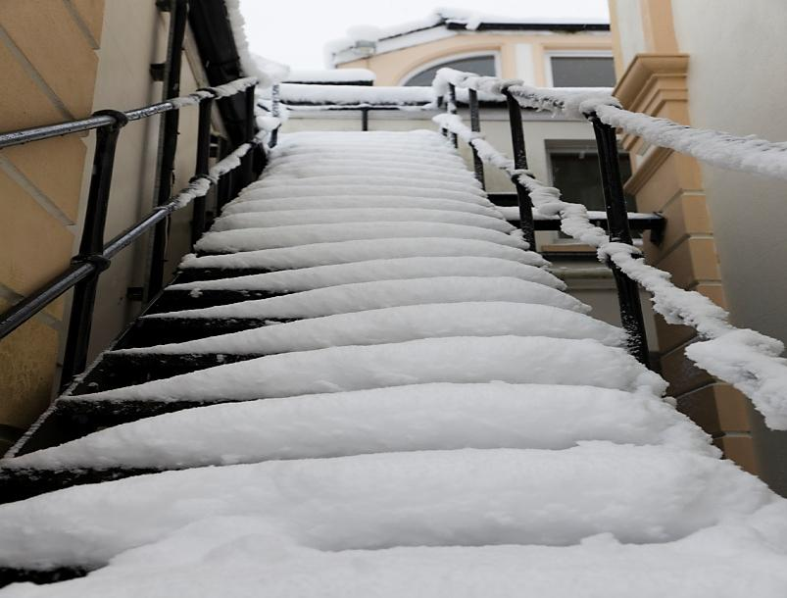
Where Ice-Related Slips and Falls Occur
As one might expect, most snow and ice-related slips and falls occur on outdoor surfaces. As shown in Figure 4, the majority happen in parking lots, roadways, driveways and walkways where individuals travel on foot between their worksites and vehicles. About 8 percent do occur indoors; in entryways, hallways and other rooms where ice and snow have been tracked in from outside.

*January 2012 through June 2013

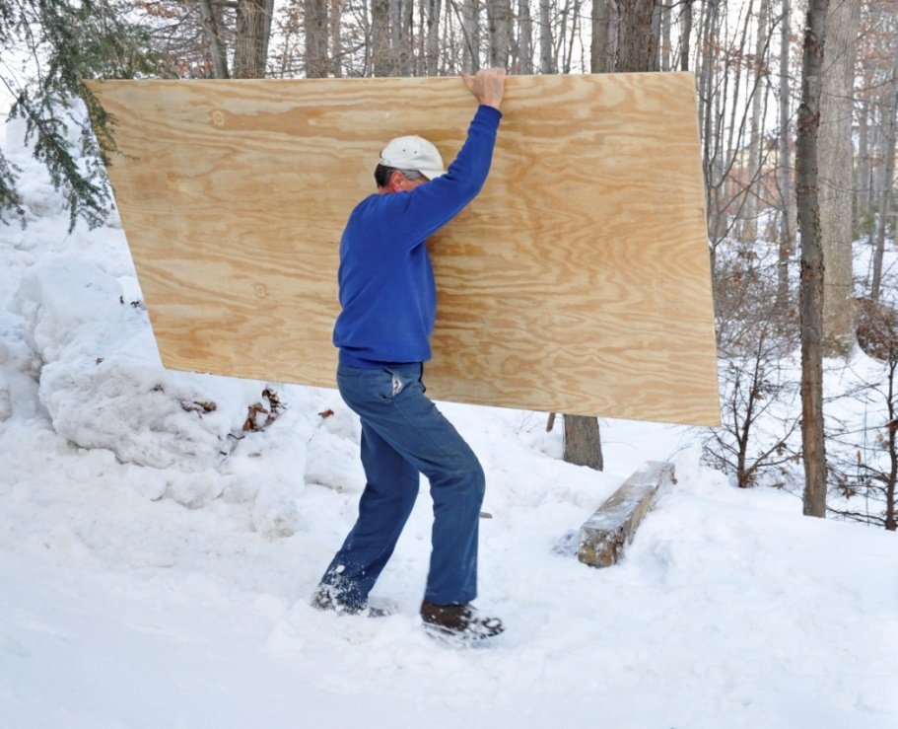
Worker Activities When Ice/Snow-Related Slips and Falls Occur

As shown in Figure 5, slips and falls on snow and ice occur as workers are on their way to and from work, performing specific work tasks, or walking about during work or other non-specified activities. While the injuries are fairly evenly distributed amongst these three types of activities, the highest number occurred as workers were going to or from their vehicles and worksites.

*January 2012 through June 2013

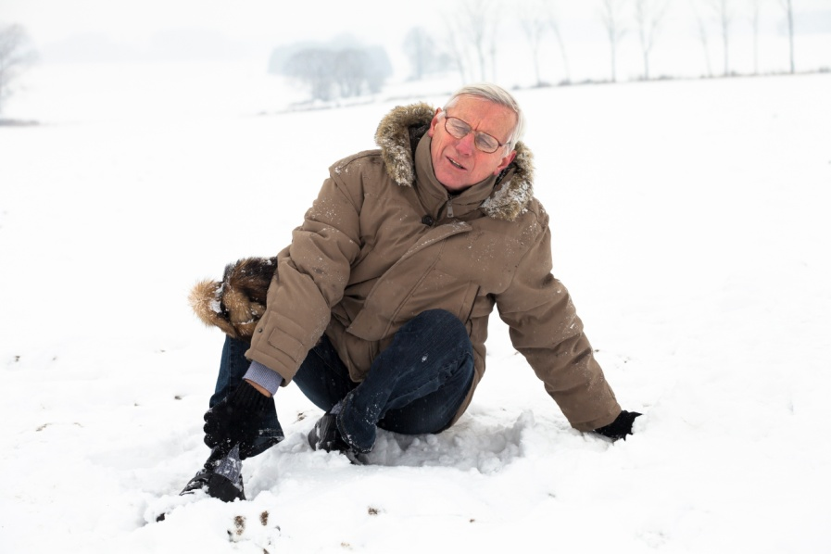
Nature and Types of Injuries
Practically all injuries from slips and falls on snow and ice fall under the classification of “traumatic injuries.” As shown by Figure 6, these injuries range from minor bruises, cuts and abrasions to serious bone fractures, spinal cord damage and concussions. Strains, sprains and tears comprise the largest category.

*January 2012 through June 2013

Figure 7 shows that snow and ice-related slips and falls cause injuries to a variety of body parts. The lower extremities are most often injured by these accidents, followed by the category called, “multiple body parts,” which refers to incidents with more than one traumatic injury to two or more unrelated parts of the body.

Factors Affecting the Incidence of Ice/Snow Related Injuries
Obviously, ambient temperature is the most determining factor in the incidence of ice/snow-related slips and falls. Without freezing temperatures, snow and ice cannot form. Therefore, these accidents only occur in winter months, roughly from the beginning of November through the end of April.
Worker slips and falls on ice and snow can occur anytime throughout the winter; however, they are not evenly distributed from day to day. As shown by Figure 8, injury events ranged from 0 to 44 incidents per day.

Figure 8: Incidence of Ice/Snow-Related from Slips and Falls During Winter *

*January 2012 through June 2013

To some extent, climatic occurrences affect the incidence of worker slips and falls on snow and ice. As shown by Figure 9, incidences are associated with weather conditions such as snowfall and temperature shifts. Over the study period, higher-injury days occurred when there were snowfall events, when temperatures remained below freezing following snowfall events or when snowfall accumulations were subject to daily thawing and re-freezing. Conversely, days when temperatures rose and remained above freezing had significantly fewer injuries, even if there were accumulations of snow and ice. However, there is not a strong correlation between incidence and just the four identified climatic occurrences (r=0.20), which suggests that other variables also affect daily incidence rates.
Number of injuries / Climatic Condition

Time of day is also a factor in the incidence of snow and ice related injuries. As shown in the Figure 10, snow/ice related slips and fall injuries occur in a pattern throughout the day. Most injuries happened between 6 a.m. and 6 p.m., the typical working and commuting hours, with the highest number of injuries occurring between 6 and 9 a.m. About 17 percent occur during lunchtime (11:30 a.m. to 1:30 p.m.).
One might anticipate a different distribution of incidents for businesses or establishments that operate both day and night with injuries spreading out across a 24-hour period because a larger number of employees would work throughout the night, arriving at and leaving work during non-typical commuting hours. However, as Figure 10 also shows, there was only slight variation in the daily distribution of injuries between one such “24/7” establishment (the health care industry) and all others.

Number of Injuries
*January 2012 through June 2013

Discussion
If there were a tool, machine, process or worksite condition that caused 25,000 days of lost-time injuries each year in Maine with more than $1.5 million in annual medical costs, no doubt it would be in the headlines. One could imagine that by now regulators would have looked for engineering controls or would have required administrative controls and personal protection requirements to minimize those injuries. Indeed, economics alone would compel many establishments and employers to take such measures. Yet such steps have not been implemented to combat slips and falls on snow and ice in spite of the large number of injuries and economic costs.
There seems to be no systemic approach (regulatory, voluntary or otherwise) to limit these accidents beyond the OSHA General Duty Clause and indirect workplace controls. This may be, in part, because winter weather hazards are ubiquitous and uncontrolled; they do not lend themselves nicely to straight-forward regulations or corrective actions and, by their nature, may be viewed as inevitable. Moreover, since slips and falls on snow and ice happen as much in the outside world as they do at work and they happen the same way to individuals in either setting, they may be less perceived as work-related problems and therefore not fully considered a singular responsibility of employers.
That is not to imply that employers, regulators or workers are unconcerned or uninvolved with the hazards of ice and snow. Most establishments carry out diligent roadway, walkway and parking lot clearing and maintenance and many have implemented special prevention strategies. There also seems to be no shortage of publications by companies, insurance carriers, attorneys, agencies and other organizations that offer tips, ideas and sometimes even friction coefficient-reducing materials to help workers avoid these accidents. However, most are in the form of suggestions for others to follow rather than coordinated approaches involving employers, workers and others in their respective roles. Few, if any, actually measure or report the success of any techniques or programs in reducing the accidents or injuries.
Perhaps the first step should be a coordinated exchange or symposium to gather and share ideas, experiences, and measured results among employers, workers, agencies and others. This could serve to inform, enlighten and generally help everyone find better and, perhaps, more systematic means to reduce these kinds of injuries and costs. It could also lead to development of a “Best Practices” manual to help employers and employees target injury-prevention activities. In the future the Department of Labor and other organizations may benefit by organizing and/or facilitating such an exchange.

Research for this report was prepared by Mark B. Dawson
Research and Statistics Unit, Division of Technical Services
Bureau of Labor Standards
Maine State Department of Labor

For more information regarding this report, contact
Mark B. Dawson, 207-623-7904
TTY users call Maine Relay 711

The Maine Department of Labor provides equal opportunity in employment and programs.
Auxiliary aids and services are available to individuals with disabilities upon request

