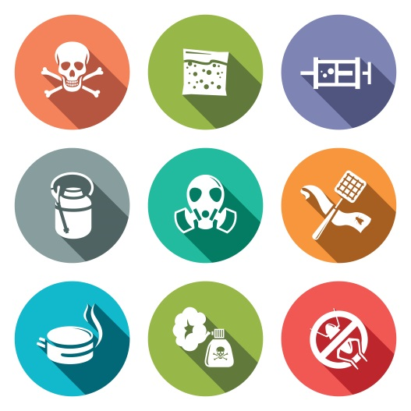

Report on

INJURIES AND ILLNESSES DUE TO WORKPLACE CHEMICALS AND RELATED HAZARDS

February 2015

Submitted by
Maine Department of Labor
Bureau of Labor Standards

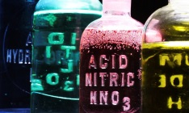

Figure 1. Hazardous Chemical Reagents

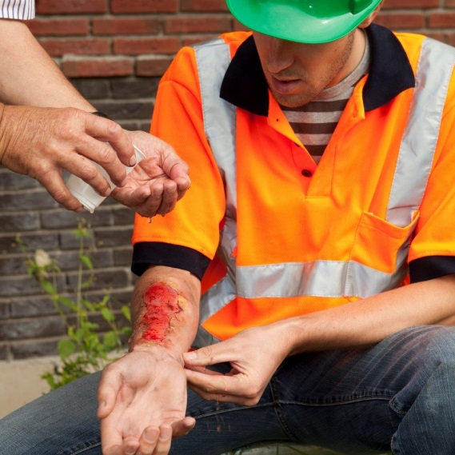
Figure 2. Treating a serious chemical burn

INTRODUCTION
This report was produced by the Maine Department of Labor, Bureau of Labor Standards (BLS). It presents data from Maine’s 2012–2013 Workers’ Compensation injury and illness claims¹ resulting from direct or indirect exposure to injurious chemicals or workplace environmental hazards, such as poor indoor air quality resulting from microbiological (mold and fungus) growth.² These exposures present occupational health and safety hazards to workers that can result in acute injuries as well as acute or chronic respiratory, allergenic, and other types of illnesses.
In order to assess the status of such injuries and illnesses affecting Maine workers, the Research and Statistics Unit (R&S) of BLS conducted this study in collaboration with the Workplace Safety and Health Division of BLS. The objective of the study was to identify the nature and extent these exposures so that BLS staff and other health and safety professionals can determine how best to approach them in order to improve workplace conditions for Maine workers.

METHODOLOGY
R&S extracted data from the Workers’ Compensation claims database for injuries and illnesses that occurred during 2012 and 2013. These are limited to 406 incidents, which comprise the more serious (lost-time) injuries or illnesses that resulted from worker exposure to hazardous chemicals or adverse environmental/microbiological conditions. Non-lost time injuries are not included in the study as their data are for some cases less complete because of limited need for injury detail and administrative follow-up on those kinds of injuries and outcomes.
R&S tabulated and analyzed the coded elements (as discussed below) and also reviewed any descriptive narratives in each claim to clarify the coded data. R&S also analyzed data values and trends specific to public and private employers’ workplaces, worker occupations, and employer industries.
Finally, R&S tabulated and analyzed cost data related to the 2012–2013 claims for both private- and public- sector industries. Reporting of the cost analysis is limited to aggregates of 10 or more incidents in order to protect the privacy of affected workers and employers.
Note: Not all cases involving smoke inhalation are included in this report. Injuries and illnesses from poor indoor air quality caused by incidental smoke from external sources, such as cigarettes or compromised ventilation systems are included, but smoke-related injuries or illnesses from firefighting or responding to incipient fires are not. Smoke in fire-response setting is not typically regarded as a “workplace chemical” source, and, since those cases are more appropriately grouped and studied with other firefighting-related injuries and illnesses, they are not included in this report. There were 18 such fire-response incidents in 2012 and 2013.

CODING OF CLAIMS
When Workers’ Compensation reports are filed, much of their information is further “coded” into a database so that state agencies can better retrieve, analyze, and manage the information. This study is made possible by the retrieval of the coded data as they relate to injuries and illnesses from exposures as explained above. The descriptions of data elements below explain how workers’ compensation injury and illness claims are categorized and coded.
- “Nature” data identify the actual nature of the injury or illness (e.g., chemical burn, respiratory system symptoms, infection)

- “Source” data identify the cause of the injury or illness (e.g., a caustic cleaner or carbon monoxide emissions in the case of exposure to vehicle fumes)

- A “Secondary Source” may also be provided to identify an additional cause, such as the accident or event that directly led to release of the chemical causing the worker’s injury or illness.

- “Event” data identify the circumstances bringing about the injury or illness incident (e.g., a motor vehicle accident, inhalation of a harmful substance, contact exposure to a harmful chemical)

- “Part(s) of the Body” data identify what body part(s) are injured or affected by illness (e.g., upper and lower limbs, the eyes, body systems)

- “Occupation” data identify the occupation/profession of the affected worker. Occupations are coded using the federal Standard Occupation Coding (SOC) classification system.³

- “Industry” data identify the assigned federal classification of the employer industry. The federal classification system used is the North American Industry Classification System (NAICS). ⁴
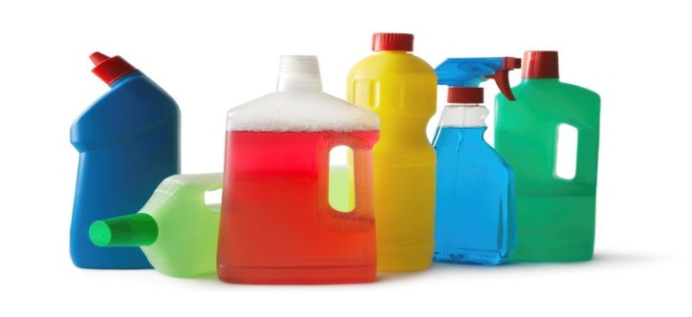

Figure 3. Even common cleaning agents can be chemical workplace hazards.

ANALYSES OF DATA ELEMENTS
Tables I through V present information related to the data elements, worker occupations and employer industries for the 406 lost time injury/illness claims during 2012 and 2013.
Nature of Injuries or Illnesses
Table 1 presents 2012– 2013 data for claims by the nature of the injury or illness.
TABLE 1
NATURE OF WORKERS’ COMPENSATION CLAIMS FROM EXPOSURE TO HAZARDOUS CHEMICALS OR ADVERSE ENVIRONMENTAL/MICROBIOLOGICAL CONDITIONS
(2012–2013)
NATURE OF INJURY OR ILLNESS | INCIDENTS | PERCENT | PRIVATE SECTOR | PUBLIC SECTOR
Respiratory symptoms: coughing, irritation, inflammation, difficulty breathing, asthma | 136 | 33.5% | 90 | 46
Thermal, chemical and inhalation vapor burns | 54 | 13.3% | 47 | 7
Swelling, inflammation, infections | 43 | 10.6% | 39 | 4
Dermatitis, allergic skin reactions | 37 | 9.1% | 33 | 4
Unspecified injuries and disorders | 35 | 8.6% | 26 | 9
Unspecified allergic reactions | 35 | 8.6% | 28 | 7
General, physical symptoms | 23 | 5.7% | 17 | 6
Dizziness, weakness or nausea | 20 | 4.9% | 14 | 6
Headache, migraine, visual loss | 9 | 2.2% | 6 | 3
Shock, loss of consciousness, convulsions | 7 | 1.7% | 4 | 3
Other traumatic injuries | 7 | 1.7% | 7 | 0
TOTALS FOR ALL CLAIMS | 406 |  | 311 | 95

Of the 406 reported chemical and related claims, one third involved respiratory problems. Thermal, chemical, and inhalation vapor burns accounted for over 13 percent of the claims; and infections, swelling and inflammations accounted for just over 10 percent.

Sources of Injuries or Illnesses
Table 2 provides 2012– 2013 chemical and related claims data by the source of the injury or illness. Data in this table are presented for all sources with specific data for sources having 10 or more incidents.
TABLE 2
SOURCES OF WORKERS' COMPENSATION CLAIMS FROM EXPOSURE TO HAZARDOUS
CHEMICALS OR ADVERSE ENVIRONMENTAL/MICROBIOLOGICAL CONDITIONS
(2012–2013)
SOURCES | INCIDENTS | PERCENT | PRIVATE SECTOR | PUBLIC SECTOR
Cleaning and polishing agents | 61 | 15.0% | 47 | 14
Ambient conditions, unknown chemicals/microbes in the air | 66 | 16.3% | 38 | 28
Unspecified or unclassified chemicals | 58 | 14.3% | 44 | 14
Mold, fungi | 35 | 8.6% | 24 | 11
Propane, natural gas, gasoline, diesel fuel, petroleum fuels | 21 | 5.2% | 19 | 2
Drugs, alcohol, medications, vaccines | 19 | 4.7% | 17 | 2
Paint, lacquer, varnish, thinners | 18 | 4.4% | 14 | 4
Cosmetics, beauty preparation | 18 | 4.4% | 12 | 6
Other specific chemicals with less than three incidents | 13 | 3.2% | 10 | 3
Disinfectants | 9 | 2.2% | 8 | 1
Soaps detergents, shampoos | 9 | 2.2% | 8 | 1
Bleach | 9 | 2.2% | 8 | 1
Acids | 9 | 2.2% | 8 | 1
Smoke (non-firefighting) | 9 | 2.2% | 7 | 2
Freon | 8 | 2.0% | 8 | 0
Alkalis, wet cement, lime | 7 | 1.7% | 7 | 0
Pesticides, herbicides | 7 | 1.7% | 6 | 1
Glues, adhesives | 6 | 1.5% | 5 | 1
Sulfur compounds | 5 | 1.2% | 4 | 1
Aldehydes | 4 | 1.0% | 4 | 0
Antifreeze | 4 | 1.0% | 4 | 0
Carbon monoxide | 4 | 1.0% | 3 | 1
Metallic particles and lead | 4 | 1.0% | 4 | 0
Solvents, degreasers | 3 | 0.7% | 2 | 1
TOTALS | 406 |  | 311 | 95
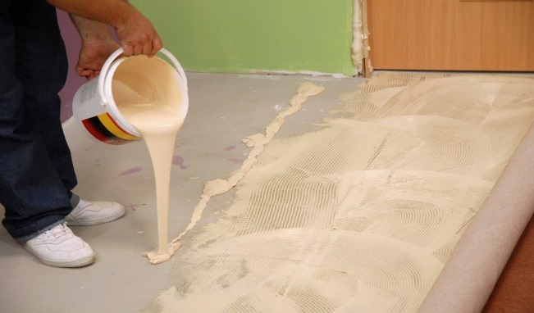
Figure 4. Carpet adhesives can release noxious vapors creating adverse environmental conditions (poor indoor air quality).

Ambient environmental conditions including the presence of chemicals and microbes in the air were the largest identified cause, accounting for just over 16 percent of the injuries and illnesses. This source category was followed closely by cleaning and polishing agents at 15 percent. The third largest source category is the set of chemicals and agents that could not be coded specifically due to insufficient information. Mold exposure was the fourth highest specified source with 8.6 percent of the claims.


Figure 5. Mold along a stairway wall.

Affected Part(s) of the Body
Table 3 provides 2012– 2013 chemical and related claims data by affected part(s) of the body.
TABLE 3
AFFECTED PART(S) OF THE BODY FOR WORKERS' COMPENSATION CLAIMS FROM EXPOSURE TO HAZARDOUS CHEMICALS OR ADVERSE ENVIRONMENTAL/MICROBIOLOGICAL CONDITIONS
(2012–2013)

PART(S) OF THE BODY | INCIDENTS | PERCENT | PRIVATE SECTOR | PUBLIC SECTOR
Body systems ( e.g., respiratory, circulatory, and nervous) | 120 | 29.6% | 89 | 31
Chest and trunk | 111 | 27.3% | 76 | 35
Facial locations and sinuses | 66 | 16.3% | 56 | 10
Multiple body parts (injuries to specified multiple body parts) | 39 | 9.6% | 32 | 7
Arms, hands and fingers | 36 | 8.9% | 33 | 3
Head and ears | 12 | 3.0% | 9 | 3
Legs and feet | 9 | 2.2% | 7 | 2
Neck and throat | 7 | 1.7% | 6 | 1
Abdomen and organs | 3 | 0.7% | 2 | 1
Pelvic region | 2 | 0.5% | 1 | 1
Not classified | 1 | 0.2% | 0 | 1
Totals for all affected body part(s) | 406 |  | 311 | 95

Body Systems constituted the highest number of body part(s) affected by chemical and related injuries or illnesses, accounting for almost 30 percent of the claims. Injuries and illnesses involving the Chest and trunk (includes both internal and external locations) were second highest, accounting for over 27 percent.


Figure 6. Airborne chemicals in the workplace can trigger asthma attacks and respiratory problems affecting body systems.

Worker Occupations
Table 4 provides incident totals for chemical and related injuries and illnesses for all employee occupations and specific data for occupations based on the Standard Occupation Classification Manual.
TABLE 4
OCCUPATIONS INVOLVED WITH WORKERS' COMPENSATION CLAIMS FROM EXPOSURE TO HAZARDOUS CHEMICALS OR ADVERSE ENVIRONMENTAL/MICROBIOLOGICAL CONDITIONS
(2012–2013)
OCCUPATION (SOC CODE) | INCIDENTS | PERCENT | PRIVATE SECTOR | PUBLIC SECTOR
Office and administrative support workers (43-0000) | 50 | 12.3% | 31 | 19
Production workers (51-0000) | 39 | 9.6% | 38 | 1
Healthcare practitioners and technicians (29-0000) | 36 | 8.9% | 33 | 3
Building/ grounds maintenance and cleaning workers (37-0000) | 30 | 7.4% | 18 | 12
Equipment installation, maintenance /repair workers (49-0000) | 29 | 7.1% | 24 | 5
Healthcare support workers (31-0000) | 28 | 6.9% | 27 | 1
Transportation and material moving workers (53-0000) | 28 | 6.9% | 26 | 2
Education, training and library workers (25-0000) | 25 | 6.2% | 6 | 19
Food preparation and serving workers (35-0000) | 23 | 5.7% | 21 | 2
Sales and retail workers (41-0000) | 18 | 4.4% | 18 | 0
Management (11-0000) | 17 | 4.2% | 14 | 3
Community and social services workers (21-0000) | 17 | 4.2% | 7 | 10
Personal care and service workers (39-0000) | 14 | 3.4% | 13 | 1
Construction workers (47-0000) | 13 | 3.2% | 10 | 3
Life, physical and social scientists (19-0000) | 8 | 2.0% | 5 | 3
Arts, sports, entertainment, media, and design workers (27-00000 | 6 | 1.5% | 6 | 0
Business, financial, computer, and math workers (13-0000) | 5 | 1.2% | 3 | 2
Architecture, engineering, survey, and mapping workers (17-0000) | 5 | 1.2% | 5 | 0
Protective service workers – firefighting (33-2000) | 5 | 1.2% | 0 | 5
Protective service workers – law enforcement (33-3000) | 3 | 0.7% | 0 | 3
Fishing, farming, and forestry workers | 3 | 0.7% | 3 | 0
Protective service workers – other (33-1000 and 33-9000) | 1 | 0.2% | 1 | 0
Unclassified (99-9999) | 3 | 0.7% | 2 | 1
TOTAL: | 406 |  | 311 | 95

Incidents of injuries and illnesses were distributed broadly over many occupational classifications. The occupational category with the highest frequency of claims was Office and administrative support workers at 12.3 percent followed by production workers at 9.6 percent. However, if taken as a whole, the healthcare occupations (healthcare practitioners and technicians, and healthcare support workers) would account for the largest number of claims at 15.8 percent.

Employer Industries

Table 5 provides claim incident numbers for chemical and related claims by employer industries based on the North American Industrial Classification System.
TABLE 5
TOP EMPLOYER INDUSTRIES INVOLVED WITH WORKERS' COMPENSATION CLAIMS FROM EXPOSURE TO HAZARDOUS CHEMICALS OR ADVERSE ENVIRONMENTAL/MICROBIOLOGICAL CONDITIONS
(2012–2013)
INDUSTRY (NAICS CODE) | NUMBER OF INCIDENTS | PERCENT | PRIVATE SECTOR | PUBLIC SECTOR
Hospitals (622000) | 55 | 13.5% | 53 | 2
Public Administration (920000) | 51 | 12.6% | 1 | 50
Education (610000) | 42 | 10.3% | 11 | 31
Manufacturing (310000 – 330000) | 39 | 9.6% | 39 | 0
Ambulatory Services (621000) | 29 | 7.1% | 29 | 0
Administrative support waste management and remediation (560000) | 26 | 6.4% | 26 | 0
Retail trade (non-food/ beverage) (440000 – 450000 excluding 445000) | 25 | 6.2% | 25 | 0
Accommodation and food services (720000) | 23 | 5.7% | 23 | 0
Retail food and beverage (445000) | 20 | 4.9% | 20 | 0
Nursing and residential health care (623000) | 20 | 4.9% | 16 | 4
Construction (230000) | 13 | 3.2% | 8 | 5
Professional, scientific, and real estate (540000) | 12 | 3.0% | 12 | 0
Repair, maintenance, and other service (810000) | 11 | 2.7% | 11 | 0
Wholesale trade (420000) | 9 | 2.2% | 9 | 0
Transportation and warehousing (480000 – 490000) | 8 | 2.0% | 6 | 2
Social assistance (624000) | 8 | 2.0% | 8 | 0
Information, finance, and insurance (510000 and 520000) | 5 | 1.2% | 5 | 0
Management (550000) | 4 | 1.0% | 4 | 0
Agriculture, forestry, and fishing (110000) | 2 | 0.5% | 1 | 1
Arts, entertainment, and recreation (710000) | 2 | 0.5% | 2 | 0
Unclassified (999999) | 2 | 0.5% | 2 | 0
Grand Total: | 406 |  | 311 | 95

The hospital industry was the largest category with 13.5 percent of the total claim incidents. This was followed by Public Administration with 12.6 percent and Education with 10.3 percent.
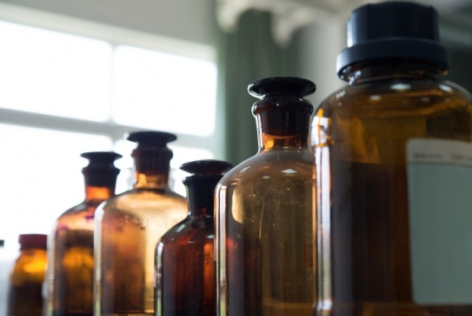
Figure7. Reagent bottles in a medical lab

COSTS
Of the claims filed with the Workers’ Compensation Board for illnesses and injuries caused by workplace exposure to hazardous chemicals or adverse environmental/microbiological conditions in 2012 and 2013, 46 resulted in workers’ compensation awards totaling $665,564.22 and averaging $14,469 per awarded incident. Awarded costs include wage replacement benefits for days that employees are unable to work, lump-sum settlement payments, medical, rehabilitation, legal, and other related expenses.
In order to protect the privacy of affected workers, the Workers’ Compensation Board has asked R&S to limit the reporting of Workers’ Comp Injury data to aggregates of 10 or more incidents when analyzing costs and compensation awards.

Public Employer Worker Claims in 2012–2013
In 2012 and 2013, sixteen claims for such illnesses and injuries were awarded to public sector employees. These resulted in workers’ compensation payments totaling $45,769.65.
Private Employer Worker Claims in 2012–2013
In 2012 and 2013, thirty claims for such injuries and illnesses were awarded to private sector employees. These resulted in workers’ compensation payments totaling $619,794.57. Table 6 provides a further breakdown of payments for these claims.
TABLE 6
COST DATA * FOR WORKERS' COMPENSATION CLAIMSFROM EXPOSURE TO HAZARDOUS CHEMICALS OR ADVERSE ENVIRONMENTAL/MICROBIOLOGICAL CONDITIONS
(2012–2013)
EMPLOYER SECTOR | NUMBER OF PAID CLAIMS | MEDICAL/ REHABILITATION COSTS | WAGE REPLACEMENT BENEFIT COSTS | TOTAL LEGAL AND OTHER COSTS | TOTAL CLAIM COSTS | AVERAGE
Public Employers | 14 | $ 14,949.17 | $ 22,703.99 | $ 2,658.88 | $ 40,312.04 | $2,879
Private Employers | 30 | $ 409,605.59 | $ 169,668.56 | $ 40,520.42 | $ 619,794.57 | $20.660
ALL EMPLOYERS | 46 | $ 424,554.76 | $ 192,372.55 | $ 43,179.30 | $ 660,106.61 | $14,350
‘
*Cost data as of April 2014 (364 total claims).

KEY POINTS
- With regard to nature of illnesses or injuries, the largest category by far was respiratory problems/ ailments at 33.5 percent. The other categories were evenly distributed and none comprised more than 14 percent of the cases.

- The largest overall source group was the combination of unexplained ambient conditions and unspecified or unclassified chemicals at 16.3 percent. This was followed by cleaning and polishing agents at 15 percent, and mold and fungi at 14.3 percent.

- The body part most affected by chemical and microbiological sources was the category called body systems which accounted for the respiratory, digestive and other maladies caused the chemicals and microbes. Chest/trunk was the next most-affected category of body parts.

- Office and administrative workers accounted for the largest number of claims by individual occupation category with 12.3 percent of the total. However, the two occupational categories that comprise healthcare workers (health practitioners/ technicians and healthcare support workers), if combined, would be the largest group at 15.8 percent.

- Injury and illness claims were distributed evenly amongst a sizeable number of industry types. Hospitals accounted for the largest number of claims at 13.5 percent followed public administration, education and manufacturing.

- Of the Workers’ Compensation claims for chemical and related injuries and illnesses in 2012–2013, roughly 12 percent resulted in the payment of employee wage replacement benefits and other claim-related costs.

- Chemical/related claims over the two years incurred $665,564.22 in combined medical, wage replacement and related costs.

REFERENCES

- Maine Workers’ Compensation Board. Selected 2012–2013 employee lost time claims data. Data were selected based on severity and source. These include: Severity Codes 1 and 2 for fatalities (none) and lost-time injuries, Source Code 1series for chemicals, Source Code 532 series for mold and fungi, Source Code 924 series for smoke (further filtered for non-fire and non-firefighting incidents), and Source Code 9296 for poor indoor air quality.

- “Preventing Mold – Related Problems in the Indoor Workplace” OSHA 3304 – 04N 2006.

- Standard Occupational Classification Manual 2010, US Department of Commerce,
ISBN 978-1-935329-04-8.

- North American Industrial Classification System United States, 2012, Executive Office of the President, Office of Management and Budget, ISBN 978-1-59888-549-1.
This report was prepared by Mark B. Dawson with initial
data and cost analyses by Barbara A. Spillane.
Research and Statistics Unit, Division of Technical Services
Bureau of Labor Standards
Maine State Department of Labor
For more information regarding this report, contact
Mark Dawson, 207-623-7904.

The Maine Department of Labor provides equal opportunity employment and programs.
Auxiliary aids and services are available to individuals with disabilities upon request.

Telephone (207) 623-7900 TTY Users Call Maine Relay 711 FAX (207) 623-7937

This publication is available at: www.maine.gov/labor/labor_stats/publications/substanceabuse

