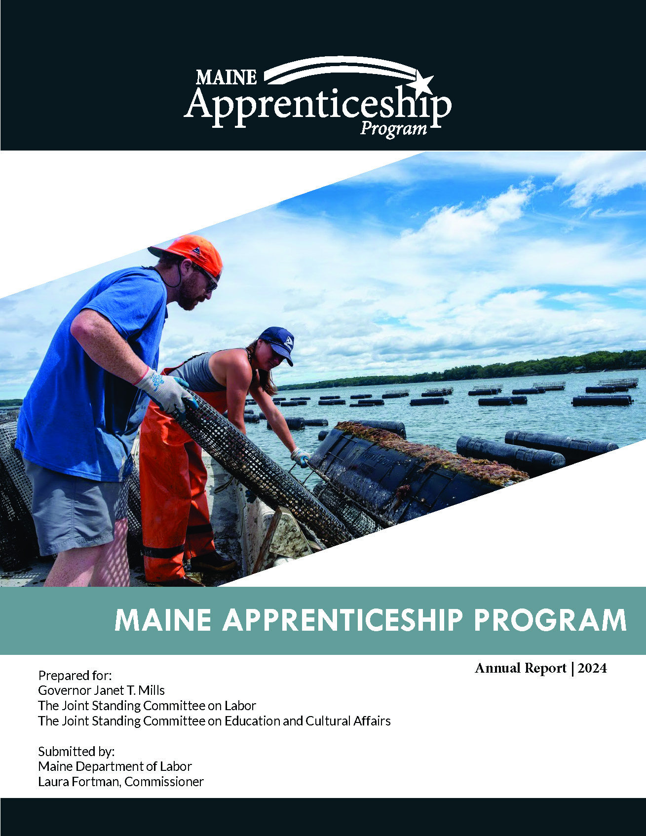

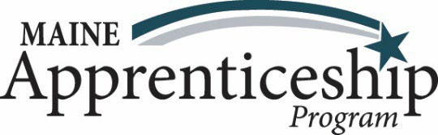
Registered Apprenticeships play a crucial role in Maine’s economy by offering pathways to high-quality careers, allowing apprentices to earn wages while gaining valuable experience. Employers can shape their future workforce by creating programs where workers perform essential tasks while acquiring the skills needed for more advanced roles. These registered apprenticeships have been part of the Maine Apprenticeship Program (MAP) since 1941.
The MAP operates under Maine Statute Title 26 Chapter 37 § 3202 and Title 29 Parts 29 and 30 of the U.S. Code of Federal Regulations. Registered apprenticeships require a minimum of 2,000 hours of on-the-job training and at least 144 hours of formal coursework per year. The MAP continues to evolve, responding to the demand for skilled labor from employers and providing workers with the opportunity for competitive wages and a clear path to career growth.

Maine Apprenticeship Program: Goals and Guiding Principles
A well-connected Registered Apprenticeship system offers various entry and exit points, creating a clear pathway for individuals to explore careers. It also facilitates connections to certified pre-apprenticeship and registered apprenticeship programs, ensuring a seamless transition through different stages of career development
Overarching Goals for the Maine Apprenticeship Program
- Increase the availability of high-quality certified pre-apprenticeships and Registered Apprenticeship programs in priority communities.
- Boost the participation of underrepresented workers in Registered Apprenticeship programs.
- Develop a robust, statewide Registered Apprenticeship system that is integrated, sustainable, and effective.
Guiding Principles for the Continued Development and Expansion of Maine’s Registered Apprenticeship System
Maine’s vision for a statewide system is based on the Registered Apprenticeship model and is guided by the following principles:
- Aligned, accessible, and easy to navigate system including transparent entry and success requirements with common quality standards, continuum of learning with multiple on- and off-ramps, presence of strong intermediary organizations, and embedded into Adult Education, K-12, Career and Technical Education (CTE), and the Maine Community College System
- Clear connection to quality job and credentials including culmination in industry- recognized credential, skills development through mentored, work-based learning, and connection to a Registered Apprenticeship program
- Supported participation of under-represented populations through mentorship, and supportive services including academic, career exploration, and wraparound supports
- Inclusive, safe, supportive, and fair workplaces including training for sponsors on creating inclusive workplaces and fair compensation and robust labor protections
- Sustainable system, accountable to outcomes including equity standards for Registered Apprenticeship programs, accountability to equity outcomes, clear systems and defined metrics to measure progress, and policies, practices, and structures to sustain the apprenticeship system
Certified Pre-Apprenticeship
Certified pre-apprenticeship programs in Maine are established under Title 26 §3213. Through MJRP grantees, these programs are available across various sectors, including healthcare, construction, automotive technology, manufacturing, aquaculture, and hospitality.
Pre-apprenticeship initiatives have played a crucial role in advancing apprenticeship programs, fostering a more integrated and sustainable workforce development strategy. Workforce Innovation and Opportunity Act (WIOA) service providers assess pre-apprentices for co-enrollment eligibility to ensure they receive necessary support services.
To obtain certification in Maine, pre-apprenticeship programs must include the following:
- A formal agreement with a registered apprenticeship sponsor that allows graduates of pre-apprenticeship programs to transition directly into registered apprenticeship programs, including articulation agreements to recognize prior skills and competencies.
- A documented outreach strategy aimed at increasing apprenticeship opportunities for individuals from underrepresented, disadvantaged, or low-skilled backgrounds, as well as those from historically marginalized communities.
- The incorporation of standards set by the U.S. Department of Labor for a high-quality pre-apprenticeship framework.
- Full adherence to state and federal equal employment opportunity laws in apprenticeship and training practices.
- A training program and curriculum, aligned with industry standards and approved by the Maine Apprenticeship Program, which prepares individuals with the necessary skills and competencies to successfully enter a registered apprenticeship program, following recommendations from the Maine Apprenticeship Council.
- Hands-on, supervised training along with workplace safety education to ensure comprehensive learning and skill development.

Funding for the Maine Apprenticeship Program
The Maine Apprenticeship Program (MAP) is funded through a combination of State General Funds, formula and discretionary Federal Grants. In 2023, the Maine State Legislature created a new funding line within the state budget to directly support the ongoing efforts of the Maine Apprenticeship Program. Annually, MAP receives annual funding from State General Funds to support three Full-Time Equivalents (FTEs), along with an additional $300,000 to help cover apprenticeship training costs and another $200,000 to reduce barriers and assist individuals in participating in apprenticeship programs.

Figure 1: Current Federal Funding Sources | Start Date | End Date
Federal - Maine Jobs and Recovery Program (MJRP) through American Recovery Program Act (ARPA) | 10/1/22 | 9/30/26
Purpose: 1: Expand high-quality pre & apprenticeships; 2: Increase number of under-represented workers
in apprenticeship; 3: Develop an integrated & effective statewide apprenticeship system.
Federal - State Apprenticeship Expansion, Equity & Innovation Grant (SAEEI) | 7/1/21 | 6/30/25
Purpose: Funds 4 MAP FTE’s to engage with CareerCenters; funds apprenticeship 1 FTE MAP navigator for Community College and Bureau of Rehab Services; inventive funds to engage employers' development of new programming and occupations
Federal State Apprenticeship Expansion Fund (SAEF) annual formula funding | 7/1/23 | 6/30/25**
Purpose: purchase and implement Software to better engage and serve Maine businesses. Host an apprenticeship summit.

In March 2025, MAP will apply for federal base apprenticeship formula funds totaling $420,202. Once received, the funds will be allocated to support the current apprenticeship staff in State fiscal year 2025. Additionally, MAP plans to apply for a highly competitive 3-year federal discretionary grant worth $5 million. If awarded, the grant will enable MAP to further expand its pre-apprenticeship and apprenticeship programs, focusing on the education and infrastructure sectors.

Inaugural Maine Apprenticeship Summit
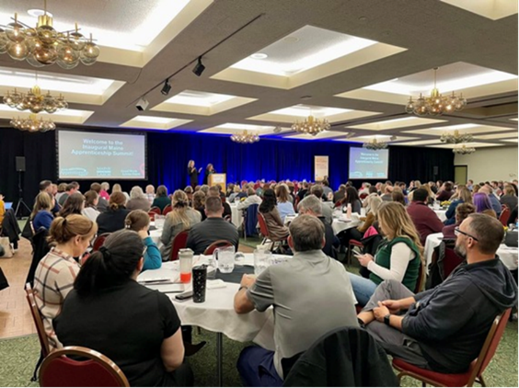
The Maine Apprenticeship Program hosted an Inaugural Maine Apprenticeship Summit in Augusta on November 18, 2024. Originally targeting approximately 100 attendees, the event exceeded expectations by selling out to 250 participants within two weeks. The attendees were businesses, unions, and workforce professionals.
The summit kicked off with opening remarks and a proclamation recognizing Maine's role in National Apprenticeship Week by Governor Janet Mills.
"Apprenticeships are a win for our workers, our employers, and our economy providing on-the-job training that results in a stable workforce, good-paying jobs, and a stronger, more diverse economy," Governor Mills said. "With employers looking for workers across Maine, paid apprenticeship programs are a great opportunity to get more individuals, especially younger people into new exciting fields that can provide a good paycheck."
Following those remarks, attendees picked from a variety of different breakout sessions to join. They included information for scaling existing apprenticeship programs, advice on how to implement a program for prospective businesses, mentoring, and labor laws. A handful of resource providers were also in attendance for participants to connect with.
In a post-event survey, attendees rated the summit as a 90/100 and one attendee shared afterwards, “Thank you for hosting the event. I think it was time well spent for the businesses and resource providers that attended.”

Maine Jobs and Recovery Program Apprenticeship Update
In 2022, the Maine Apprenticeship Program awarded $12.3 million to expand apprenticeships and pre-apprenticeships across Maine through the Maine Jobs & Recovery Plan and federal apprenticeship grant funding. To date, these grantees have:
- Registered 894 new apprentices
- Enrolled 1,386 new pre-apprentices
- Registered 104 new apprenticeship sponsors and sub-sponsors
- Expanding programming to an additional 66 new occupations

This past year marked over 1,000 pre-apprentices completing a program since pre-apprenticeships were first certified in 2023. To date, 379 of those participants have entered directly into a registered apprenticeship program; many more are in the application process.
Pre-apprenticeship programs have been particularly effective in engaging youth, women, and other under-represented populations with new career opportunities. Nationally, only about 12% of registered apprentices are women. Meanwhile, 38% of participants in these grant-funded programs identify as female. Additionally, over 7% of participants identified as having a disability. In comparison, in 2021, less than 1% of apprentices in Maine identified as having a disability.
These programs have helped diversify the workforce within these organizations to better reflect the demographics of Maine.

Development of Educator Apprenticeships in Maine.
In response to the workforce challenges in education, the Maine Department of Labor (DOL) partnered with the Maine Department of Education (DOE) to approve Maine’s first educator apprenticeship programs. This initiative aligns with DOE’s Teach Maine plan, developed in collaboration with educators and stakeholders, to strengthen teacher recruitment and retention strategies. With encouragement from the U.S. Departments of Education and Labor, Maine has joined several states in establishing apprenticeship programs for educators.
To support and promote the expansion of educator apprenticeship programs in Maine, in addition to the original 14 Maine Job’s and Recovery Act grantees, Maine DOL and DOE collaboratively awarded $985,000 in December 2023 to six schools to recruit, train, and retain educators through pre-apprenticeship and apprenticeship programs. With the support of grant funds, in 2024, apprenticeship programs for Educational Technician II and III and Early Childhood Education Teachers were approved by MAP. In early 2025, we anticipate grantees will add apprenticeship programming for K-12 teachers, including Ed. Tech. III to teacher and conditionally certified teacher to fully certified teacher.


Maine’s education apprenticeship programs are guided by industry-based curriculum documents known as Schedules of Work (SOWs), which outline required on-the-job competencies and classroom instruction. These SOWs are adapted from nationally approved standards and customized based on employer needs in collaboration with higher education partners.
Maine’s Chapter 115 rules, which govern teacher credentialing, are currently open for review, presenting a unique opportunity to formally recognize registered apprenticeship as an alternative pathway to teacher certification in Maine. Apprenticeships consistently attract a diverse range of applicants, including those who may face barriers to entry. Maine’s investment in registered apprenticeship continues to strengthen career pathways, expand workforce opportunities, and address critical labor shortages in education.

Outreach
In 2024, MAP continued its contract with Ethos to develop an outreach campaign aimed at increasing apprenticeships, particularly among large employers in priority industries. The campaign positioned MAP as a trusted resource for workforce development, using storytelling and multi-platform advertising to build awareness and engagement.
Ethos enhanced branding with virtual media graphics and executed targeted outreach via traditional and digital media, including TV, Google Ads, programmatic display, social media (Facebook, Instagram, YouTube), and in-person events.
Leveraging data-driven insights, Ethos optimized content to boost engagement among career seekers and employers. The campaign will continue through December 2025, with ongoing performance tracking and reporting.

Active Apprenticeship Sponsors and Occupations in 2024
In 2024, apprenticeship programs active in Maine included 155 separate entities as active sponsors of 3,639 apprentices. Currently, two types of apprenticeship sponsors are operating in Maine: individual and intermediary (multiple employer) sponsors. Please refer to Appendix 1 for a list of all sponsors active in 2024.
Throughout 2024, most MAP sponsors continued to be individual businesses (112). Many businesses employ one apprentice, while some larger sponsors served more than 50 apprentices as illustrated in figure 3 below. Intermediary sponsors registered most (70%) of apprentices in 2024. Intermediaries act as apprenticeship agents for their signatory sub-employers who agree to hire and train apprentices using the curriculum and on-the-job training outlines established by the sponsor.
The focus of the Maine Apprenticeship Program in 2025 will remain on expanding quality registered apprenticeship and certified pre-apprenticeship opportunities in four primary occupational sectors: healthcare, construction, manufacturing, and education with a secondary focus on continued development of apprenticeship opportunities in and within the financial and civic sectors. The expansion of our intermediary sponsors will remain a priority, as they facilitate small businesses’ engagement with Registered Apprenticeship programming.

Figure 3: Illustration of Sponsors with 50 or more Apprentices in 2024

* Sponsors indicated work collaboratively with General Dynamics, Bath Iron Works to train apprentices.
Registered apprenticeship programs help businesses address their ongoing workforce hiring, training, and retention needs. During 2024, 24 new sponsors were registered and 76 new occupations were added by existing and new sponsors. At the close of 2024, MAP staff were engaged with 94 new or existing sponsors to expand the Maine Apprenticeship Program by adding new occupations, new pre-apprenticeship and registered apprenticeship program sponsors. Please refer to Appendix 2 for a list of all occupations registered in Maine.
Portsmouth Naval Shipyard (PNSY) registers its apprentices directly with the U.S. Department of Labor. In 2024, PNSY employed 1,459 apprentices across 25 trades. York County Community College provided classroom training for 642 (44%) of them. PNSY apprentices do not register with or receive funding from MAP. Maine's first certified pre-apprenticeship program was launched at York County Community College to help residents enter PNSY's apprenticeship programs in 2024. The average starting wage for PNSY apprentices was $22.81 in 2024, increasing by 44% to $32.84 upon completion.

Sector Breakdown and Participation of 2024 Apprentices
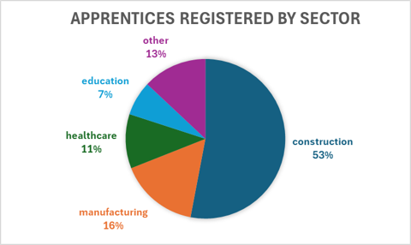
Figure 4: Sector Breakdown

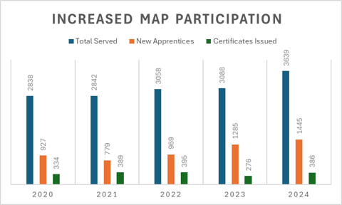
The construction sector represented the largest percentage of apprentices registered with the Maine Apprenticeship Program during 2024 at 53%. Electricians comprise 37% of all apprentices registered in Maine. At 16%, the manufacturing sector was the second largest sector served, with healthcare third (11 percent) and the education sector gaining momentum in fourth at 7%. For a listing of all occupations supported by Apprenticeship in 2024, see Appendix 2.
Over the past five years, 15,465 individuals have enrolled as apprentices, dedicating themselves to structured, typically multi-year work schedules. Among them, 1,780 successfully completed their apprenticeships, achieving journey worker status in their respective fields. Notably, 2024 saw the highest number of new apprentice registrations, totaling 1,445.
Figure 5: Increased MAP Participation Over 5-Years

Demographics of 2024 Apprentices
In 2024, a total of 3,639 apprentices were actively working toward industry-recognized skill certifications. Over the past five years, the average age of apprentices has declined from 32 in 2019 to 29 in 2024, a positive outcome of efforts to expand apprenticeship and pre-apprenticeship programs. These initiatives have successfully engaged younger individuals, increasing awareness of career opportunities in Maine and equipping them with the necessary skills to become successful apprentices.
Among active apprentices in 2024, 758 were female. Of these, 366 (representing 10.1% of all apprentices, up from 6.9% in 2019) pursued training in non-traditional occupations (NTOs) such as machinist, non-destructive tester, pipefitter, electrician, shipfitter, and welder—fields traditionally dominated by men.
Figure 6: Demographics of MAP Participants in 2019 and 2024
Year | Total Served | Male | Female | Female NTO | BIPOC or Hispanic | Veteran
2024 | 3,639 | 2,786* | 758* | 366 | 429 | 304
2019 | 2,813 | 2,356 | 457 | 195 | 119 | 455
* 95 individuals did not identify as male or female
** BIPOC – Black, Indigenous, People of Color

Additionally, 429 apprentices (11.8%) identified as Hispanic or as members of BIPOC communities, a significant increase from 4.2% in 2019. The rising participation of women, Hispanic, and BIPOC individuals in apprenticeship programs reflects the success of ongoing efforts to enhance diversity and expand apprenticeship opportunities. Over the past decade, deaths have outnumbered births in Maine, according to the state's Center for Research and Information (CWRI). However, during the same period, Maine’s population grew by 5.1%, driven by an influx of newcomers from other states and countries, particularly during the pandemic. Apprenticeship programs play a crucial role in bridging the skills and knowledge gap among younger workers and foreign-born new hires and strengthening Maine’s workforce and economy.

Apprenticeship Evaluation Project
The Center for Workforce Research and Information (CWRI) manages the Maine Department of Labor (MDOL) data warehouse, which combines information from various sources to better understand the employment and earnings outcomes of participants in education and workforce training programs. Apprenticeship program data from the Registered Apprenticeship Partners Information Database System (RAPIDS) has been integrated with employment and wage records in the MDOL data warehouse to better understand the effectiveness of these training programs.
Since 2017, 788 apprentices have completed a program and had enough time elapse to measure their earnings within the year following completion. After finishing their training programs, apprentices experience increases in both wages and employment rates. Median earnings more than doubled, rising from $29,200 in the year before beginning the program to $60,000 in the first year after completion. Employment rates also increased, from 82 percent in the year before starting to 93 percent in the year after completing the program. The share of apprentices whose wages exceeded full-time equivalent nearly doubled, from 37 percent before starting to 72 percent in the year after completing their program. Among those employed with at least full-time equivalent earnings, median wages increased from $44,250 annually two years before beginning the program to $70,625 annually two years after completion.

Figure 2: Adjusted Median Earnings and Employment Rate of Apprenticeship Completers by Outcome Year
Participants trained for a variety of occupations. Fifty-three percent pursued careers in the trades, such as electricians, machinists, and plumbers. Twenty-nine percent trained for health-related occupations including nurses, nursing assistants, and medical assistants. The remaining participants prepared for careers in various other fields.
Employer sponsors of apprenticeship programs benefit from upskilling their workforce and retaining talent. In the year after completion, 80 percent of apprentices who were employed remained with their sponsoring employer, and 93 percent remained employed in the same sector as their sponsorship. More than half continued working for their sponsoring employer after three years, and 85 percent remained employed in the sponsoring sector. CWRI has created a website and interactive data visualization to make this information accessible to the public and inform career planning here: www.maine.gov/labor/cwri/data-by-topic/education-and-training-outcomes
Notes: to enable a comparison of earnings in different time periods, wages and salaries have been adjusted for inflation and are expressed in 2024-dollar terms. A small share of apprenticeship records is excluded because a high-quality match between datasets is not attainable. Generally, matching rates are near 90 percent. Apprentices are determined to be working a full-time schedule if their earnings exceed the equivalent to working 32 hours per week at the state minimum wage in that year. Wage and employment records include a vast majority of employment within the state. These data do not capture jobs in other states or employment not covered by unemployment insurance such as unincorporated self-employment or independent contracting.

Quality Assurance of Programming
MAP continues to strengthen the review and monitoring of apprenticeship programs, addressing sponsor needs, facilitating program modifications, and improving program goals. Efforts have been made to connect employer sponsors with essential resources, including webinars, Workforce Innovation and Opportunity Act (WIOA) partnerships, and informational sessions such as lunch-and-learn events, aimed at expanding understanding and engagement with registered apprenticeships. In 2024, MAP staff conducted 47 quality assurance reviews of registered apprenticeship programs to verify that quality apprenticeship programs in compliance with CFR parts 29 and 30 are being delivered. Eighteen of the sponsors monitored were moved from provisional to permanent sponsor status and sixteen continued their permanent registration status. Thirteen sponsors were provided with technical assistance on how to make improvements to record keeping and curriculum of their program or were kept at provisional status due to having newly registered apprentices when the review took place. These programs will be assessed again in 2025. All 47 sponsors reviewed in 2024 met the U.S. Department of Labor requirements of sponsoring quality apprenticeship programs.
The Maine Apprenticeship Program is evaluating the total value package of registered apprenticeship programs, as required by recent changes to Maine Statute Title 26 MRSA § 3204, sub§2 and sub§5. In December 2024, all current sponsors were asked to submit data on wages, healthcare, and retirement benefits available to apprentices. This data is now under analysis. Looking ahead, we hope that RAPIDS, the federal database used to track apprentice activity, will incorporate new fields to streamline data collection and simplify the process.

Maine Apprenticeship Council
The Maine Apprenticeship Council supports and advises the Department in administering the Maine Apprenticeship Program (MAP). As mandated by Title 26 §3209 of Maine statute, the Council comprises twelve voting members appointed by the Governor, along with four non-voting members appointed by their respective organizations' leadership.
  - 2024 Members of the Maine Apprenticeship Council:

Council Members Representing Labor Organizations
Jennifer McKenna, United Association of Plumbers and Pipefitters, Local 716
Jason Shedlock, Laborers’ International Union of North America, Maine State Building Trades & Construction Trades Council
George Howe, International Brotherhood of Electrical Workers, Local 1253
Donald Nazaroff, Sheet Metal Workers Local 17

Council Members Representing Employers
Robin Wood, Chair, Reed & Reed, Inc.. Council Chair
Daniel Coffey, Cianbro Corporation
Lescar Beane, E.S. Boulos Company
Jennifer Boynton, MaineGeneral Medical Center
Council Members Representing the Public. May not be an industrial employee or employer or be directly concerned with any particular industrial employee or employer. Two of the public appointees must represent the interest of women and minorities and recipients of benefits under the Temporary Assistance for Needy Family’s (TANF) program.
Tracey Cooley, PhD, Career Systems Development Corporation
Dawn Croteau, Department of Health and Human Services, Office of Family Independence
Open Seat*
Open Seat*

Non-Voting Council Members Representing Maine’s State Workforce Board, Department of Economic & Community Development, Community College System and Department of Education
Allyson Coombs, State Workforce Board
Denise Garland, Department of Economic & Community Development
Christopher Winstead, Maine Community College System
Dwight Littlefield, Department of Education
*Application packets to fill open seats will be submitted to the Governor’s Office in early 2025

Apprenticeship Success Stories
Maine Passive House’s First Registered Apprentice, in partnership with Educate Maine
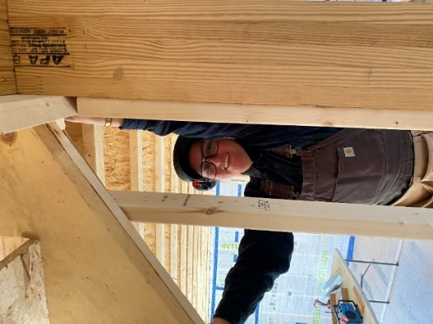
Entering a male-dominated field like carpentry can be daunting, but Maine Passive House (MPH) demonstrates how Registered Apprenticeship Programs (RAPs) create clear pathways to success. Delaney, MPH’s first registered apprentice, benefits from structured training, technical instruction, and mentorship. MPH, specializing in energy-efficient home construction, developed the Registered Passive House Builder Apprenticeship with the Maine Department of Labor and Educate Maine. Anna Heath, now a project manager, spearheaded this effort after experiencing an unstructured start herself.
The RAP model integrates on-the-job training, technical instruction, and mentorship, leading to an industry-recognized certificate. Delaney appreciates the program’s structured support, a stark contrast to past jobs where learning felt unstructured. “I never felt like a burden,” she notes, highlighting the value of an intentional apprenticeship environment. Anna emphasizes that formalizing the program allows both apprentices and mentors to prioritize learning alongside productivity.
Mentorship is another key element. Ian, one of Delaney’s mentors, guides her in both standard carpentry and Passive House techniques. “Teaching is a natural part of becoming proficient,” he says. Anna adds that the program ensures mentors are trained and recognized, fostering a strong learning culture.
As Delaney progresses, she is gaining confidence and becoming a vital part of the team. Anna and Ian commend her motivation and rapid skill development. “She adds value to the job site and influences how we operate,” Anna notes. Ian agrees, saying, “She’s taken on so much in such a short time.”
Delaney’s rapid growth has made her a valuable team member. Once she completes her training, she’ll earn an industry-recognized certificate, validating her skills and reinforcing the importance of RAPs in building skilled, inclusive workforces.

Robert Andrews
Lebanon, Maine
MaineHealth
Medical Assistant Apprentice Graduate
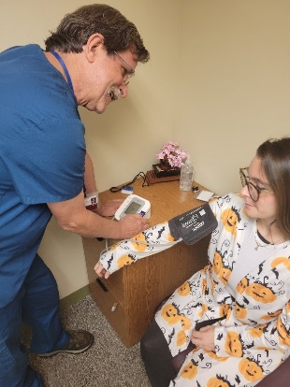
I was amazed when I discovered the apprentice program to become a Medical Assistant. In fact, it seemed “too good to be true.” Before I started the program, I had been a DSP working at a group home and later I was a CNA at a long-term care facility. This work was rather taxing physically, and I knew I needed to find a different occupation long term. It was discouraging for me because I wanted to be in an occupation where I could “help” people.
It was at that time I heard about the apprenticeship program. It was so good to see the practice from day one the staff and my mentor, Rachel, were so nice, welcoming and instructive. At this point I have just graduated from the program, and I work in Behavioral Health, where I am learning new things every day, and still in my own way am able to help people. If you like being a service to our community, I highly recommend the occupation of Medical Assistant and this excellent apprentice program.

Morgan Cash
Belgrade, Maine
Maine Roads to Quality Professional Development Program, in partnership with Educare
Early Childhood Education Specialist 1 Apprentice Graduate
I joined the Maine ECE Registered Apprenticeship Program because I wanted to learn/ support children and their families better, as well as work toward personal growth and experience. Becoming an apprentice has been beneficial for me because it has allowed me to have more hands-on experience and help me build a stronger foundation, opening opportunities such as a pay increase, working towards personal growth and goals, as well as helping me become a better teacher assistant by taking on more responsibilities in the classroom and stepping out of my comfort zone.

The ultimate goal and outcome of my apprenticeship experience was to achieve my personal goals and to work harder in my field. I have taken many trainings throughout my career at Educare including Touchpoints, Conscious Discipline, and CPR/First Aid that have helped me in the process. Through my apprenticeship experience I was able to receive feedback from peers, receive resources, and learn techniques that I can use to support children and their families. My apprenticeship experience has given me the confidence I need in my field so I can become a better teacher. I would recommend the apprenticeship program to anyone interested in the early childhood field because it can provide them opportunities, personal growth, and experience. The program helped me to step out of my comfort zone and become confident in my role. I have taken a lot more responsibility in the classroom after taking the apprenticeship. Yes, it’s a lot of work and it may seem overwhelming but, I’m so glad I was able to take the apprenticeship. After 18 long months of hard work and dedication, I became the first participant to complete the Maine apprenticeship program while working full time, raising two children (ages 2 and 1), and eventually having my third child in the process. While it was, at times, a bittersweet experience, I’m so thankful to have had this opportunity.
Kloey Arsenault
Bowdoin, Maine
Ironworkers Local 7 JATC
Ironworker
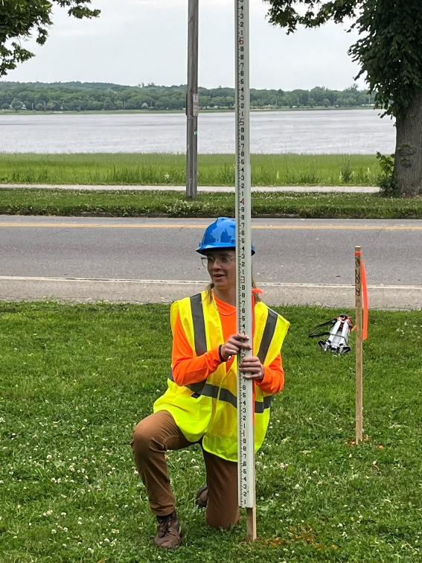
Kloey Arsenault wasn’t sure about her next steps after graduating high school in 2024. She had a part-time farm job and enjoyed hands-on outdoor work but didn’t know how to break into the trades. A friend suggested the Union Construction Academy, a Maine AFL-CIO pre-apprenticeship program offering pathways into union careers in construction and manufacturing.
During the five-week training, Kloey earned six industry-recognized credentials, including OSHA-10 and First Aid/CPR, while exploring different trades under experienced instructors. She worked alongside 16 peers on tasks like pouring concrete, wiring outlets, and framing drywall, gaining skills, confidence, and teamwork experience in a fast-paced construction setting. Presentations from apprentices provided insights and advice on industry success.
“The program helped me figure out a career path by showing me the ups and downs of different trades,” Kloey said. “They expected us to act like we were on a job site and taught us vital field skills.” After completing the program in July 2024, she pursued ironworking, reaching out to Grant Provost of Ironworkers Local 7, who had presented to her class. She soon joined the Ironworkers’ Apprenticeship program and started working on the Crewe Center for the Arts at the University of Southern Maine. Grant praised her dedication, saying, “She shows up, works hard, and we’re lucky to have her.”
Kloey loves the strong pay, benefits, and camaraderie of the Ironworkers Union. “There’s something special about bonding over hard work, sweat, and tears. I go to work everyday ecstatic to be with my best friends.” She encourages others interested in the trades to consider a pre-apprenticeship.


Aaron O’Donnell
Bangor, Maine
Cianbro
Millwright Instructor
Seventeen years ago, I began my journey with Cianbro, drawn by the opportunities they provided. Four years later, I was selected to join the millwright apprenticeship program through the Cianbro Institute. The development I have received has shaped my career, and in 2023, I was invited to become a millwright instructor at the institute. An apprenticeship is incredibly valuable because it combines hands-on experience with education, giving you the tools to build a strong foundation in your career. It not only gets your foot in the door but also gives you a head start with practical knowledge and education.

Benefits of Apprenticeship

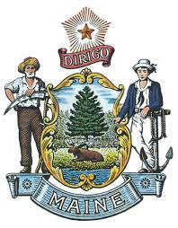
For Apprentices:
Increased skills
Paycheck while in training
Higher wages
Mentor support
Safer workplace
Nationally recognized, portable credential
For Employers:
Improved recruitment and a more diverse workforce
Reduced turnover costs, higher productivity and fewer accidents
Allows access to offset training costs with multiple workforce development and other funding.
Formalized, customizable approach that enhances existing business practices
Average return on investment of $1.47 for every $1 invested
For Maine:
Dollar for dollar, no workforce training method packs as much punch as Registered Apprenticeship. In addition to the $1.47 return on investment for every $1 spent on apprenticeship programs lead to a public return of approximately $28 in benefits.
Strengthens the State’s economy by developing highly trained and educated workers.
Driven by employer demand and eliminates mismatch between skills taught and employer need
Provides a customized, long-term solution to filling business workforce gaps as workers retire
Encourages secondary, post-secondary, and workforce development system to work together with business to understand and better serve Maine’s workforce development needs

Appendix 1 – 2024 Maine Apprenticeship Sponsors
24 New Sponsors in 2024
Sponsor Name | Sponsor City | State | Sponsor Type
Wilson Funeral Home, LLC | Gray | ME | Single Employer
W.D. Matthews Machinery Co. | Auburn | ME | Single Employer
University of Southern Maine | Portland | ME | Multi-Employer
The Bath Group, LLC | Bath | ME | Single Employer
SolarLogix LLC | Belfast | ME | Single Employer
Sappi North America | Skowhegan | ME | Single Employer
Quirion Construction | Augusta | ME | Single Employer
Purpose Pups | Newport | ME | Single Employer
Mockler Funeral Home | Caribou | ME | Single Employer
Mid-Maine Technical Center | Waterville | ME | Multi-Employer
Maine Veterans' Homes | Augusta | ME | Single Employer
Maine Machine Products Company | South Paris | ME | Single Employer
Maine Center for Cancer Medicine and Blood Disorders | Scarborough | ME | Single Employer
Ignite Presque Isle | Presque Isle | ME | Multi-Employer
Helios Energy LLC | Bellingham | MA | Single Employer
Freedom Forever Maine, LLC | Lewiston | ME | Single Employer
Employment Experts, Inc. | Presque Isle | ME | Single Employer
Eastern Maine Community College | Bangor | ME | Multi-Employer
Dobson Funeral Services | Arundel | ME | Single Employer
Chad Poitras Enterprises LLC | Buxton | ME | Single Employer
CapEx Services | Leominster | MA | Single Employer
Brunswick School Department | Brunswick | ME | Single Employer
Benchmark Construction | Westbrook | ME | Single Employer
American Apprenticeship Round Table (AART) | Brunswick | ME | Multi-Employer

130 Continuing Sponsors in 2024
Sponsor Name | Sponsor City | State | Sponsor Type
Aero Heating & Ventilating, Inc. | Westbrook | ME | Single Employer
Associated Builders & Contractors of Maine, Inc. | Auburn | ME | Multi-Employer
Associated General Contractors of Maine, Inc. | Augusta | ME | Multi-Employer
Aurora Contracting | Farmington | ME | Single Employer
Aware Recovery Care | S. Portland | ME | Single Employer
Barrette Outdoor Living, Inc. | Biddeford | ME | Single Employer
BASiX Automation Integrators, Inc. | Dover | NH | Single Employer
Bassett Custom Home Builders Inc | Durham | ME | Single Employer
Bibber Memorial Chapel | Kennebunk | ME | Single Employer
Birmingham Funeral Home | Old Town | ME | Single Employer

Sponsor Name | Sponsor City | State | Sponsor Type
Bowers Funeral Home | Houlton | ME | Single Employer
Boyne Resorts | Newry | ME | Multi-Employer
Brackett Funeral Home | Brunswick | ME | Single Employer
Bragdon-Kelley Funeral Homes | Ellsworth | ME | Single Employer
Bristol Seafood | Portland | ME | Single Employer
Brookings-Smith Funeral Home | Bangor | ME | Single Employer
Burpee, Carpenter & Hutchins Funeral Home | Rockland | ME | Single Employer
C&L Aviation Group | Bangor | ME | Single Employer
Casco Bay Electric, LLC | Portland | ME | Single Employer
Casella Resource Solutions | Saco | ME | Single Employer
Chandler Funeral Homes & Cremation Service | South Paris | ME | Single Employer
Cianbro | Pittsfield | ME | Multi-Employer
Conroy-Tully Walker Funeral Homes | Portland | ME | Single Employer
Coon & Horch LLC | S. Portland | ME | Single Employer
Coutts Bros | Randolph | ME | Single Employer
Davis Ulmer | Auburn | ME | Single Employer
Day & Ross | Houlton | ME | Single Employer
Day's Jewelers | Waterville | ME | Single Employer
Dead River Company | S. Portland | ME | Single Employer
DeBlois Electric, Inc. | Lewiston | ME | Single Employer
Deer Valley O and M | Somers | CT | Single Employer
DePco Mechanical LLC | Plainville | CT | Single Employer
Doc's Upholstery and Restoration | West Bath | ME | Single Employer
Dog House Energy Services | Freeport | ME | Single Employer
Downeast Direct Cremation, LLC | Bangor | ME | Single Employer
Duncan Graves Funeral Home | Presque Isle | ME | Single Employer
East Coast Electric of ME LLC | Saco | ME | Single Employer
ECI Services of Maine | Lewiston | ME | Single Employer
Educate Maine | Portland | ME | Multi-Employer
Estes Oil & Propane | York | ME | Single Employer
Everon Solutions | Portland | ME | Single Employer
Fabian Oil Inc | Manchester | ME | Single Employer
Family First Funeral Homes | Gardiner | ME | Multi-Employer
Finishing Trades Institute of New England | Roslindale | MA | Single Employer
Foster Career and Technical Education Center | Farmington | ME | Multi-Employer
Gallant Funeral Home | Waterville | ME | Single Employer
Gallop Construction Services | Hodgdon | ME | Single Employer
General Dynamics, Bath Iron Works | Bath | ME | Single Employer
Gifford Electric | Brewer | ME | Single Employer

Sponsor Name | Sponsor City | State | Sponsor Type
Gorham School Department | Gorham | ME | Multi-Employer
Heat & Frost Insulators, LU 6/Axion | Billerica | MA | Multi-Employer
Hobbs Funeral Home | S. Portland | ME | Single Employer
Hope Memorial Chapel | Portsmouth | NH | Single Employer
HospitalityMaine | Augusta | ME | Multi-Employer
IBEW1253, Augusta Electrical JATC | Newport | ME | Multi-Employer
IBEW567, Portland Electrical JATC | Lewiston | ME | Multi-Employer
Industrial Roofing Company | Lewiston | ME | Single Employer
InterMed, P.A. | S. Portland | ME | Single Employer
Interstate Electrical Services, Inc. | Eliot | ME | Single Employer
Ironworkers Local 7 JATC | Clinton | ME | Multi-Employer
Jim Michaud Heating and Cooling | Medway | ME | Single Employer
Jones, Rich & Barnes Funeral Home | Portland | ME | Multi-Employer
Jordan Custom Carpentry, Inc. | Lovell | ME | Single Employer
Jordan-Fernald Funeral Home | Mount Desert | ME | Single Employer
Ken L. Electric, Inc. | Saint Agatha | ME | Single Employer
Kincer Funeral Home, DBA Funeral Alternatives Group | Richmond | ME | Multi-Employer
Lajoie Funeral Home and Cremation Services, LLC | Madawaska | ME | Single Employer
Lamson Funeral Home | Millinocket | ME | Single Employer
Lewiston Public Schools | Lewiston | ME | Multi-Employer
Louth Callan Renewables, LLC | Suffield | CT | Single Employer
Maine Aquaculture Association | Hallowell | ME | Multi-Employer
Maine Association of Plumbing, Heating, Cooling Inc. | Cumberland | ME | Multi-Employer
Maine Department of Corrections | Charleston | ME | Single Employer
Maine Department of Corrections Apprenticeship Office | Charleston | ME | Multi-Employer
Maine Department of Health and Human Services | Augusta | ME | Multi-Employer
Maine Department of Marine Resources - Marine Patrol | Augusta | ME | Single Employer
Maine Kayak, Inc | New Harbor | ME | Single Employer
Maine Roads to Quality Professional Development | Portland | ME | Multi-Employer
Maine Rural Water Association | Richmond | ME | Multi-Employer
Maine Solar Solutions | Freeport | ME | Single Employer
MaineGeneral Health | Augusta | ME | Single Employer
MaineHealth | S. Portland | ME | Multi-Employer
Martin's Point Healthcare | Portland | ME | Single Employer
Massachusetts and Northern New England Laborers | Hopkinton | MA | Multi-Employer
Mays Funeral Home | Calais | ME | Single Employer
MCD Global Health | Augusta | ME | Multi-Employer
McIntire-McCooey Funeral Home | S. Berwick | ME | Single Employer
Meklin Masonry Inc. | Waterboro | ME | Single Employer

Sponsor Name | Sponsor City | State | Sponsor Type
Mid-Coast Energy Systems | Damariscotta | ME | Single Employer
Mid-State Machine | Winslow | ME | Single Employer
Mitchell-Tweedie, Inc. | Bucksport | ME | Single Employer
Modula | Lewiston | ME | Single Employer
Moody's Collision | Gorham | ME | Single Employer
Nestle Waters North America | Poland Spring | ME | Single Employer
North Atlantic States Carpenters Training Fund | Portland | ME | Multi-Employer
Northeast Residential Services | Gray | ME | Single Employer
Northern Light Health | Portland | ME | Multi-Employer
Northern Maine Community College | Presque Isle | ME | Multi-Employer
Novel Energy Solutions | Saint Paul | MN | Single Employer
Panolam Industries, Inc. | Auburn | ME | Single Employer
Pine State Services | Westbrook | ME | Single Employer
Pine Tree Solar | Hermon | ME | Single Employer
Plumbers and Pipefitters UA Local 716 | Augusta | ME | Multi-Employer
Pratt & Whitney | North Berwick | ME | Single Employer
Professional Electrical Contractors of Connecticut Inc | Cumberland | RI | Single Employer
RCBI Apprenticeship Works-Maine | Huntington | WV | Multi-Employer
Revision Energy, Inc. | S. Portland | ME | Single Employer
Riposta Funeral Home | Belfast | ME | Single Employer
SAFAL Maine | Houston | TX | Multi-Employer
Seabee Electric, Inc. | Scarborough | ME | Single Employer
Segee Enterprises | Windham | ME | Multi-Employer
Sentry Electrical Group | Lawrenceville | GA | Single Employer
Sheet Metal Workers Local 17 | Lewiston | ME | Multi-Employer
SLH Maine Manager LLC | Auburn | ME | Single Employer
Smith Builders Inc | Glenburn | ME | Single Employer
Somerset Career & Technical Center | Skowhegan | ME | Multi-Employer
Southern Kennebec Child Development Corporation | Farmingdale | ME | Single Employer
Southern Maine Community College | S. Portland | ME | Multi-Employer
T&D Wood Energy, LLC | Sanford | ME | Single Employer
Thos. Moser Cabinetmakers | Auburn | ME | Single Employer
True Enterprises LLC | York | ME | Single Employer
Unity Environmental University | New Gloucester | ME | Single Employer
Veilleux Funeral Home | Waterville | ME | Single Employer
Warren Mechanical | Westbrook | ME | Single Employer
Washington County Community College | Calais | ME | Multi-Employer
Wayne J Griffin Electric | Holliston | MA | Single Employer
Wiles Funeral Homes, Inc | Farmington | ME | Single Employer
WYEcon Inc. | Newport | ME | Single Employer
Wyman Electric LLC | Windham | ME | Single Employer
York County Community College | Wells | ME | Multi-Employer

Appendix 2

Occupations Sorted by Major
Occupational Group
Management
Operations Management
Farmer, General (Agriculture)
Foreman
Lodging Manager
Business & Financial
Cost Estimator
Project Manager/Installation
Events Planner and Manager
Certified Workforce Development Professional
Workforce Development Specialist
Computer & Mathematics
IT Analyst
Cyber Security Support Technician
Computer Support Specialist
Help Desk Technician
IT Generalist
Database Technician
Network Support Technician
Computer Programmer
Application Developer
User Experience Designer
Penetration Tester
Data Scientist
Architecture & Engineering
Design Drafter/Electromechanical
PV Design Specialist
Basic Designer
Drafter, Mechanical
Marine Designer
Electrical & Instrumentation Technician
Electrical Technician
Basic Production Technician
Manufacturing & Production Technician I
Manufacturing Production Technician
Non-Destructive Tester
Basic Surveyor
Life, Physical & Social Science
Agricultural Technician
Community & Social Service
Peer Specialist
Community Health Worker
Educational Instruction & Library
Assistant Teacher
Early Childhood Education Specialist 2
Early Childhood Educator
Educational Technician III
Teacher Aide I
Healthcare Practitioners
Emergency Room Nurse
Float Nurse
Front Line Nurse Leader
Med Surg Nurse Residency
Nurse - Critical Care Residency
Nurse - Emergency Room Residency
Nurse - Med-Surg RN Residency
Nurse - Mental Health RN Residency
Psychiatric Nurse
Nurse - Mental Health
Nurse - Critical Care Unit
Medical Laboratory Technician
Dietary Aide / Food Service
Behavioral Health Aide
Health Support Specialist
Certified Nursing Assistant (CNA)
Medical Assistant
Veterinary/Lab Animal Technician
Protective Services
Fire Suppression Technician
Corrections Officer
Marine Patrol Officer
Food Preparation & Serving
Sous / Head Chef
Kitchen Manager
Restaurant Manager
Cook (Hotel & Restaurant)
Line Cook
Production Cook
Building & Grounds Cleaning & Maintenance
Custodian
Housekeeper
Landscape Management Technician
Tree Surgeon
Personal Care & Services
Hospitality Services II
Animal Trainer
Service Dog Trainer
Funeral Practitioner
Early Childhood Education Specialist 1
Sales
Assistant Store Manager
Technical Sales Representative
Office & Administrative Support
Accounting Technician
Financial Management
(Alternate Title: Finance Specialist)
Teller (Financial)
Customer Service Representative
Hospitality Services I
Advanced Planner
Basic Planner
Farming, Fishing & Forestry
Aquaculture Technician
Logger
Lead Logging Equipment Operator
Construction & Extraction
Construction Specialist
Lead Carpenter
Boilermaker Fitter
Bricklayers & Mason (Ext. Title: Bricklayer
(Brick & Tile) or (Masonry))
Bridge Carpenter/Heavy Highway
Carpenter
Carpenter - Framing and Finishing
Carpenter - NCCER Core & Level 1
Carpenter - NCCER Level 2
Carpenter - NCCER Level 3
Carpenter - NCCER Level 4
Carpenter / Ship
Construction Carpenter
Form Builder Carpenter (Existing Title: Form Builder)
Pile Driver
Residential Carpenter
Floor Layer (Alternate Title: Floor Cover)
Building Construction Craft Laborer
Construction Craft Concrete Laborer
Construction Craft Laborer
Construction Craft Laborer - Heavy / Highway
Earthwork Construction Craft Laborer
Earthworks Laborer
Construction Equipment Operator
Drywall Finisher
Electrician
Electrician (Alternate Title: Interior Electrician)
Electrician (Ship & Boat)
Electrician, Maintenance
Glazier
Insulator
Insulation Worker
Pipe Coverer & Insulator
Painter
Painter (Construction)
PAINTER, INDUST COATING AND LINING APP SPECIALIST
Preservation Tech
Pipe Fitter (Construction)
Pipe Fitter (Ship & Boat)
Pipefitter
Plumber
Sprinkler Fitter
Roofer
Duct Installation Technician
Sheet Metal Worker
Ironworker
Structural Iron Worker
Pipe Inspector
Fencing Installer
Home Performance Laborer Residential, Revised
Installation, Maintenance & Repair
Telecommunications Technician
Substation Technician
Security and Fire Alarm System Installer
A&P Aviation Mechanic
Automobile Body Repairer
Automotive Technician I
Crane Mechanic
Heavy Equipment Technician
Shop Service Technician - Toyota Bronze Level
Certification
Vehicle Maintenance Mechanic
Environmental Control System
Heating & Ventilation Technician
HVAC Technician
Master Oil Burner, Solid Fuel, Propane & Natural Gas Technician
Oil Heat and Propane Technician
Maintenance Mechanic
Millwright
Line worker
Line worker - Distribution
Line worker - Transmission
Fiber Optic Technician
Installation, Maintenance & Repair
Line Installer-Repairer
Industrial Maintenance Repairer
Industrial Manufacturing Mechanical
Maintenance Technician
Maintenance Electrician
Yard Rigger
Outside Machinist
Production
Advanced Front Line Supervisor
Associate Production Manager
Assembler Installer General
Laminator
Machinist
Machinist (Alternate Title: Precision Machinist)
Machinist / Manufacturing Technologist
Machinist, Outside (Ship)
Engineering Assistant
Welder
Welder, Arc
Shipfitter (Ship & Boat)
Industrial Sewing Machine Operator
Upholsterer
Cabinetmaker
Sawyer
Boiler Operator
Wastewater Systems Operations Specialist
Painter, Transportation Equipment
CNC Machinist
Transportation & Material Moving
CDL Tractor Trailer / Tanker Operator
Heavy & Tractor Trailer Truck Driver
Crane Operator
Truck Crane Operator
Dock Worker

Published by the Maine Department of Labor March 2025

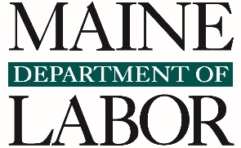
The Maine Department of Labor provides equal opportunity in employment and programs.
Auxiliary aids and services are available to people with disabilities upon request.

– data from U.S. Department of Labor - https://www.apprenticeship.gov/data-and-statistics/apprentice-population-dashboard
/3 National Apprenticeship retrieved on 2/12/2025: https://caf-fca-org/apprenticeship-101/hiring-an-apprentice

