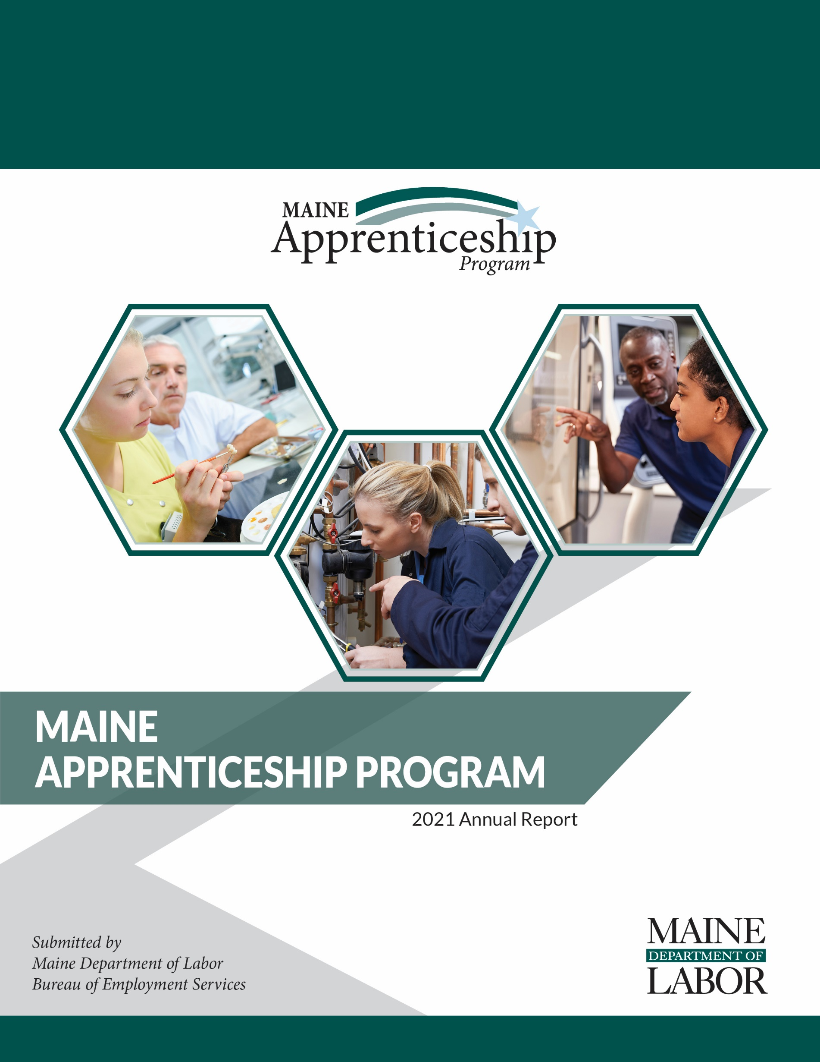

Maine Apprenticeship Program 2021 Annual Report
For the Period January 1, 2021 – December 31, 2021

Prepared for:
Governor Janet T. Mills
The Joint Standing Committee on Labor and Housing
The Joint Standing Committee on Education and Cultural Affairs

Submitted by:
Maine Department of Labor
Laura Fortman, Commissioner

The Maine Department of Labor provides equal opportunity in employment and programs.
Auxiliary aids and services are available to individuals with disabilities upon request.
Tel: (207) 623-7969 TTY users call Maine Relay 711 Fax: (207) 287-5292

2021 Apprenticeship Program Overview
The success of Maine’s economy is tied directly to the skill of our workforce and the creativity and innovation of our employers. Registered Apprenticeships are a vital part of Maine’s economy – they provide career pathways to high-quality jobs that allow apprentices to earn while they learn. Employers hone their future workforce by developing programs in which workers are performing required duties while learning skills needed for higher-level performance.
In Maine, these registered apprenticeships are part of the Maine Apprenticeship Program (MAP), which has been in place since 1941. The MAP is governed by Maine Statute Title 26 Chapter 37 § 3202 and Title 29 Parts 29 and 30 of the United States Code of Federal Regulations. Registered apprenticeships require at least 2,000 hours of on-the-job training and a minimum of 144 hours formal coursework for each year of the apprenticeship. MAP continues to innovate and adapt to meet employers’ needs for skilled labor and workers’ needs for good wages with a clearly defined pathway to career advancement.
In 2021, the construction sector contained the largest percentage of apprentices registered with the Maine Apprenticeship Program, at 42 percent. The production sector was the second largest served, at 21 percent. Approximately 31 percent of all Maine apprentices are pursuing journey worker status as electricians, found in multiple sectors.

Business and Training Engagement
Registered apprenticeship programs help businesses address their ongoing workforce hiring, training, and retention needs. Despite unprecedented unemployment and uncertainty caused by the COVID-19 pandemic, employer engagement with MAP remains strong; 22 new sponsors were registered, and 67 potential new sponsors are working with MAP to explore becoming an apprenticeship sponsor.
Quality Assurance of Programming
In 2021 Maine Apprenticeship Program (MAP) staff conducted 17 quality assurance reviews of registered apprenticeship programs to verify that quality apprenticeship programs in compliance with CFR parts 29 and 30 are being delivered. Eight of the sponsors monitored were moved from provisional to permanent sponsor status and five continued their permanent registration status. The remaining four sponsors were provided with technical assistance on how to make improvements to either the record keeping or in modifying the curriculum of their programs and will be assessed again in 2022.

2021 Program Highlights
- In 2021, 2,842 apprentices were actively working on industry-recognized skill certifications.
- The Maine Apprenticeship Program received a $5.5 million State Apprenticeship Expansion, Equity, and Innovation (SAEEI) grant from the U.S. Department of Labor in July of 2021. The funding supports the employment of one Program Manager, an Apprenticeship Navigator with the Maine Community College System, an Apprenticeship Navigator with the Bureau of Rehabilitation Services, and three Apprenticeship Technical Representatives (ATRs). The focus of the grant is to develop, modernize, and diversify registered apprenticeship programs across the state, with a particular emphasis on diversity, equity, and inclusion initiatives.
- Apprentices who completed their programs during 2021 attained an average wage of $25.51
- The estimated gross hourly wages paid by employers to Maine apprentices in 2021 was $118.85 million.
- Veterans make up 10 percent of Maine’s total population and represent 14 percent of the state’s registered apprentices.
- 194 women (6.8 percent of all apprentices) pursued training in non-traditional occupations (NTO’s) such as machinist, non-destructive tester, pipefitter, electrician, shipfitter and welder among other occupations traditionally held by men.

Benefits of Apprenticeship
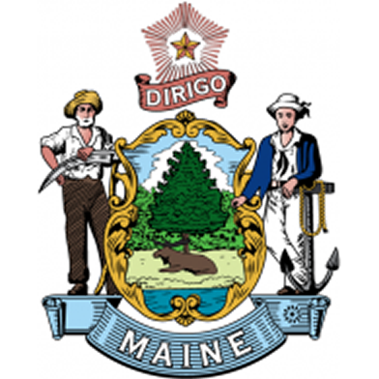
For Apprentices:
- Increased skills
- Paycheck while in training
- Higher wages
- Mentor support
- Job security
- Safer workplace
- Nationally recognized, portable credential
For Employers:
- Improved recruiting
- More diverse workforce
- Reduced turnover costs
- Higher productivity and fewer accidents
- Connection to training funds
- Apprenticeship program can be customized to meet employer needs
- Formalized approach that enhances existing business practices
- Average return on investment of $1.47 for every $1 invested¹
For Maine:
- Strengthens state’s economy by developing highly trained and educated workers
- Driven by employer demand and eliminates mismatch between skills taught and employer need
- Provides a customized, long-term solution to filling business workforce gaps as workers retire
- Allows combination with multiple workforce development and other funding streams
- Encourages secondary, post-secondary, and workforce development system to work together with business to understand and better serve Maine’s workforce development needs

_______________________
Canadian Apprenticeship Forum retrieved on 1/28/2021; https://caf-fca.org/apprenticeship-101/hiring-an-apprentice/

2021 Apprenticeship Participant Demographics

Total Served | Male* | Female* | Female - NTO | Minority | Disabled | Veteran
2,842 | 2,403 | 434 | 194 | 337 | 25 | 389
* 5 individuals did not identify as male or female

2021 In Numbers

Total taxpayer (State and Federal) dollars spent* | $599,813.74
Average annual gross wages of apprentices | $118.85 Million
Total served (new/active/completed/cancelled) | 2,842
Total new apprentices registered | 779
Total apprentices completing programs | 389
Total apprentices cancelled prior to completion | 414
Average age of apprentices at the start of their apprenticeship | 31
Age range of apprentices registered in 2021 | 18 to 65
Average starting hourly wage rate of all apprentices served in 2021 | $19.79
Average ending hourly wage rate at successful completion in 2021 | $25.51

During the past two years, despite a global pandemic, MAP numbers have remained steady and even experienced a modest increase. In the past five years, nearly 12,000 individuals have pursued apprenticeship with 1,230 of those individuals completing their apprenticeships and earning journey worker status in their chosen occupation.

Maine Apprenticeship Council
The Maine Apprenticeship Council assists and advises the Department in the administration of the MAP. As required by Title 26 §3209 of Maine statute, the Council consists of twelve voting members who are appointed by the Governor. It also includes four additional non-voting members appointed by the State Workforce Board; the Community College System; the Maine Department of Education; and the Maine Department of Economic and Community Development.
2021 Members of the Apprenticeship Council:
- Jennifer McKenna, Chair, United Association Local 716
- Jason Shedlock, Regional Organizer, Laborers’ International Union of North America
- Jennifer Boynton, MaineGeneral Medical Center
- Robin Wood, Reed & Reed, Inc.
- Dawn Croteau, Department of Health and Human Services, Office of Family Independence
- Tracey Cooley, PhD, Penobscot Job Corps Center
- Jonathan Mason, Bath Iron Works and the State Workforce Board
- Tracie Travers, Jobs for Maine Graduates
- Denise Garland, Department of Economic & Community Development
- Charles Collins, Maine Community College System
- Dwight Littlefield, Department of Education, Career & Technical Education
- Dan Coffey, Cianbro

Active Apprenticeship Sponsors 2021
In 2021, apprenticeship programs operating in Maine included 123 separate entities as active sponsors of 2,885 apprentices in 234 sponsor-customized occupational programs. Currently, five types of apprenticeship sponsors are operating in Maine: group joint, single employer, intermediary, state agencies, and a federal facility.
- The bulk of MAP sponsors continue to be individual businesses (98). Many businesses employ one apprentice, while some larger employers (ex: Bath Iron Works, Cianbro, Northern Light Health, MaineGeneral Medical Center, and Casella Resource Solutions) served more than 70 apprentices each in 2021.
- The seven joint programs registered in Maine are union-sponsored joint apprenticeship training committees (JATC) that have multiple signatory businesses working with their apprentices. Collectively, 252 apprentices were sponsored by JATC’s in 2021.
- Intermediary sponsors (17) in Maine sponsored 335 apprentices in 2021. Intermediaries act as apprenticeship agents for their sub-employers who have agreed to hire and train apprentices using the curriculum and on-the-job training outlines established by the sponsor.
- As a federally operated facility, Portsmouth Naval Shipyard (PNSY), is required to register their apprentices directly with the U.S. Department of Labor. PSNY employed 1,447 apprentices, in 32 different trades in 2021. A total of 451 (31%) of PNSY apprentices received their classroom training at York County Community College. The PNSY apprentices do not register or receive any funding through MAP.

22 New Sponsors in 2021 | Type | City | State
A.T. Hutchins LLC | Employer | Portland | ME
Aero Heating & Ventilating, Inc. | Employer | Westbrook | ME
Anthony Mancini, Inc. DBA Mancini Electric | Employer | Portland | ME
Associated Builders & Contractors of Maine, Inc. | Intermediary | Gray | ME
Bassett Custom Home Builders Inc | Employer | Durham | ME
Brackley Electric, Inc. | Employer | West Bath | ME
Bristol Seafood | Employer | Portland | ME
Conroy-Tully Walker Funeral Homes | Employer | Portland | ME
DePco Mechanical LLC | Employer | Plainville | CT
Ironworkers Local 7 JATC | Union/Labor | Clinton | ME
Limerick Supermarket | Employer | Limerick | ME
Maine Energy Marketers Association | Intermediary | Brunswick | ME
Maine Rural Water Association | Intermediary | Richmond | ME
Mays Funeral Home | Employer | Calais | ME
Military Talent Source | Intermediary | Auburn | ME
MMR Constructors, Inc. | Employer | Baton Rouge | LA
Northern Maine Community College | Intermediary | Presque Isle | ME
Regional Electric, LLC | Employer | Lewiston | ME
SAFAL Maine | Intermediary | Houston | TX
Shaw's Supermarket | Employer | Portland | ME
Somerset Career & Technical Center | Intermediary | Skowhegan | ME
Walgreens | Employer | Scarborough | ME
100 Continuing Sponsors in 2021 | Type | City | State
ADT Commercial | Employer | Portland | ME
Advantage Funeral and Cremation Services | Employer | Portland | ME
Alfred Water District | Employer | Alfred | ME
Aroostook County Action Program | Employer | Presque Isle | ME
Associated General Contractors of Maine, Inc. | Intermediary | Augusta | ME
Barrette Outdoor Living, Inc. | Employer | Biddeford | ME
Birmingham Funeral Home | Employer | Old Town | ME
Blaiklock Carpentry, Inc. | Employer | Woolwich | ME
Boston Ocular Prosthetics, Inc. | Employer | Jackson | ME
Bowers Funeral Home | Employer | Houlton | ME
Boyne Resorts | Employer | Newry | ME
Bragdon-Kelley Funeral Homes | Employer | Ellsworth | ME
Bridgton Veterinary Hospital | Employer | Bridgton | ME
Brookings-Smith Funeral Home | Employer | Bangor | ME
100 Continuing Sponsors in 2021 (continued) | Type | City | State
Burpee, Carpenter & Hutchins Funeral Home | Employer | Rockland | ME
C&L Aviation Group | Employer | Bangor | ME
Casco Bay Electric, LLC | Employer | Portland | ME
Casella Resource Solutions | Employer | Saco | ME
Central Maine Motors Auto Group | Employer | Waterville | ME
Cianbro | Employer | Pittsfield | ME
Clover Manor, Inc. | Employer | Auburn | ME
Cote Funeral Home | Employer | Saco | ME
C-Prime Valuation Group, LLC | Employer | Freeport | ME
David E Desmond Funeral Services | Employer | Bath | ME
Day's Jewelers | Employer | Waterville | ME
DeBlois Electric, Inc. | Employer | Lewiston | ME
Dennett-Craig & Pate Funeral Home | Employer | Saco | ME
Dog House Energy Services LLC | Employer | Freeport | ME
Downeast Direct Cremation, LLC | Employer | Bangor | ME
Duncan Graves Funeral Home | Employer | Presque Isle | ME
Eastern Fire Protection | Employer | Auburn | ME
Estes Oil & Propane | Employer | York | ME
Everett J Prescott, Inc. | Employer | Gardiner | ME
Family First Funeral Homes | Intermediary | Gardiner | ME
Favreau Electric | Employer | Brunswick | ME
Fortin Group Funeral Home | Employer | Lewiston | ME
Gallant Funeral Home | Employer | Waterville | ME
General Dynamics, Bath Iron Works | Employer | Bath | ME
Hall Funeral Homes | Employer | Waldoboro | ME
Heat & Frost Insulators, LU 6/Axion | Union/Labor | Boston | MA
Hobbs Funeral Home | Employer | S. Portland | ME
Hope Memorial Chapel | Employer | Biddeford | ME
HospitalityMaine | Intermediary | Augusta | ME
IBEW1253, Augusta Electrical JATC | Union/Labor | Newport | ME
IBEW567, Portland Electrical JATC | Union/Labor | Lewiston | ME
Ideal Electric | Employer | Winslow | ME
Interstate Electrical Services, Inc. | Employer | York | ME
J.S. Pelkey Funeral Home | Employer | Kittery | ME
Jones, Rich & Barnes Funeral Home | Employer | Portland | ME
Jordan Custom Carpentry | Employer | Lovell | ME
Jordan-Fernald Funeral Home | Employer | Mt. Desert | ME
Ken L. Electric, Inc. | Employer | Saint Agatha | ME
Kiley and Foley Funeral Service | Employer | Brewer | ME
Kincer Funeral Home, DBA Funeral Alternatives Group | Intermediary | Richmond | ME
Lajoie Funeral Home and Cremation Services, LLC | Employer | Madawaska | ME
Lamson Funeral Home | Employer | Millinocket | ME
LincolnHealth | Employer | Boothbay Harbor | ME
Louth Callan Renewables, LLC | Employer | Augusta | ME
100 Continuing Sponsors in 2021 (continued) | Type | City | State
Lucas & Eaton Funeral Home | Employer | York | ME
Maine Association of Plumbing, Heating, Cooling Contractors | Intermediary | Cumberland | ME
Maine Correctional Industries | State Agency | Windham | ME
Maine Department of Corrections | State Agency | Augusta | ME
Maine Department of Corrections | State Agency | Warren | ME
Maine Dept. of Corrections Apprenticeship Office/Mt. View | State Agency | Charleston | ME
Maine Medical Center / Maine Medical Partners | Employer | S. Portland | ME
Maine Shared Services Alliance | Intermediary | Waterville | ME
MaineGeneral Health | Employer | Augusta | ME
Massachusetts and Northern New England Laborers | Union/Labor | Hopkinton | MA
McIntire-McCooey Funeral Home | Employer | S. Berwick | ME
Mid-Coast Energy Systems | Employer | Damariscotta | ME
Midstate Machine | Employer | Winslow | ME
Modula | Employer | Lewiston | ME
Moody's Collision | Employer | Gorham | ME
Nestle Waters North America | Employer | Poland Spring | ME
Northern Light Health | Employer | Waterville | ME
Panolam Industries, Inc. | Employer | Auburn | ME
Pen Bay Medical Center | Employer | Rockport | ME
Penobscot Job Corps | Intermediary | Bangor | ME
Pine State Services | Employer | Westbrook | ME
Plumbers and Pipefitters UA Local 716 | Union/Labor | Augusta | ME
Pratt & Whitney | Employer | N. Berwick | ME
RCBI Apprenticeship Works-Maine | Intermediary | Saco | ME
Revision Energy, Inc. | Employer | S. Portland | ME
RGM Enterprises D/B/A Spillers | Employer | Lewiston | ME
Ricker Hill Farms, Inc. | Employer | Turner | ME
Riposta Funeral Home | Employer | Belfast | ME
Seabee Electric, Inc. | Employer | Scarborough | ME
Sheet Metal Workers Local 17 | Union/Labor | Lewiston | ME
Southern Kennebec Child Development Corporation | Employer | Farmingdale | ME
Southern Maine Community College | Intermediary | S. Portland | ME
St. Mary's Regional Medical Center | Employer | Lewiston | ME
T&D Wood Energy, LLC | Employer | Sanford | ME
Thos. Moser Cabinetmakers | Employer | Auburn | ME
UA Local 716 Plumbers & Pipefitters Union - Office | Union/Labor | Augusta | ME
Valley Gas and Oil Company | Employer | Kingfield | ME
Veilleux Funeral Home | Employer | Waterville | ME
Washington County Community College | Intermediary | Calais | ME
Wayne J Griffin Electric | Employer | Holliston | MA
Winthrop Utilities District | Employer | Winthrop | ME
WordLab, LLC | Employer | Portland | ME

Apprenticeship Occupations Active In 2021 By Occupational Groups

Occupation Group | Occupation
Architecture and Engineering | Basic Production Technician
Architecture and Engineering | Basic Surveyor
Architecture and Engineering | Designer
Architecture and Engineering | Electrical Technician
Architecture and Engineering | Electronic Industrial Control Mechanic
Architecture and Engineering | Manufacturing & Production Technician I
Architecture and Engineering | Non-Destructive Tester
Arts, Design, Entertainment, Sports & Media | Public Relations Specialist
Business and Financial Operations | Certified Workforce Development Professional
Business and Financial Operations | Project Manager/ Installation
Business and Financial Operations | Real Estate Appraiser
Computer and Mathematical | IT Generalist
Construction and Extraction | Bridge Carpenter / Heavy Highway
Construction and Extraction | Building Construction Craft Laborer
Construction and Extraction | Carpenter
Construction and Extraction | Carpenter – NCCER Core & Level 1
Construction and Extraction | Carpenter - Ship
Construction and Extraction | Composite Plastic Fabricator
Construction and Extraction | Construction Carpenter
Construction and Extraction | Construction Craft Heavy/ Highway Laborer
Construction and Extraction | Construction Craft Laborer
Construction and Extraction | Crane Electrician
Construction and Extraction | Duct Installation Technician
Construction and Extraction | Electrician
Construction and Extraction | Insulator
Construction and Extraction | Ironworker
Construction and Extraction | Marine Electrician
Construction and Extraction | Marine Pipefitter
Construction and Extraction | Painter
Construction and Extraction | Pipefitter
Construction and Extraction | Pipefitter - Construction
Construction and Extraction | Pipefitter - Ship & Boat
Construction and Extraction | Plumber
Construction and Extraction | Production Machinery Electrician
Construction and Extraction | Sheet Metal Mechanic
Construction and Extraction | Sheet Metal Worker
Construction and Extraction | Shipwright – Ship & Boat
Construction and Extraction | Temporary Services Electrician
Construction and Extraction | Temporary Services Pipefitter
Construction and Extraction | Utilities Systems
Construction and Extraction | Repair Operator – Dry Docks
Educational Instruction and Library | Assistant Teacher
Educational Instruction and Library | Childcare Development Specialist 1
Educational Instruction and Library | Childcare Development Specialist 2
Educational Instruction and Library | Early Childhood Education Teacher
Farming, Fishing, and Forestry | Professional Logger
Food Preparation and Serving Related | Cook
Food Preparation and Serving Related | Cook – Hotel & Restaurant
Occupation Group | Occupation
Healthcare Practitioners and Technical | Critical Care Unit Nurse
Healthcare Practitioners and Technical | Emergency Room Nurse
Healthcare Practitioners and Technical | Float Nurse
Healthcare Practitioners and Technical | Med Surg Nurse Residency
Healthcare Practitioners and Technical | Mental Health Nurse
Healthcare Practitioners and Technical | SHINE – Critical Care Residency
Healthcare Practitioners and Technical | SHINE – Emergency Room Residency
Healthcare Practitioners and Technical | SHINE – Med-Surg RN Residency
Healthcare Practitioners and Technical | SHINE – Mental Health RN Residency
Healthcare Support | Certified Nursing Assistant (CNA)
Healthcare Support | Medical Assistant
Healthcare Support | Nurse Assistant Certified
Healthcare Support | Psychiatric Nursing Technician
Healthcare Support | Veterinary Assistant
Installation, Maintenance, and Repair | A&P Aviation Mechanic
Installation, Maintenance, and Repair | Automobile Body Repairer
Installation, Maintenance, and Repair | Diesel Mechanic
Installation, Maintenance, and Repair | Crane Mechanic
Installation, Maintenance, and Repair | Electronics Mechanic
Installation, Maintenance, and Repair | Heating & Air Conditioner Installer / Servicer
Installation, Maintenance, and Repair | HVAC Technician
Installation, Maintenance, and Repair | Industrial Manufacturing Mechanical Maintenance  Technician
Installation, Maintenance, and Repair | Lineworker
Installation, Maintenance, and Repair | Maintenance Electrician
Installation, Maintenance, and Repair | Maintenance Mechanic
Installation, Maintenance, and Repair | Marine Machinery Mechanic
Installation, Maintenance, and Repair | Master Oil Burner, Solid Fuel, Propane & Natural  Gas Technician
Installation, Maintenance, and Repair | Millwright
Installation, Maintenance, and Repair | Production Machinery Mechanic
Installation, Maintenance, and Repair | Rigger
Installation, Maintenance, and Repair | Security and Fire Alarm System Installer
Installation, Maintenance, and Repair | Substation Technician
Installation, Maintenance, and Repair | Telecommunications Technician
Management | Operations Management
Office and Administrative Support | Accounting Technician
Office and Administrative Support | Advanced Planner
Office and Administrative Support | Basic Planner
Office and Administrative Support | Hospitality Services 1
Personal Care and Service | Funeral Practitioner
Personal Care and Service | Service Dog Trainer
Production | Advanced Front Line Supervisor
Production | Bench Jeweler
Production | Cabinetmaker
Production | Canvas Worker
Production | Engineering Assistant
Production | Fabric Worker
Production | Machinist
Production | Machinist / Manufacturing Technologist
Production | Machinist - Outside Ship
Production | Painter - Transportation Equipment
Production | Plastics Fabricator
Occupation Group | Occupation
Production (continued) | Retail Meat Cutter
Production (continued) | Shipfitter - Ship & Boat
Production (continued) | Wastewater Systems Operations Specialist
Production (continued) | Welder - Arc
Production (continued) | Welder - Combination
Protective Service | Corrections Officer
Sales and Related | Retail Operations Specialist
Sales and Related | Service Manager
Transportation and Material Moving | CDL Tractor Trailer / Tanker Operator
Transportation and Material Moving | Material Handler
Transportation and Material Moving | Refuse and Recyclable Materials Collector –  Leader Driver

Looking Forward
The Maine Apprenticeship Program received a $5.5 million State Apprenticeship Expansion, Equity, and Innovation (SAEEI) grant from the U.S. Department of Labor in 2021. Maine was one of 15 states to receive this grant funding, which will help the state continue to develop, modernize, and diversify registered apprenticeship programs across the state. The focus of the grant is to expand apprenticeship in high wage and in-demand occupations in healthcare and infrastructure, and to embed diversity, equity, and inclusion practices within apprenticeship. Efforts will focus on expanding apprenticeship to underrepresented populations including women, people with disabilities, people of color, and justice-involved individuals.
In addition to the SAEEI grant, the Maine Apprenticeship Program received $12 million in American Rescue Plan Act (ARPA) funds. These will be leveraged to expand apprenticeship to industries and communities impacted by COVID-19. In 2022, the Department plans to launch a Request for Application grant opportunity for businesses and associations to utilize these funds to expand registered apprenticeship opportunities.
A focus of each of these initiatives is connecting youth to pre-apprenticeship and apprenticeship opportunities. In 2021, the Maine Apprenticeship Program registered the first high school apprenticeship sponsor in the state. Somerset Career & Technical Center is partnering with Sheridan Construction Corporation to begin a Building Construction Craft Laborer apprenticeship program. Students will be able to apply their classroom education to this Laborer program while earning a paycheck. Our plan is to continue expanding the types of apprenticeships offered through Somerset Career & Technical Center as well as expand to other schools throughout the state.
This current strategy of connecting to schools will be supported by the Maine Community College System Apprentice Navigator – a new position funded by the SAEEI grant. The Navigator will work with both community colleges and technical schools to connect students to apprenticeship opportunities. We will also continue to connect employers and apprentices to available funding opportunities through the Maine Quality Centers and Workforce Innovation and Opportunity Act (WIOA) partners.
Maine’s Economic Development Strategy for 2020-2029 includes integrated alignment with our workforce, education, and apprenticeship partners. The MAP team has started these conversations and continue to integrate apprenticeship programs with other workforce development strategies. Another focus of Maine’s Economic Development Strategy is to “make Maine a diverse, equitable, and inclusive state where all Mainers can reach their full potential.” The Maine Apprenticeship Program will implement diversity, equity, and inclusion initiatives that encourage apprenticeship sponsors to reach underrepresented populations during recruitment and retain apprentices through inclusive programming. One key strategy is the development of pre-apprenticeship programming, which will help prepare trainees to enter a registered apprenticeship. Further integration with WIOA and related program partners, in combination with the grant funding, will help to provide supportive services to those that may face barriers to participation.
The Maine Apprenticeship Program received an unprecedented amount of funding to thoughtfully and intentionally expand apprenticeship programs over the next few years. Across the state, businesses see the need to recruit and retain employees and are creating apprenticeship programs to do so. The Department stands poised to expand apprenticeship programs to all industries and help ensure they are accessible to all individuals in Maine. Developing new programs, expanding existing programs, connecting apprentices to supportive services, and conducting outreach throughout Maine will be the focus of our apprenticeship program activities in 2022.

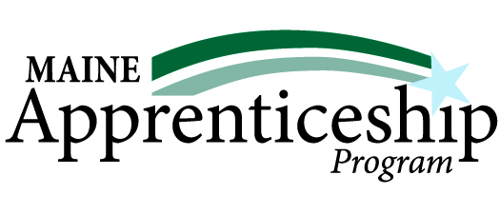

Success Stories
Rose Elliot, Electrician Apprentice
Sponsor: IBEW 567 Portland Electrical JATC and IBEW 1253 Augusta Electrical JATC
Governor Janet Mills and Commissioner Laura Fortman kicked off National Apprenticeship Week 2021 with a visit to a community solar site. E.S. Boulos was one of the contractors at the site and is also a signatory employer for both IBEW 567’s and IBEW 1253’s apprenticeship programs.
Apprentice Rose Elliot was one of the speakers during the event:
“The apprenticeship has been invaluable in my experience as it is a straightforward, incredibly affordable, and rewarding path to a stable career that can transfer to several fields and niches in every part of the world. The skills that you obtain in this field will always be valuable no matter what the future brings, and it has been a huge asset in my life.”
“Apprenticeships are a win for our workers, our employers, and our economy, providing on-the-job training that results in a stable workforce, good-paying jobs, and a stronger, more diverse economy,” said Governor Janet Mills. “With employers looking for workers across Maine, apprenticeships are a great opportunity to get more people – especially younger folks – into new, exciting fields that can provide a good paycheck. I want to see more apprenticeships in Maine and more people entering these important trades.”
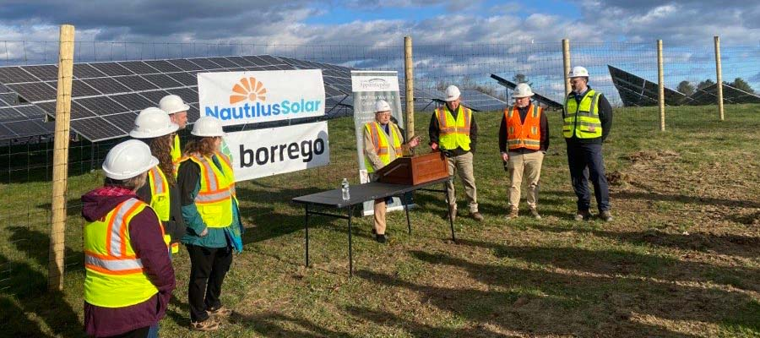
Press release of the event.

Kassandra Ayer, Hospitality Services Apprentice

Sponsor: HospitalityMaine & Maine Course Hospitality Group
I personally recommend this program to anyone who is looking to expand their hospitality knowledge. I started my journey with Maine Course Hospitality Group three years ago. I completed the apprenticeship piece of the program at the Waterville Hampton Inn, was then transferred to The Hampton Inn Augusta, and promoted to Operations Supervisor. This past spring, I was promoted to Housekeeping Manager. The apprenticeship program was an awesome hands-on way to learn about the industry and prepare for my roles in Augusta. This program also gives you college credits from Southern Maine Community College as well as your Serve Safe certification. I am very grateful for the opportunity, and I will use the things I learned every day. I want to thank my mom and my husband for keeping me motivated when times were tough during COVID and the hotel got shut down. I'm glad that the hospitality industry is finding a new normal and we are back to serving our guests with a smile.
I finished the program despite COVID and all the challenges it brought. I was very happy to finish the college courses with a wonderful teacher as well. I will now use the knowledge I learned in my everyday life as a Housekeeping Manager for Hampton Inn of Augusta, Maine.

Audra Ziobro, Carpentry Apprentice
Sponsor: Blaiklock Carpentry
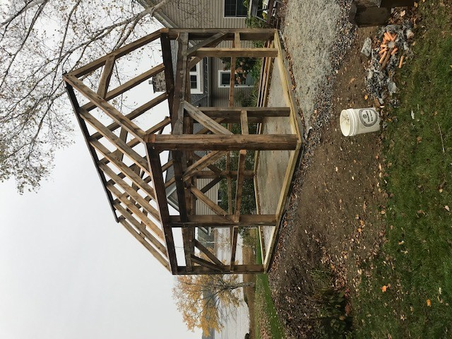
As the owner of Blaiklock Carpentry, Inc. we became a sponsor in the Maine Apprentice Program to attract good, quality employees who could develop into competent, well-rounded carpenters. When we hired Audra in 2017, we got exactly that.
Audra came to us with a variety of schooling and hands on experience. None of it was particularly focused on residential historic carpentry, but it all provided a solid background in working with her hands. When she first came to us, she was not sure she wanted to make a commitment to the apprenticeship. After she had been with us for a year, her interest and excitement in the trade had grown and she decided to give it a try.
We were able to credit her first year of employment to her apprenticeship. To fill the classroom requirement, she enrolled in the Building Technology program at CMCC. The combination of on-the-job learning, classroom work, and attending a variety of workshops and conferences, gave more of an increase in her knowledge and confidence than any one of those would have on their own. Her value to Blaiklock Carpentry, Inc. increased quickly as a result.
We are a very small company that specializes in historic restoration. Because of the small size, every person who works for us has a large impact on everything we do. The ability to do creative problem solving as a knowledgeable carpenter is critical in all our work. Audra has come a long way in the time she has been with us and much of that is due to her apprenticeship. She has become a valuable asset to our company and has a solid body of knowledge that will stay with her for the rest of her life.

Published by the Maine Department of Labor
March 2022

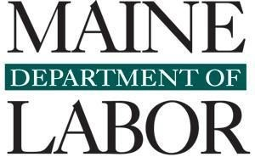
The Maine Department of Labor provides equal in employment and programs.
Auxiliary aids and services are available to people with disabilities upon request.

