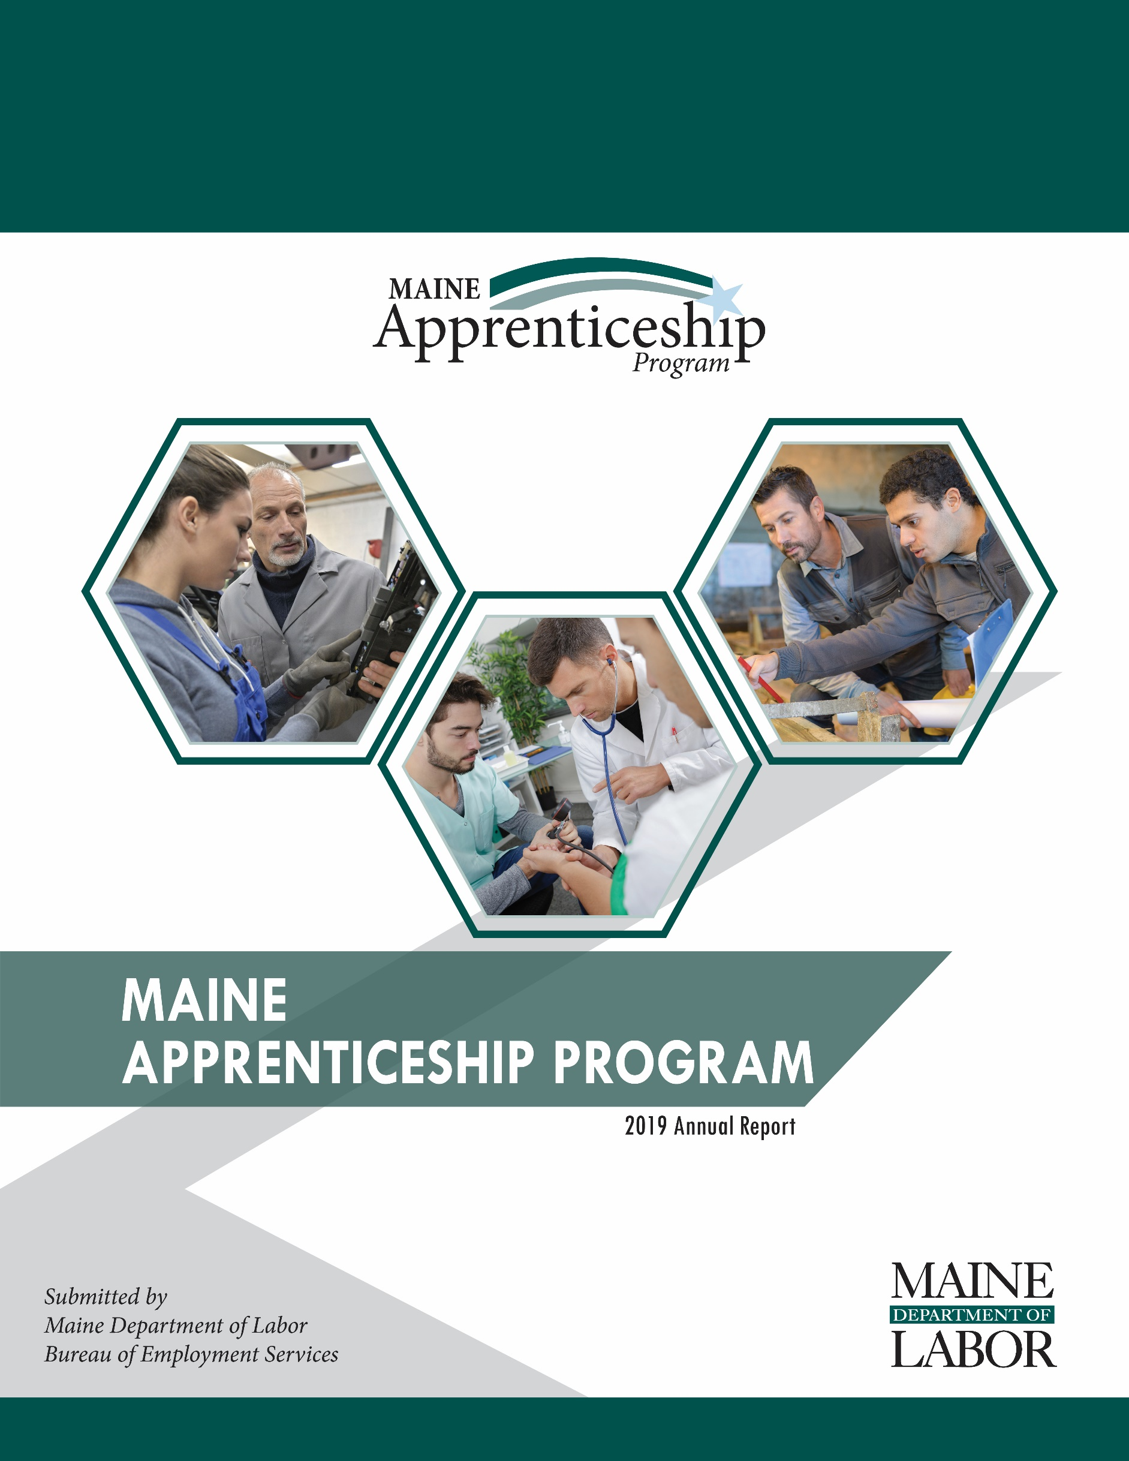
2020 Annual Report

Maine Apprenticeship Program 2020 Annual Report
For the Period January 1, 2020 – December 31, 2020

Prepared for:
Governor Janet T. Mills
The Joint Standing Committee on Labor and Housing
The Joint Standing Committee on Education and Cultural Affairs

Submitted by:
Maine Department of Labor
Laura Fortman, Commissioner

The Maine Department of Labor provides equal opportunity in employment and programs.
Auxiliary aids and services are available to individuals with disabilities upon request.
Tel: (207) 623-7969 TTY users call Maine Relay 711 Fax: (207) 287-5292

2020 Apprenticeship Program Overview
The success of Maine’s economy is tied directly to the skill of our workforce and the creativity and innovation of our employers. Registered Apprenticeships are a vital part of Maine’s economy – they provide career pathways to high-quality jobs that allow apprentices to earn while they learn. Employers hone their future workforce by developing programs in which workers are performing required duties while learning skills needed for higher-level performance.
In Maine, these registered apprenticeships are part of the Maine Apprenticeship Program (MAP), which has been in place since 1941. The MAP is governed by Maine Statute Title 26 Chapter 37 § 3202 and Title 29 Parts 29 and 30 of the United States Code of Federal Regulations. Registered apprenticeships require at least 2,000 hours of on-the-job training and a minimum of 144 hours formal coursework for each year of the apprenticeship. MAP continues to innovate and adapt to meet employers’ needs for skilled labor and workers’ needs for good wages with a clearly defined pathway to career advancement.

In 2020, the construction sector contained the largest percentage of apprentices in Maine at 46 percent. This was followed by 21 percent of apprentices pursuing certification in production occupations. Twenty-four percent of all Maine apprentices are pursuing journey worker status as electricians, found in multiple sectors.

Business and Training Engagement
Registered apprenticeship programs help businesses address their ongoing workforce hiring, training and retention needs. Despite unprecedented unemployment and uncertainty caused by the COVID-19 pandemic, employer engagement with MAP remains strong; 11 new sponsors were registered, and 56 potential new sponsors are working with MAP to explore becoming an apprenticeship sponsor.

Quality Assurance of Programming
The COVID-19 pandemic put a temporary halt to in-person monitoring of sponsors while monitoring processes were transitioned from in-person to fully remote. Despite the pandemic, in 2020 Maine Apprenticeship Program (MAP) staff conducted 15 quality assurance reviews of registered apprenticeship programs to verify that quality apprenticeship programs in compliance with CFR parts 29 and 30 are being delivered. Nine of the sponsors monitored were moved from provisional to permanent sponsor status. The remaining six sponsors were provided with technical assistance on how to make minor improvements to either the record keeping or delivery of the classroom training aspect of their programs and will be assessed again in 2021.

2020 Program Highlights
- In 2020, 2,838 apprentices were actively working on industry-recognized skill certifications. Despite the COVID-19 pandemic, the number of apprentices served in 2020 was nearly the same as in 2019 when 2,819 apprentices were served.
- A three-year, $450,000 federally funded State Apprenticeship Expansion Grant was received in July of 2020. The funding supports the employment of one additional Apprenticeship Technical Representative (ATR) for MAP. The ATR’s primary focus is to provide technical assistance to new and existing sponsors; develop youth apprenticeship programming and to develop formal agreements with local workforce area boards and/or their service providers to better align WIOA investments and activities with apprenticeship outcomes.
- Apprentices who completed their programs during 2020 attained an average wage increase of 40 percent.
- The estimated gross hourly wages paid by employers to Maine apprentices in 2020 was $113.2 million.
- Veterans make up 10 percent of Maine’s total population while 15 percent of the state’s registered apprentices.
- 214 women (7.5 percent of all apprentices) pursued training in non-traditional occupations (NTO’s) such as machinist, non-destructive tester, pipefitter, electrician, shipfitter and welder among other occupations traditionally held by men.

Benefits of Apprenticeship
For Apprentices:
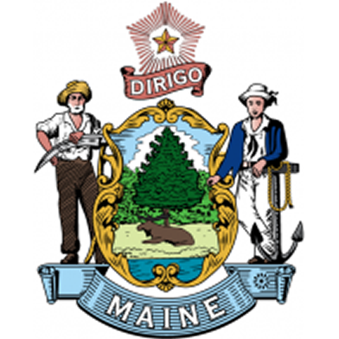
- Increased skills
- Paycheck while in training
- Higher wages
- Mentor support
- Job security
- Safer workplace
- Nationally recognized, portable credential
For Employers:
- Improved recruiting
- More diverse workforce
- Reduced turnover costs
- Higher productivity and fewer accidents
- Connection to training funds
- Apprenticeship program can be customized to meet employer needs
- Formalized approach that enhances existing business practices
- Average return on investment of $1.47 for every $1 invested
For Maine:
- Strengthens state’s economy by developing highly trained and educated workers
- Driven by employer demand and eliminates mismatch between skills taught and employers need
- Provides a customized, long-term solution to filling business workforce gaps as workers retire
- Allows combination with multiple workforce development and other funding streams
- Encourages secondary, post-secondary and workforce development system to work together with business to understand and better serve Maine’s workforce development needs

2020 Apprenticeship Participant Demographics
TOTAL SERVED | MALE | FEMALE | FEMALE-NTO | MINORITY | VETERANS
2,838 | 2,345 | 493 | 214 | 161 | 416

2020 In Numbers
Total taxpayer (State and Federal) dollars spent * | $541,767
Average annual gross wages of apprentices | $41, 122
Total served (new/active/completed/cancelled) | 2,838
Total new apprentices registered | 730
Total apprentices completing programs | 334
Total apprentices cancelled prior to completion | 374
Average age of apprentices at the start of their apprenticeship | 31
Age range of apprentices registered in 2020 | 16 to 72
Average starting hourly wage rate of all apprentices served in 2020 | $18.31
Average ending hourly wage rate at successful completion in 2020 | $24.79

Between 2017 and 2020, the number of apprentices served has increased by 169% and the number of nationally recognized apprenticeship certificates of completion issued by MAP has increased by 159%.

*This figure is less than last year’s total as MAP staff were re-assigned to assist the Bureau of Unemployment Compensation due to the pandemic. While working for BUC, MAP staff did not charge their time to apprenticeship.

Maine Apprenticeship Council
The Maine Apprenticeship Council assists and advises the Department in the administration of the MAP. As required by Title 26 §3209 of Maine statute, the Council consists of twelve voting members who are appointed by the Governor. It also incldues four additional non-voting members appointed by the State Workforce Board; the Community College System; the Maine Department of Education; and, the Maine Department of Economic and Community Development.

2020 Members of the Apprenticeship Council:
- Jennifer McKenna, Chair, United Association Local 716
- Jason Shedlock, Regional Organizer, Laborers’ International Union of North America
- Jennifer Boynton, MaineGeneral Medical Center
- Robin Wood, Reed & Reed, Inc.
- Dawn Croteau, Department of Health and Human Services, Office of Family Independence
- Tracey Cooley, PhD, Penobscot Job Corp Center
- Jonathan Mason, BIW and the State Workforce Board
- Tracie Travers, Jobs for Maine Graduates
- Denise Garland, Department of Economic & Community Development
- Lisa Larson, Eastern Maine Community College
- Dwight Littlefield, Department of Education, Career & Technical Education
            - Dan Coffey, Cianbro

Active Apprenticeship Sponsors 2020
In 2020, apprenticeship programs operating in Maine included 110 separate entities as active sponsors of 2,813 apprentices in 234 sponsor customized occupational programs. Currently, five types of apprenticeship sponsors are operating in Maine: group joint, single employer, intermediary, state agencies and a federal facility.

- The bulk of MAP sponsors continue to be individual businesses (88). Many businesses employ one apprentice while some larger employers (ex: Bath Iron Works, CIANBRO, MaineGeneral Medical Center, and Casella Resource Solutions) served more than 75 apprentices each in 2020.
- The seven joint programs registered in Maine are union-sponsored joint apprenticeship training committees (JATC) that have multiple signatory businesses working with their apprentices. Collectively, 230 apprentices were sponsored by JATC’s in 2020.
- Intermediary sponsors (7) and Community Colleges (2) in Maine sponsored 116 apprentices in 2020. Intermediaries act as apprenticeship intermediaries for their sub-employers who have agreed to hire and train apprentices using the curriculum and on-the-job training outlines established by the sponsor.
- As a federally operated facility, Portsmouth Naval Shipyard (PNSY), is required to register their apprentices directly with the U.S. Department of Labor. PSNY employed 1,667 apprentices, including 220 Maine residents in 32 different trades in 2020. The PNSY apprentices do not register or receive any funding through MAP.

11 New Sponsors in 2020 | Sponsor Type | Program City | State
Valley Gas and Oil Company | Employer | Kingfield | ME
Louth Callan Renewables, LLC | Employer | Suffield | CT
J.S. Pelkey Funeral Home | Employer | Kittery | ME
Heat & Frost Insulators, LU 6/Axion | Union/Labor | Oxford | ME
Favreau Electric | Employer | Brunswick | ME
Duncan Graves Funeral Home | Employer | Presque Isle | ME
Downeast Direct Cremation, LLC | Employer | Bangor | ME
Dog House Energy Services LLC | Employer | Freeport | ME
C&L Aviation Group | Employer | Bangor | ME
Bowers Funeral Home | Employer | Houlton | ME
Birmingham Funeral Home | Employer | Old Town | ME
Continuing Sponsors | Sponsor Type | Program City | State
ADT Commercial | Employer | Portland | ME
Jordan-Fernald Funeral Home | Employer | Mount Desert | ME
Allagash Brewing Company | Employer | Portland | ME
DeBlois Electric, Inc. | Employer | Lewiston | ME
Maine Department of Corrections | State Agency | Augusta | ME
T&D Wood Energy, LLC | Employer | Sanford | ME
American Security Alarm | Employer | Sanford | ME
Cris Contractors | Employer | Fryeburg | ME
Pine State Services | Employer | Westbrook | ME
RGM Enterprises D/B/A Spillers | Employer | Lewiston | ME
Metz Culinary Management | Employer | Lewiston | ME
Ideal Electric | Employer | Winslow | ME
Revision Energy, Inc. | Employer | South Portland | ME
Estes Oil & Propane | Employer | York | ME
Franklin Homestead Kitchen, Bar and Bakery | Employer | Farmington | ME
Modula | Employer | Lewiston | ME
WordLab, LLC | Employer | Portland | ME
Family First Funeral Homes | Employer | Gardiner | ME
Maine Correctional Industries | State Agency | Windham | ME
Day's Jewelers | Employer | Waterville | ME
HospitalityMaine | Intermediary | Augusta | ME
Maine Department of Corrections | State Agency | Warren | ME
Riposta Funeral Home | Employer | Belfast | ME
Jordan Custom Carpentry | Employer | Lovell | ME
Mountain View Correctional Facility | State Agency | Charleston | ME
RCBI Apprenticeship Works-Maine | Intermediary | Saco | ME
Ricker Hill Farms, Inc. | Employer | Turner | ME
Maine Shared Services Alliance | Intermediary | Waterville | ME
Strong Agency, Inc | Employer | Thomaston | ME
Casella Resource Solutions | Employer | Saco | ME
Boyne Resorts | Intermediary | Newry | ME
Casco Bay Electric, LLC | Employer | Portland | ME
Penobscot Job Corps | Intermediary | Bangor | ME
Acadia Integrative Medicine | Employer | Mt. Desert | ME
C-Prime Valuation Group, LLC | Employer | Freeport | ME
Northern Light Health | Employer | Waterville | ME
UA Local 716 Plumbers & Pipefitters Office | Union/Labor | Augusta | ME
Cote Funeral Home | Employer | Saco | ME
David E Desmond Funeral Services | Employer | Bath | ME
Associated General Contractors of Maine | Intermediary | Augusta | ME
Bridgton Veterinary Hospital | Employer | Bridgton | ME
Barrette Outdoor Living, Inc. | Employer | Biddeford | ME
Mid-Coast Energy Systems | Employer | Damariscotta | ME
Nestle Waters North America | Employer | Poland Spring | ME
Blaiklock Carpentry, Inc. | Employer | Woolwich | ME
Interstate Electrical Services, Inc. | Employer | York | ME
Autumn Green Funeral Home | Employer | Alfred | ME
Kiley and Foley Funeral Service | Employer | Brewer | ME
Gallant Funeral Home | Employer | Waterville | ME
Aroostook County Action Program | Employer | Presque Isle | ME
Boston Ocular Prosthetics, Inc. | Employer | Jackson | ME
Lamson Funeral Home | Employer | Millinocket | ME
St. Mary's Regional Medical Center | Employer | Lewiston | ME
McIntire-McCooey Funeral Home | Employer | South Berwick | ME
Pen Bay Medical Center | Employer | Rockport | ME
Clover Manor, Inc. | Employer | Auburn | ME
LincolnHealth | Employer | Boothbay Harbor | ME
Winthrop Utilities District | Employer | Winthrop | ME
Central Maine Motors Auto Group | Employer | Waterville | ME
Shorey-Nichols Funeral Home | Employer | Pittsfield | ME
Veilleux Funeral Home | Employer | Waterville | ME
Eastern Fire Protection | Employer | Auburn | ME
Ken L. Electric, Inc. | Employer | Saint Agatha | ME
Hobbs Funeral Home | Employer | South Portland | ME
Kennebec Valley Community Action Program | Employer | Waterville | ME
Panolam Industries, Inc. | Employer | Auburn | ME
Lucas & Eaton Funeral Home | Employer | York | ME
Pratt & Whitney | Employer | North Berwick | ME
Advantage Funeral Services | Employer | Portland | ME
Everett J Prescott, Inc. | Employer | Gardiner | ME
Midstate Machine | Employer | Winslow | ME
MaineGeneral Health | Employer | Augusta | ME
Burpee, Carpenter & Hutchins Funeral Home | Employer | Rockland | ME
Moody's Collision | Employer | Gorham | ME
Bragdon-Kelley Funeral Homes | Employer | Ellsworth | ME
Hope Memorial Chapel | Employer | Biddeford | ME
Hall Funeral Homes | Employer | Waldoboro | ME
Brookings-Smith Funeral Home | Employer | Bangor | ME
Fortin Group Funeral Home | Employer | Lewiston | ME
Plumbers and Pipefitters UA Local 716 | Union/Labor | Augusta | ME
Dennett-Craig & Pate Funeral Home | Employer | Saco | ME
Seabee Electric, Inc. | Employer | Scarborough | ME
Thos. Moser Cabinetmakers | Employer | Auburn | ME
Bath Iron Works | Employer | Bath | ME
Jones, Rich & Barnes Funeral Home | Employer | Portland | ME
Cianbro | Employer | Pittsfield | ME
IBEW1253, Augusta Electrical JATC | Union/Labor | Fairfield | ME
IBEW567, Portland Electrical JATC | Union/Labor | Lewiston | ME
Sheet Metal Workers Local 17 | Union/Labor | Lewiston | ME
Mass. and Northern New England Laborers | Union/Labor | Hopkinton | MA
Lajoie Funeral Home and Cremation Services, LLC | Employer | Madawaska | ME
Alfred Water District | City/County Agency | Alfred | ME
Maine Medical Center / Maine Medical Partners | Employer | South Portland | ME
Maine Association of Plumbing, Heating, Cooling Contractors, Inc | Intermediary | Cumberland | ME
Southern Kennebec Child Development Corporation | Employer | Farmingdale | ME
Washington County Community College | Community College | Calais | ME
Southern Maine Community College | Community College | South Portland | ME
Kincer Funeral Home, DBA Funeral Alternatives Group | Employer | Richmond | ME

Apprenticeship Occupations Active in 2020 by Occupational Groups

Architecture and Engineering
Basic and Advanced Surveyor
Basic Production Technician
Electromechanical Design/Drafter
Electrical Technician
Manufacturing & Production Technician I
Non-Destructive Tester

Arts, Design, Entertainment, Sports, and Media
Public Relations Specialist

Business and Financial Operations
Advanced Buyer
Project Manager/Installation
Real Estate Appraiser

Educational Instruction and Library
Assistant Teacher
Childcare Development Specialist 1
Childcare Development Specialist 2
Early Childhood Education Teacher
Education Technician III
Teacher Aide I

Farming, Fishing, and Forestry
Logger

Food Preparation and Serving Related
Cook

Healthcare Support
Certified Nursing Assistant (CNA)
Health Support Specialist
Medical Assistant
Psychiatric Nursing Technician
Veterinary Assistant

Construction and Extraction
Boilermaker/Fitter
Bridge Carpenter/Heavy Highway
Carpenter
Carpenter - NCCER Core & Level 1
Carpenter - NCCER Level 2
Carpenter - NCCER Level 3
Carpenter - NCCER Level 4
Carpenter - Ship
Construction Carpenter
Construction Craft Laborer
Construction Equipment Operator
Electrician
Electrician (Ship & Boat)
Floor Layer Specialist
Insulation Worker
Ironworker
Pipe Fitter (Construction)
Pipe Fitter (Ship & Boat)
Plumber
Sheet Metal Mechanic
Sheet Metal Worker

Healthcare Practitioners and Technical
Critical Care Unit Nurse
Emergency Room Nurse
Float Nurse
Front Line Nurse Leader
Mental Health Nurse
Nurse Residency - Med-Surg
Nurse Residency - Critical Care
Nurse Residency - Emergency Room
Nurse Residency - Mental Health
Polysomnographic Technician

Installation, Maintenance, and Repair
A&P Aviation Mechanic
Automobile Body Repairer
Automotive Technician
Diesel Mechanic
HVAC Technician
Industrial Manufacturing Mechanical Maintenance Technician
Lineworker
Maintenance Mechanic
Maintenance Electrician
Maintenance Supervisor
Maintenance Technician
Master Oil Burner, Solid Fuel, Propane & Natural Gas Technician
Millwright
Refrigeration Mechanic
Security and Fire Alarm System Installer
Service Technician
Substation Technician
Telecommunications Technician

Management
Funeral Director
Office Manager/Admin Services
Operations Management

Office and Administrative Support
Accounting Technician
Advanced Planner
Basic Planner
Financial Management Specialist
Hospitality Services 1
Service Coordinator / Dispatcher

Personal Care and Service
Funeral Practitioner
Service Dog Trainer

Production
Advanced Front-Line Supervisor
Artificial Eye Maker
Bench Jeweler
Boiler Operator
Cabinetmaker
Engineering Assistant
Front Line Supervisor - Production
Industrial Sewing Machine Operator
Layout Manufacturing Production Technician
Machinist
Painter, Transportation Equipment
Shipfitter (Ship & Boat)
Water Systems Operator
Water Treatment Plant Operator
Waterworks Tradesperson
Welder, ARC
Wood Pellet Plant Operator

Protective Service
Corrections Officer
Fire Suppression Technician

Sales and Related
Service Manager
Technical Sales Representative

Transportation and Material Moving
CDL Tractor Trailer / Tanker Operator
Refuse and Recyclable Material Collector - Lead Driver
Truck Crane Operator

Looking Forward
Since mid-March of 2020, COVID-19 has greatly reduced the collaborative interactions with our partners as everyone has been focused on coping with our “new normal.” Despite recent challenges, the University of Southern Maine Cutler School, one of 15 recipients nationwide to receive a Jobs for the Future (JFF) Grant to modernize apprenticeship programs for opportunity youth has become a new MAP partner. The grant provides the Cutler Institute with access to JFF youth apprenticeship coaches, nationwide peer learning and technical support for their efforts to provide opportunity youth with expanded access to apprenticeships. The MAP team will regularly interface with Cutler Institute staff to leverage the technical assistance and coaching provided by JFF to expand the foundation necessary to collaboratively develop high quality standards for youth apprenticeship programs in Maine.
In 2021, the Department plans to collaborate with JFF, Educate Maine, Jobs for Maine Graduates, Career and Technical Education (CTE) High School programs, business and workforce partners to expand MAP programs to encompass high-quality youth apprenticeship programs. Our plan is to develop and launch youth pre-apprenticeship and apprenticeship programming in the construction sector for youth aged 16 – 24. Quality youth apprenticeship programs provide a continuum of experiences beginning in middle school or even earlier with career exploration, job shadowing, work-based learning and relevant classroom training to prepare youth for entry into paid apprenticeship opportunities that begin as early as the age of 16 . Ideally, youth apprentices earn credit toward high school graduation and college while earning a paycheck.
The State’s economic development plan calls for increasing the knowledge, skills and abilities of Maine people. A vital piece of this is increasing the number of youth who continue their learning beyond high school graduation. Making career exploration available to youth from kindergarten up through their first year after high school graduation is a priority. The economic plan also calls for paid internships for youth to connect them to Maine’s workforce. Registered apprenticeships can play an important role in fulfilling this goal.
The current strategy to register intermediary sponsors of apprenticeship including associations, chambers of commerce and community college systems will continue in 2021. Registering intermediary sponsors of apprenticeship will increase the likelihood of small companies engaging with apprenticeship programing and help to leverage funding. The MAP program will continue to work closely with the Maine Community College System, Workforce Innovation and Opportunity Act programs, and other available programs to co-enroll apprentices providing affordable training and access to necessary support services.
The Bureau of Rehabilitation Services (BRS) Apprenticeship Project first piloted in 2019 continues to assist MAP with marketing the benefits of apprenticeship and to improve stakeholder understanding of the value added by apprenticeship. This organic outreach strategy increases MAP capacity; supports employer EEO compliance; increases apprenticeship opportunities for clients and adds viable skills to the workforce. BRS staff has embraced the apprenticeship training model and regularly reaches out to MAP staff to seek apprenticeship opportunities for their clients and/or recommend new apprenticeship sponsors to be registered.
The COVID-19 crisis alongside Maine’s already looming economic and workforce crisis demands strategic investment and innovation to help Maine thrive. Now is an important opportunity to reflect upon Maine’s current apprenticeship program and consider any changes that may be advisable. The Department will continue its review of policies and practices in order to identify what changes, if any, are needed to meet the demands of workers and sponsors. Registered apprenticeships can play an important role in helping Maine’s economy thrive. When the pandemic is over, and as Baby Boomers (28% of Maine’s population) begin to retire in large numbers, Maine employers will scramble to hire, train and retain the workforce they need to succeed. Maintaining established partnerships, creating new partnerships, expanding apprenticeship programs for youth and entry level workers while strengthening Maine’s existing apprenticeship programs will be the focus of our apprenticeship program activities in 2021. When employers are ready to hire new employees and/or upskill their existing workforce, Maine’s apprenticeship program will be well positioned to assist.

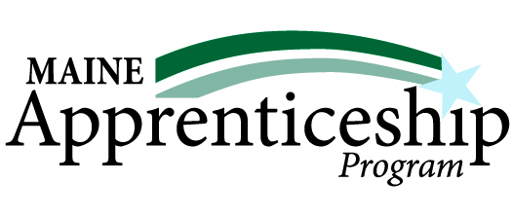

Success Stories
Patrick Tshala
Electrical Journeyworker Apprentice
Sponsor: DeBlois Electric, Inc.

In August of 2018, DeBlois Electric was contacted by the local FedCAP office that there was a match for its need for trained electricians. Patrick Tshala was looking to regain his electrical journeyworker license in the United States, having immigrated here from Lubumbashi, Democratic Republic of the Congo, in December of 2017. Upon meeting Patrick, who was fully certified as an electrician in the DRC, DeBlois Electric immediately offered him a job as an electrical helper.


Patrick and his wife have four children, which makes working and going to school that much more difficult; he simply could not sacrifice earning a wage to support his family. Patrick’s greatest challenge was finding a way to become fully licensed in his new country. “I could not find a program that allowed me to have enough time for school and work to support my family,” he recalls. In April of 2019, DeBlois Electric announced to its employees that it was instituting an apprenticeship program. Patrick took the opportunity immediately. “Having the chance to earn a living while working on my electrical degree has been a life-changing situation for me,” says Patrick.

With the support of the Associated Builders and Contractors of Maine, DeBlois Electric offers the NCCER online electrical program to its apprentices. The self-paced program includes CORE and four levels of electrical. The DeBlois Electric apprenticeship program currently has 18 apprentices working each at his or her own pace on the education portion while working full time in the field.

Mitch DeBlois, president of DeBlois Electric, says Patrick is an inspiration to the team. It typically takes an apprentice three to four years to complete the education part of the program, but Patrick is on pace to finish in under two years – a testament to his commitment. “Since starting the apprenticeship program, Patrick has grown exponentially,” says Mitch. “It’s much more than his professional development – he has taken on the role of mentor for the younger people in the program, always encouraging them. We look forward to having Patrick on our team for a long time.” For his part, Patrick believes that the self-paced online learning while working in the field is the most effective way to learn. “I recommend the program to anyone looking to start in the electrical field as the perfect way to earn a living while learning your craft. This is the best program I found, and I can’t imagine anything better.”

Maine State Prison in Warren
Service Dog Training Apprenticeship Program

America's VetDogs works with the Maine State Prison in Warren to train future service dogs. Residents who meet very specific criteria are selected to participate in a 4000-hour, 2-year dog training apprenticeship which helps them to prepare for future employment such as working in a veterinary clinic, as a canine trainer or as a groomer, upon release. Socialization, puppy development, behavior theory, animal husbandry, grooming, and first aid are all part of the VetDogs apprenticeship curriculum. Handlers not only teach basic obedience but service dog tasks as well, such as retrieving dropped items, tugging doors open, pushing handicapped door buttons, and providing brace and balance on stairs.

In this special program, inmates are raising and training puppies who will one day work as service dogs for wounded veterans. Incarcerated veterans are encouraged to participate. In order to be chosen as dog handlers, inmates are vetted through a rigorous selection process. Case workers, case managers, and program staff are all involved in choosing a good candidate. Inmates who are honorably discharged veterans are given preference to become raisers, but all candidates must have acceptable behavioral records while they have been incarcerated.

In March 2020 four Maine State Prison residents were recognized for successfully completing this Registered Apprenticeship Training Program. Other apprenticeships offered to inmates through the Maine Department of Corrections include Wood Harvesting, Carpentry, Commercial Stitching, and Culinary 1.

Compiled from various websites:
https://www.vetdogs.org/av/dogprograms/prisonpuppyprogram.aspx#:~:text=Correctional%20institutions%20from%20Maine%20to,service%20dogs%20for%20wounded%20veterans.
https://www.maine.gov/corrections/about/resident-employment/vocational-programming-information

Published by the Maine Department of Labor
March 2021

Canadian Apprenticeship Forum retrieved on 1/28/2021; https://caf-fca.org/apprenticeship-101/hiring-an-apprentice/
2 Linked Learning. (n.d.). About the Linked Learning Approach. Retrieved February 11, 2021 from https://www.linkedlearning.org/about/linked-learning-approach

