There are six sections that need to be completed in CNPweb:
- Upload Required Documents
- Sponsor level questions
- Resource Management
- Meal Compliance Risk Assessment
- Dietary Specifications
- Corrective Action Responses
Login into CNPweb: https://www.cnpwebsite.com/Maine/Login
Enter your User Id and Password. For assistance with User Ids and Passwords, contact child.nutrition@maine.gov or 624-6842.
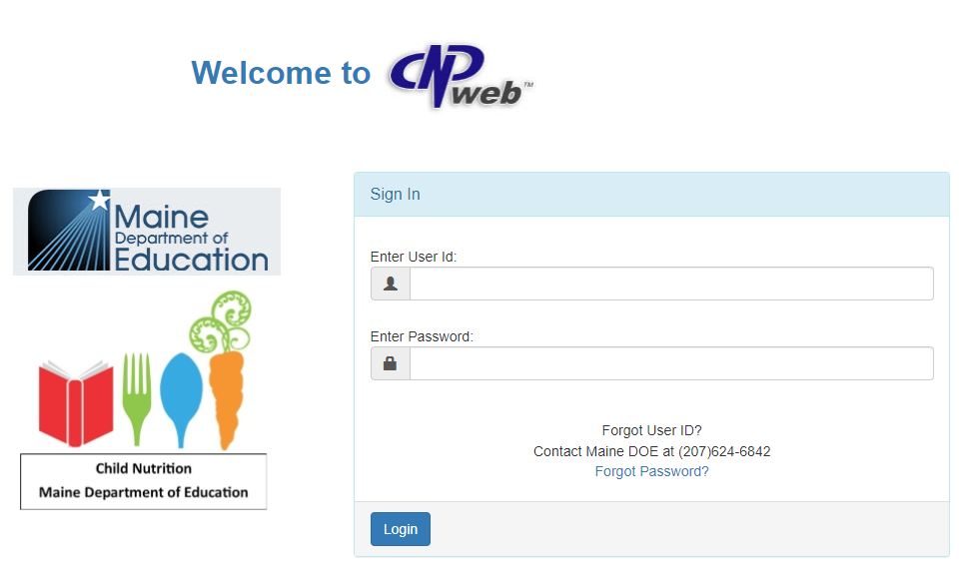

Select ‘SNP’
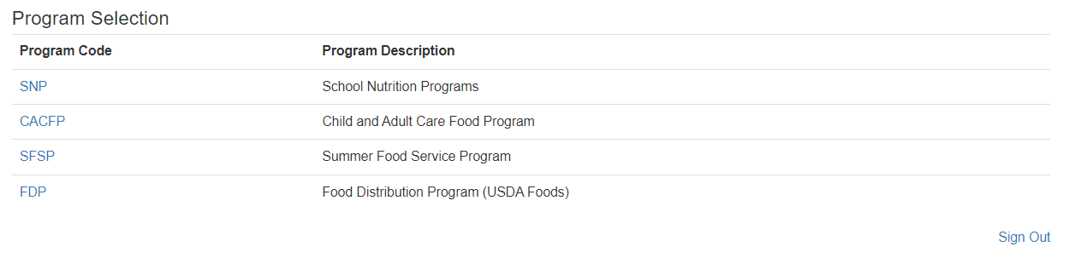
Select the school year being reviewed
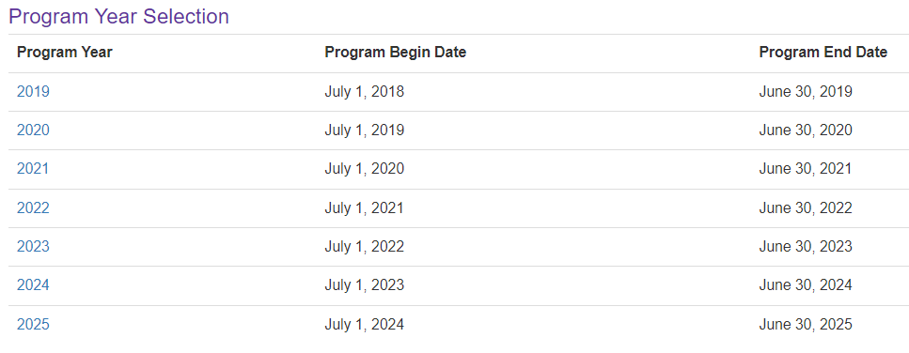

Click “E-Reviews” and select “E-Review Log by Sponsor.”
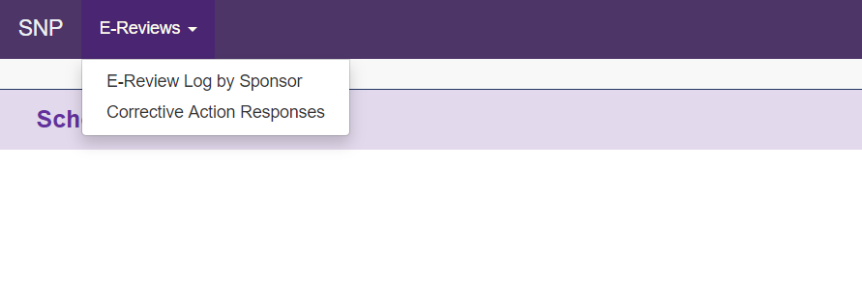
Click on the 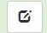 symbol under “E-Review Log”. This will open up the Review Summary Page.
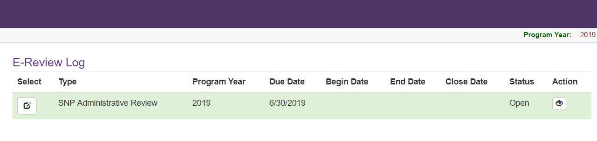
- Upload Required Documents
Refer to the email from your reviewer and the Administrative Review Checklist for a list of documents to be uploaded. Name each document so it clearly indicates what it is. For example, when uploading production records, ‘HS lunch production records 10.21.24’.
On the Review Summary page, click on the light blue folder icon.
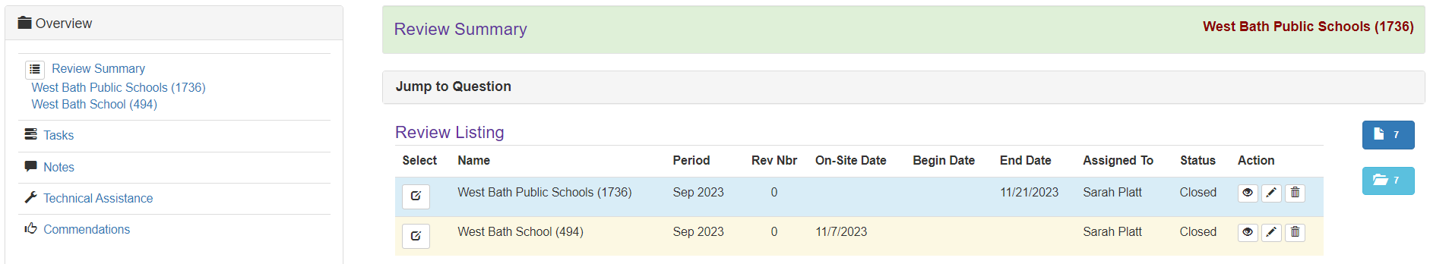

- Off-site Questions
Complete Sponsor level questions by clicking on the  symbol under the blue portion of “Review Listing” to anwser the district level question.
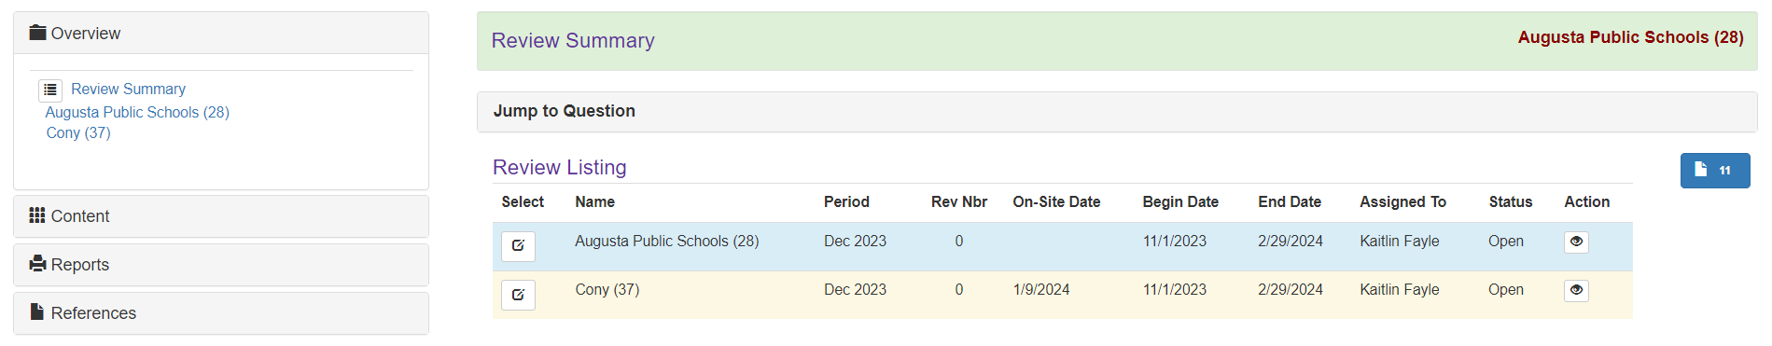
There are five categories: Certification and Benefit Issuance, Verification, Meal Counting & Claiming, General Program Compliance, and IX Special Provision Options. Anwser questions in each area. As you anwser and save questions in each area, the red bar will change to green.
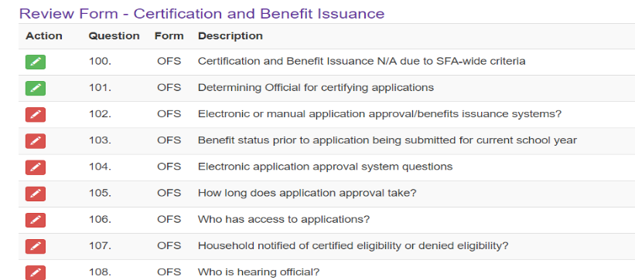
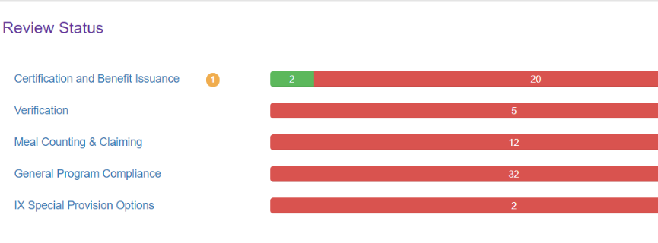

- Resource Management

On the left side of the screen Click on ‘Overview’ ‘Review Summary’ Click ‘Content’ ‘Resource Management’.
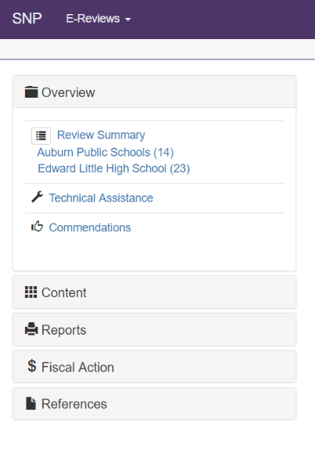

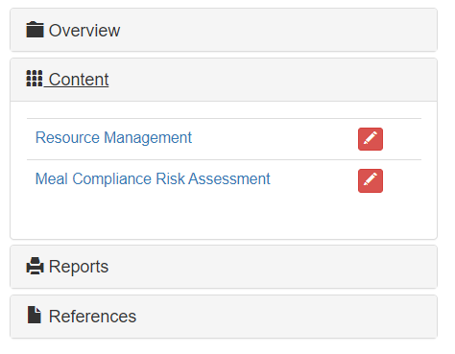

Resource Management has four sections: Non-Profit FS Account, Paid Lunch Equity, Nonprogram Foods Revenue, and Indirect Costs. Each must be selected and contain questions to anwser. Don’t forget to save after you answer each question. As each question is answered and saved, the red box with the pencil will turn green to indicate completion.
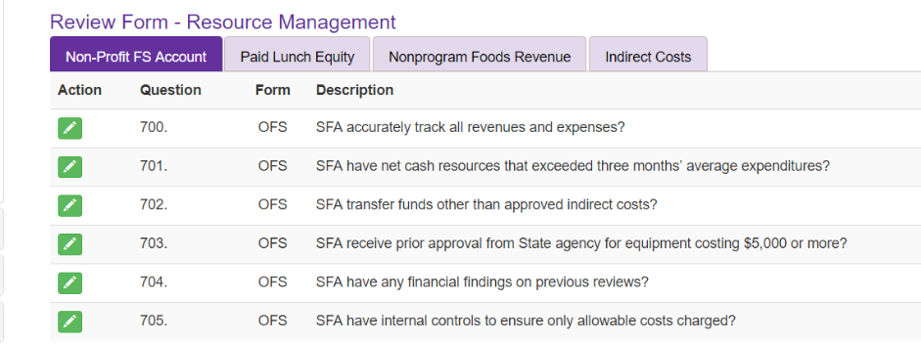

- Meal Compliance Risk Assessment

On the left side of the screen Click on ‘Overview’ ‘Review Summary’ Click ‘Content’ ‘Meal Compliance Risk Assessment’. Answer the questions in the Meal Compliance Risk Assessment Tool.

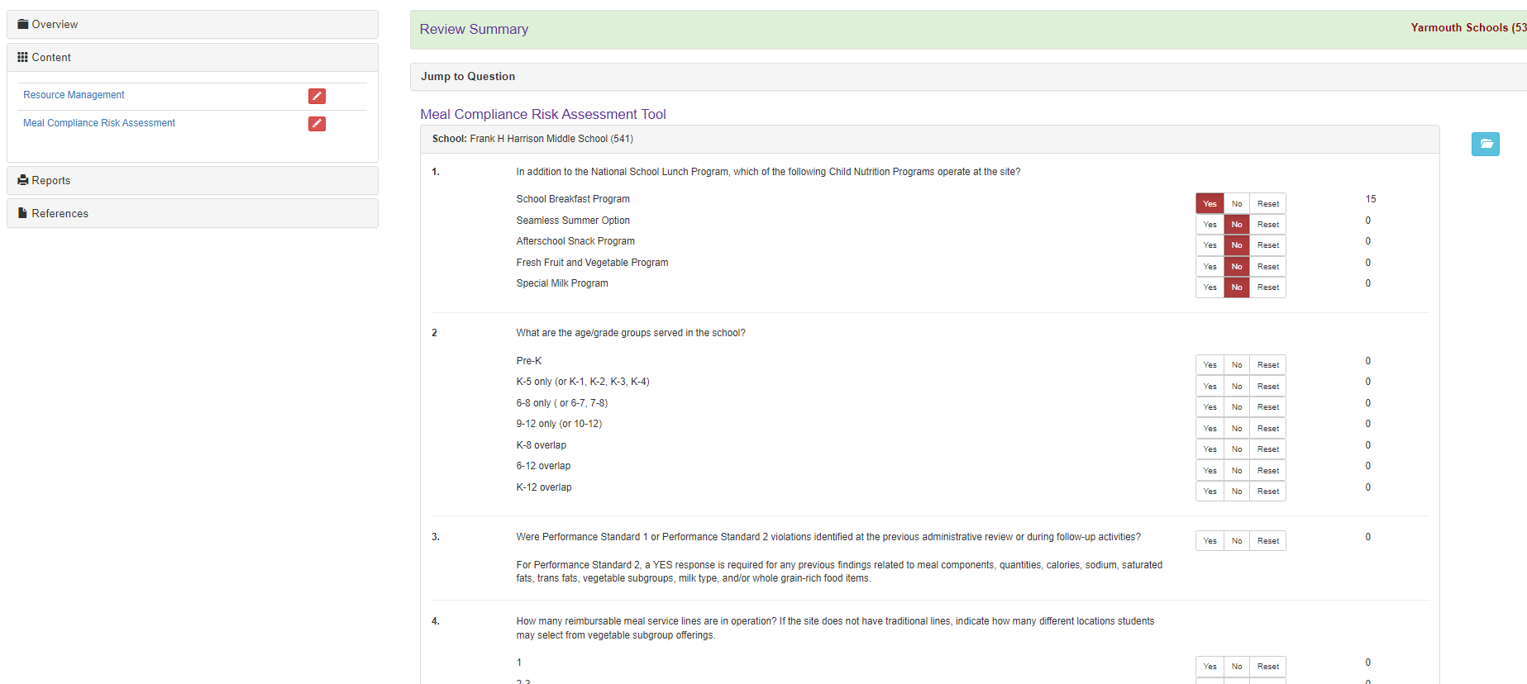

- Dietary Specifications Assessment
On the left side of the screen Click on ‘Overview’ ‘Review Summary’ Site/School Name Tools & Forms Dietary Specifications Assessment
Click the icon under the yellow portion of “Review Listing” to complete the dietary specifications tool for the site/school receiving the on-site review.
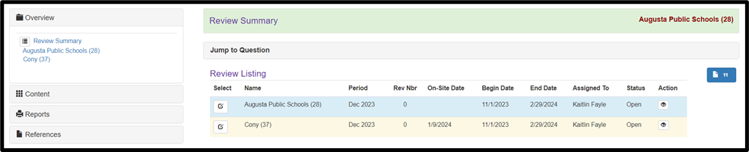
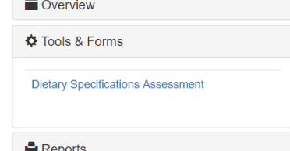

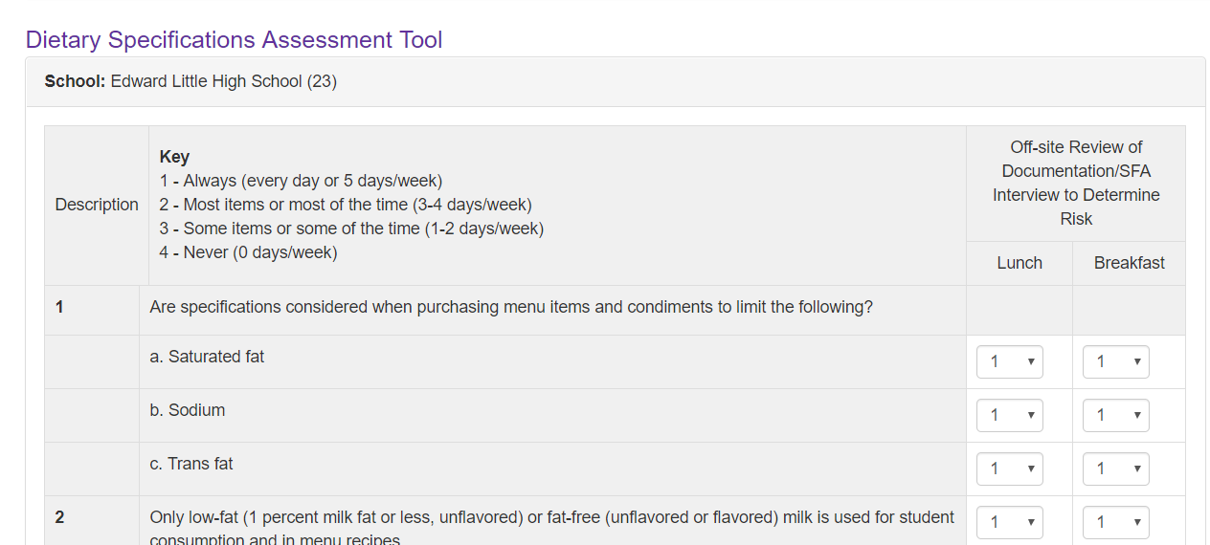

- Corrective Action Responses
Click E-Reviews “Corrective Action Responses.”
On the Corrective Action Responses navigation page the School Nutrition Department and Maine State Agency staff work together on Corrective Action needs.
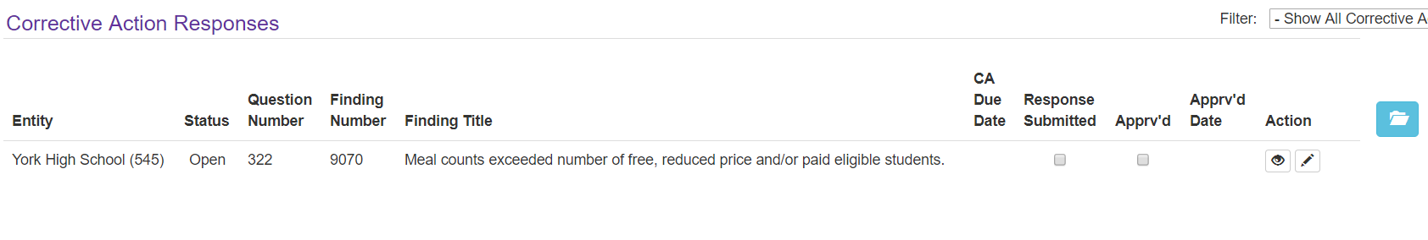

For each finding, select the pencil box to add a Corrective Action response.
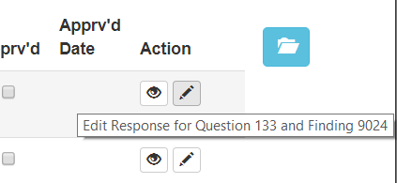

Each finding includes a description of the finding and required Corrective Action. Enter a detailed response for each request for corrective action.
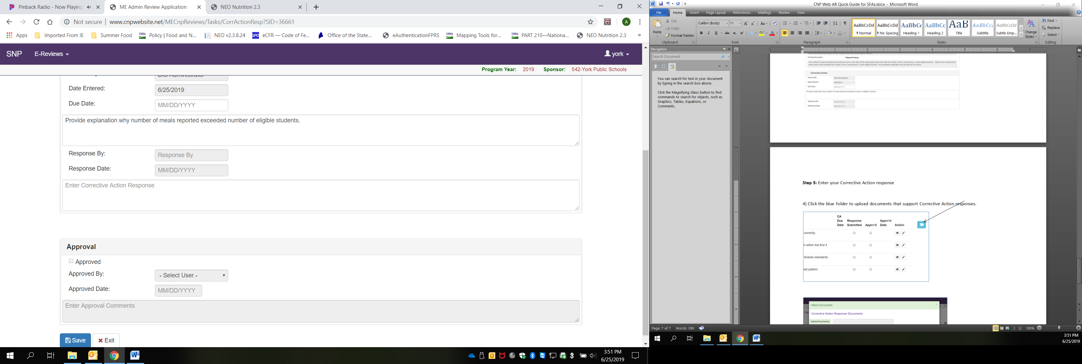
Click on the blue folder to upload supporting documentation.
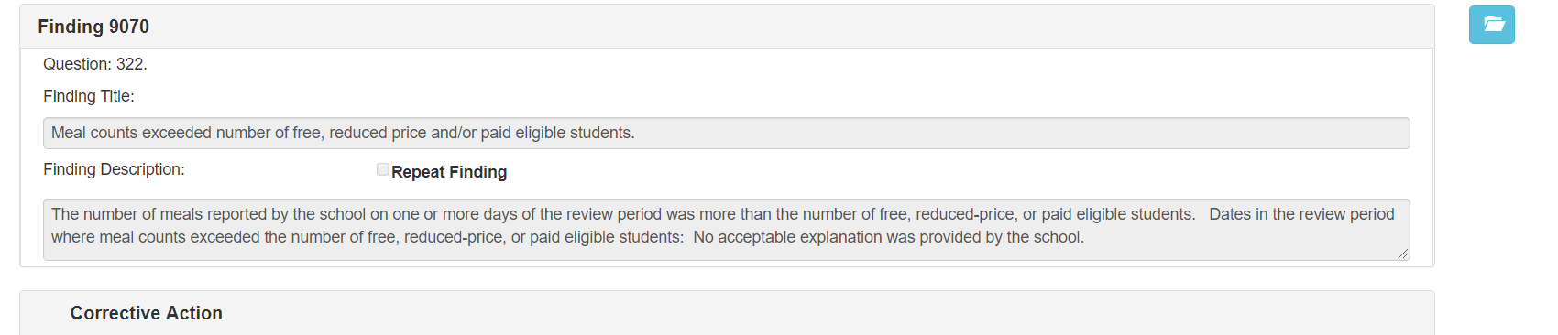
Click “Upload Document(s) and select the file you wish to attach.
Be sure to save after the response and file has been uploaded.

