
Maine Weekly Arboviral Surveillance Report
July 29, 2025

January 1, 2025 – July 26, 2025:

Local Arboviral Activity

Humans – Endemic arboviral illnesses
 | Number Tested | WNV positive | EEE positive | JCV positive | POW positive
Current Week | 3 | 0 | 0 | 0 | 1
2025 Year to Date | 37 | 0 | 0 | 1 | 1
EEE, JCV, and WNV are endemic mosquito-borne arboviruses. POW is the only endemic arbovirus spread by ticks in Maine. Human arboviral testing performed at Maine’s Health and Environmental Testing Laboratory (HETL). Testing may be performed year round. Number tested only reflects testing performed at HETL. Confirmation testing performed at CDC Fort Collins

Humans – Travel-associated arboviral illnesses
 | CHIK positive | DEN positive | OROV positive | ZIK positive
2025 Year to Date | 0 | 1 | 0 | 0
Imported arboviral testing may be performed at HETL, CDC Fort Collins, or other national reference laboratories

Veterinary
 | Number Tested | WNV positive | EEE Positive
Current Week | 1 | 0 | 0
2025 Year to Date | 5 | 0 | 0
Veterinary arboviral testing may be performed at HETL, through University of Maine Veterinary Diagnostic Laboratory, through the Cornell University Animal Health Diagnostic Center, or through the USDA National Veterinary Services Laboratory (NVSL); testing may be performed year round

Avian
 | Number Tested | WNV positive | EEE Positive
Current Week | 5 | 1 | 0
2025 Year to Date | 22 | 1 | 0
Avian arboviral testing performed at HETL

Mosquitoes – Endemic arboviruses
 | Pools Tested | WNV positive | EEE positive | JCV positive
Current Week | 79 | 0 | 0 | 0
2025 Year to Date | 193 | 0 | 0 | 0
Mosquito EEE, JCV and WNV testing performed at HETL; mosquito collection begins in June and continues through October

Only completed testing is included in this report.

EEE = Eastern Equine Encephalitis
CHIK = Chikungunya
DEN = Dengue
JCV = Jamestown Canyon
OROV = Oropouche
POW = Powassan
SLE = Saint Louis Encephalitis
WNV = West Nile
ZIK = Zika

2025 Maine positive results
Surveillance | Species | Collection Date | Town | County | Agent
Human |  | 2/24/2025 |  | Franklin | JCV
Human |  | 6/22/2025 |  | Hancock | POW
Avian | American Crow | 7/16/2025 | Hollis Center | York | WNV

Maine Mosquito Meter

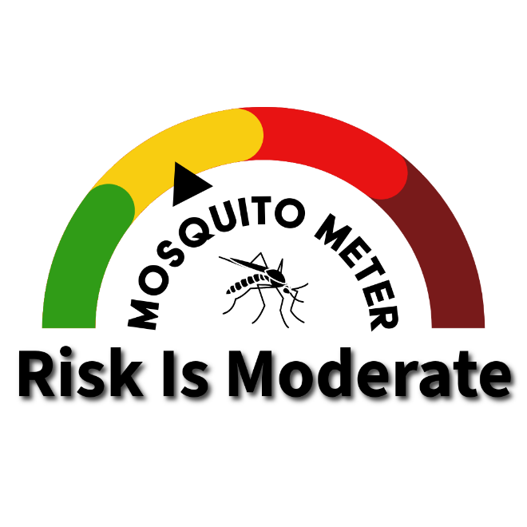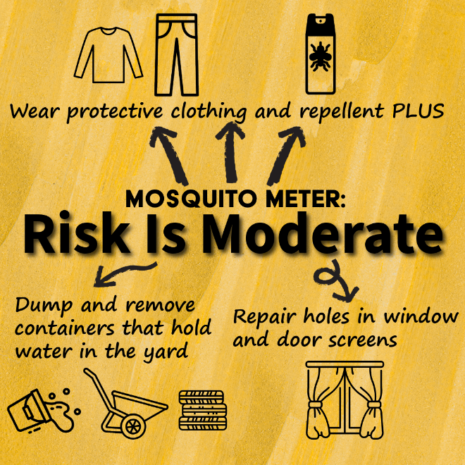
Provides a statewide assessment of the risk of arboviral transmission by mosquitoes in Maine. Reassessment occurs weekly

National Arboviral Activity

2025 Locally-acquired human cases – United States
 | Dengue positive | Zika positive* | Oropouche*
Florida | 4 | 0 | 0
* There is no current local transmission of Oropouche or Zika virus in the continental United States

International Arboviral Activity

2025 CDC travel health notices
Level | Disease | Location
2 | Chikungunya | Kenya, Madagascar, Mauritius, Mayotte (France), Réunion (France), Santa Cruz (Bolivia), Somalia, Sri Lanka
2 | Yellow Fever | Bolivia, Brazil, Colombia, Peru
2 | Oropouche | Espírito Santo (Brazil), Darién Province (Panama)
1 | Dengue | Bangladesh, Colombia, Comoros, Cook Islands, Ecuador, Fiji, French Polynesia, Guatemala, Kiribati, Mali, Panama, Philippines, Samoa, Sudan, Tonga, Tuvalu
1 | Oropouche | Brazil, Colombia, Cuba, Panama, Peru
More information on travel health notices is available here: https://wwwnc.cdc.gov/travel/notices.

