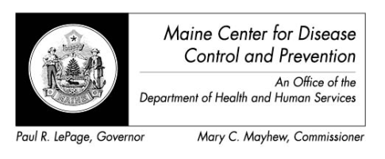
Maine Zika Report
May 13, 2016

Important Considerations
- The types of mosquitoes that can transmit Zika virus are NOT found in the state of Maine

Recent Global Updates
- 3/31/2016 – WHO situation report determines that based on observational, cohort, and case-control studies there is strong scientific consensus that Zika virus is a cause of Guillain-Barre syndrome (GBS), microcephaly and other neurological disorders
- 4/13/2016 – CDC concludes Zika causes microcephaly and other birth defects
- 4/2016 – CDC launches US Zika Pregnancy Registry

Current Data – Maine (as of 5/13/16)
- Travel-associated Zika virus disease cases reported: 3

Current Data – US States (as of 5/11/16)
- Travel-associated Zika virus disease cases reported: 503
- Locally acquired vector-borne cases reported: 0
- Of the 503 cases reported:
  - Pregnant: 48
  - Sexually transmitted: 10
  - Guillain-Barre syndrome: 1

Current Data – US Territories (as of 5/11/16)
- Travel-associated Zika virus disease cases reported: 3
- Locally acquired vector-borne cases reported: 698
- Of the 701 cases reported
  - Pregnant: 65
  - Guillain-Barre syndrome: 5

Countries currently affected by Zika (as of 4/13/16 – newly identified countries in red)
- Americas: Aruba, Barbados, Belize, Bolivia, Bonaire, Brazil, Colombia, Costa Rica, Cuba, Curacao, Dominica, Dominican Republic, Ecuador, El Salvador, French Guiana, Grenada, Guadeloupe, Guatemala, Guyana, Haiti, Honduras, Jamaica, Martinique, Mexico, Nicaragua, Panama, Paraguay, Peru, Puerto Rico, Saint Barthelemy, Saint Lucia, Saint Martin, Saint Vincent and the Grenadines, Sint Maarten, Suriname, Trinidad and Tobago, US Virgin Islands, Venezuela

- Oceania/Pacific Islands: American Samoa, Fiji, Kosrae - Federated State of Micronesia, Marshall Islands, New Caledonia, Papua New Guinea, Samoa, Tonga

- Africa: Cape Verde

All Countries and Territories with Active Zika Virus Transmission (CDC, 5/12/16)
