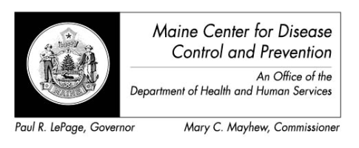
Maine Zika Report
April 15, 2016

Important Considerations
- The types of mosquitoes that can transmit Zika virus are NOT found in the state of Maine

Recent Global Updates
- 3/31/2016 – WHO situation report determines that based on observational, cohort, and case-control studies there is strong scientific consensus that Zika virus is a cause of Guillain-Barre syndrome (GBS), microcephaly and other neurological disorders
- 4/13/2016 – CDC concludes Zika causes microcephaly and other birth defects

Current Data – Maine (as of 4/15/16)
- Travel-associated Zika virus disease cases reported: 2
- # of samples submitted for testing: 87

Current Data – US States (as of 4/13/16)
- Travel-associated Zika virus disease cases reported: 358
- Locally acquired vector-borne cases reported: 0
- Of the 358 cases reported:
  - 31 were pregnant
  - 7 were sexually transmitted
  - 1 had Guillain-Barre

Current Data – US Territories (as of 4/13/16)
- Travel-associated Zika virus disease cases reported: 4
- Locally acquired vector-borne cases reported: 471
- Of the 475 cases reported
  - 58 were pregnant
  - 1 had Guillain-Barre

Countries currently affected by Zika (as of 4/13/16 – newly identified countries in red)
- Americas: Aruba, Barbados, Bolivia, Bonaire, Brazil, Colombia, Costa Rica, Cuba, Curacao, Dominica, Dominican Republic, Ecuador, El Salvador, French Guiana, Guadeloupe, Guatemala, Guyana, Haiti, Honduras, Jamaica, Martinique, Mexico, Nicaragua, Panama, Paraguay, Puerto Rico, Saint Lucia, Saint Martin, Saint Vincent and the Grenadines, Sint Maarten, Suriname, Trinidad and Tobago, US Virgin Islands, Venezuela

- Oceania/Pacific Islands: American Samoa, Fiji, Kosrae - Federated State of Micronesia, Marshall Islands, New Caledonia, Samoa, Tonga

- Africa: Cape Verde

All Countries and Territories with Active Zika Virus Transmission (CDC, 4/13/16)
