
Maine Weekly Influenza Surveillance Report
2024-2025 Influenza Season
May 20, 2025
Data for MMWR week 20 (ending 5/17/2025)

U.S. Outpatient Influenza-like Illness Surveillance Network (ILINet)

Outpatient Visits for ILI –ILINet, Maine, 2023-25

Percent of Outpatient Health Care Visits Due to ILI
1.07
Number of ILINet Reporting Providers
46

Syndromic Surveillance

Percent of Emergency Room (ED) Visits Due to ILI
1.13
Percent of Emergency Medical Services (EMS) calls for ILI
0.17

Hospitalizations
Influenza-Associated Hospitalizations This Week
1
Total Influenza-Associated Hospitalizations This Season
1,487

Syndromic Surveillance data for ILI – Maine, 2023 -25

Influenza Hospitalizations – Maine, 2023-25

Pneumonia and Influenza (P&I) Deaths

Percent of Deaths Due to P&I
2.73
Influenza-Associated Deaths This Week*
0
Total Influenza-Associated Deaths This Season*
103
Pediatric Influenza-Associated Deaths This Season
1

Deaths Attributable to P&I – Maine, 2023-25

*This number represents the number of individuals who had influenza specifically listed on their death certificate. This is likely an underrepresentation of the true burden, as many influenza-associated deaths are due to secondary infections. This is why Maine CDC reports Pneumonia and Influenza (P&I) deaths.

Virologic Surveillance
Health and Environmental Testing Laboratory | Week 20 | 2024-25 Season
No. of specimens tested | 5 | 2,033
No. of positive specimens | 5 (100%) | 1,871 (92%)
Positive specimens by type
Influenza A | 3 (60%) | 941 (50%)
(H1N1)pdm09 | 3 (60%) | 741 (40%)
H3N2
Influenza B | 2 (40%) | 189 (10%)
Yamagata lineage | - | -
Victoria lineage | - | -
Influenza Positive PCR Tests, HETL – Maine, 2024-25

Maine Reference Laboratories | Week 20 | 2024-25 Season
No. of specimens tested | - | 38,999
No. of positive specimens (%) | - | 5,584 (14%)
Positive specimens by type
Influenza A | - | 4,501 (80%)
Influenza B | - | 1,093 (20%)

Influenza Positive Tests, Maine Reference Labs – Maine, 2024-25

All Reported Laboratory Results | Week 20 | 2024-25 Season
No. of specimens positive by antigen test | 9 | 3,768
No. of specimens positive by molecular test | 26 | 14,025
Positive specimens by type
Influenza A | 8 (31%) | 14,005 (79%)
Influenza B | 18 (69%) | 3,768 (21%)

Total Reported Positive Influenza Tests – Maine, 2024-25

Antigenic Characterization (Vaccine Strain Match)

US CDC characterizes antigenicity by how well antibodies made against the vaccine strains recognize circulating virus that have been grown in cell culture. Of the characterized viruses, the vaccine strain antibodies recognized:
- 99.5% of influenza A/H1N1 viruses were well-recognized by ferret antisera raised against the cell-grown A/Wisconsin/67/2022-like reference virus for the season
- 58.0% of influenza A/H3N2) viruses were well-recognized by ferret antisera raised against the cell-grown A/Massachusetts/18/2022-like reference virus for the season.
- 97.1% of influenza B/Victoria lineage viruses were well-recognized by ferret antisera raised against the cell-grown B/Austria/1359417/2021-like reference virus.
- No influenza B/Yamagata samples were available for characterization

Weekly County-level Influenza, Maine, Week 20
County | Positive labs | Hospitalizations | Activity Trend | Severity Estimate§
Androscoggin | 1 | 0 | Sustained Decrease | Low
Aroostook | 1 | 0 | Sustained Decrease | Low
Cumberland | 8 | 1 | Sustained Decrease | Low
Franklin | 3 | 0 | Plateau | Low
Hancock | 0 | 0 | Sustained Decrease | Low
Kennebec | 2 | 0 | Sustained Decrease | Low
Knox | 0 | 0 | Sustained Decrease | Low
Lincoln | 0 | 0 | Sustained Decrease | Low
Oxford | 0 | 0 | Sustained Decrease | Low
Penobscot | 3 | 0 | Sustained Decrease | Low
Piscataquis | 0 | 0 | Sustained Decrease | Low
Sagadahoc | 0 | 0 | Sustained Decrease | Low
Somerset | 2 | 0 | Decrease | Low
Waldo | 0 | 0 | Sustained Decrease | Low
Washington | 0 | 0 | Plateau | Low
York | 6 | 0 | Sustained Decrease | Low
Total | 26 | 1 | - | -
*Activity trends are determined by county-level emergency department visits due to ILI. Activity trend levels include “sustained increase”, “increase”, “plateau”, “decrease”, and “sustained decrease.” This will become available when enough weeks of data have been collected.
§Severity is estimated using county-level P&I deaths, syndromic surveillance, and hospitalizations. Thresholds are calculated statewide from previous seasons’ data using the moving epidemic method, as described at https://www.cdc.gov/flu/about/classifies-flu-severity.htm

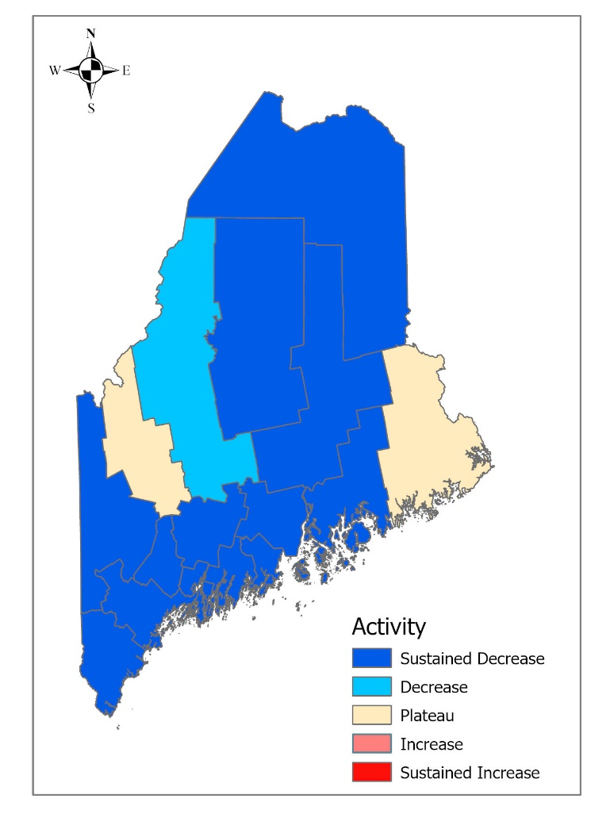
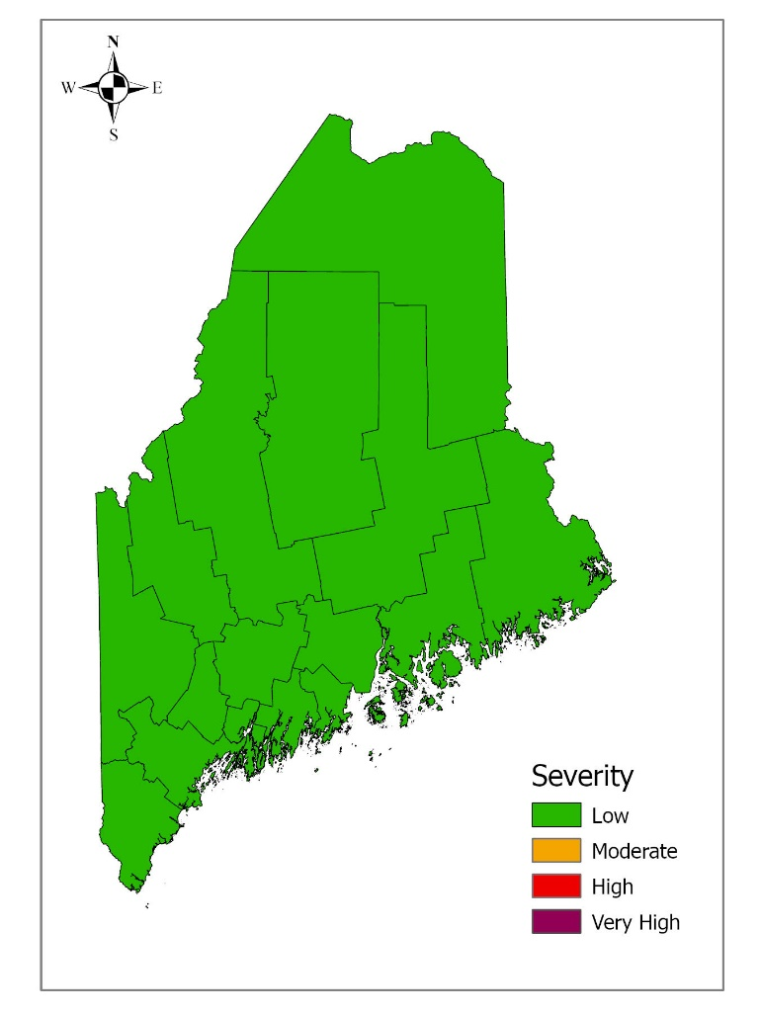
Influenza Activity Trends, Maine, Week 20 Influenza Severity Estimates, Maine, Week 20

Age Information – Maine, 2024-25 Influenza Season

Positive Influenza Tests by Age and Hospitalization Status
– Maine, 2024-25

 | Age (years)
 | Min. | Mean | Max
Cases | < 1 | 37 | 104
Hospitalizations | <1 | 63 | 103
Deaths | <18 | 77 | 103

Influenza-Like Illness Outbreaks – Maine, 2024-25 Influenza Season

Number of New Outbreak Investigations
0
Total Outbreaks This Season
165
Influenza-Like Illness Outbreaks by Facility Type – Maine, 2024-25
Outbreak Facility Type Key:
LTC - Long Term Care Facility
AC - Acute Care Facility (nosocomial)
K12 - School (K-12) or daycare
Univ - School (residential) or University
HCW - Health care workers
Inst - Other institutions (workplaces, correctional facilities etc)
Camp - Camp

Influenza-Like Illness Outbreak by Facility Type and County – Maine, 2024-25
County | LTC | AC | K12 | Univ | HCW | Inst | Camp | Total
Androscoggin | 6 | 3 | 1 |  |  |  |  | 10
Aroostook | 9 | 1 | 6 |  |  |  |  | 16
Cumberland | 34 | 5 | 3 |  | 1 |  |  | 43
Franklin | 3 | 1 |  |  |  |  |  | 4
Hancock | 3 | 2 | 4 |  |  |  |  | 9
Kennebec | 7 | 2 | 8 |  |  |  |  | 17
Knox | 1 | 1 | 3 |  |  |  |  | 5
Lincoln | 3 |  |  |  |  |  |  | 3
Oxford | 5 |  | 5 |  |  |  |  | 10
Penobscot | 7 | 2 | 0 |  |  |  |  | 9
Piscataquis |  |  |  |  |  |  |  | 0
Sagadahoc | 2 |  | 1 |  |  |  |  | 3
Somerset | 2 |  | 4 |  |  |  |  | 6
Waldo | 1 |  | 6 |  |  |  |  | 7
Washington |  |  | 5 |  |  |  |  | 5
York | 14 | 3 | 1 |  |  |  |  | 18
Total | 97 | 20 | 47 | 0 | 1 | 0 | 0 | 165

National Influenza Surveillance Data
Source: https://gis.cdc.gov/grasp/fluview/main.html
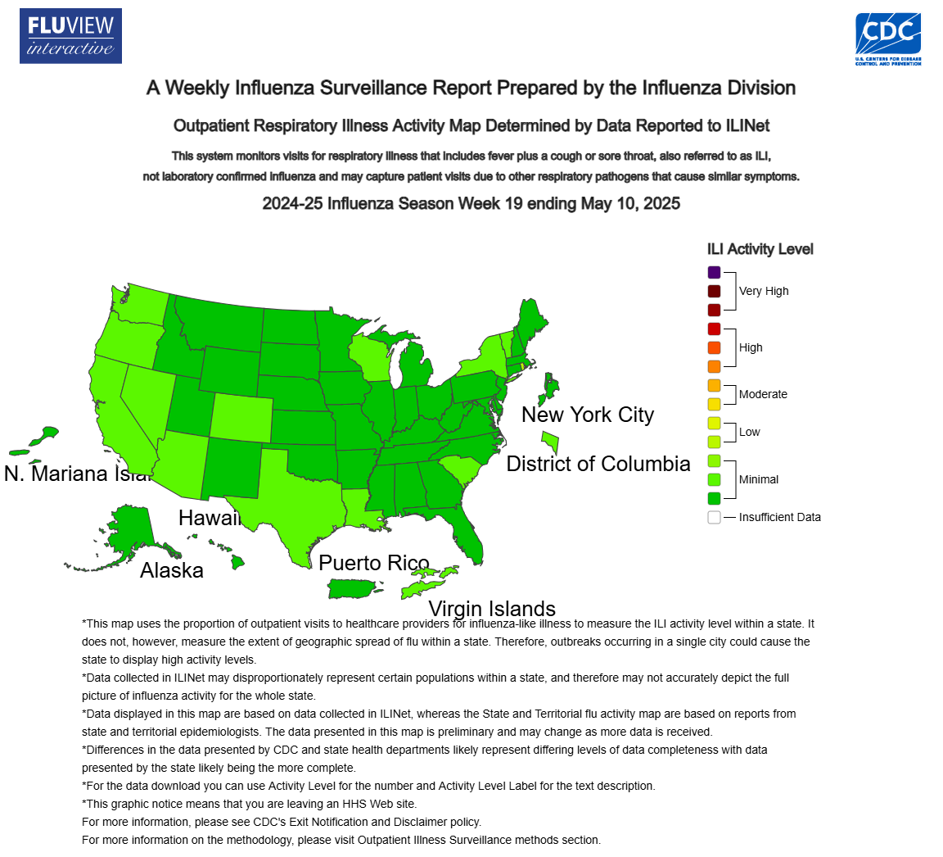

- All current and archived influenza surveillance reports are located at www.maine.gov/dhhs/flu/weekly
- Sign up to automatically receive influenza surveillance report at https://public.govdelivery.com/accounts/MEHHS/subscriber/new?preferences=true
- An overview of Maine influenza surveillance, including descriptions of the surveillance systems and data used to generate surveillance reports can be found at https://www.maine.gov/dhhs/mecdc/infectious-disease/epi/influenza/documents/Flu-Surveillance-Data-Overview-24-25.pdf

